Abstract
This report presents a protection coordination and fault analysis of the Ashuganj South 450 MW Combined Cycle Power Plant in Brahmanbaria, Bangladesh. The studied system includes a 360 MW, 458 MVA Siemens generator, a 515 MVA, 22/230 kV step-up transformer, a 230 kV GIS switchyard, auxiliary transformers, and the connection to the national grid. The study was carried out through power-flow analysis, short-circuit analysis, protection coordination, breaker duty assessment, and dynamic simulation. Four types of faults, namely three-phase, single-line-to-ground, line-to-line, and double-line-to-ground faults, were analyzed at different locations. The results showed that the three-phase fault produces the highest fault current, reaching 126.21 kA at the 22 kV generator terminal and 50.53 kA at the 230 kV busbar. The protection coordination study showed no coordination failures, while the dynamic simulation showed that a 230 kV busbar fault was cleared in approximately 87 ms. The power-flow study also showed that the step-up transformer operates at 105.87% of its ONAN rating but only 72.98% of its ODAF rating. An apparent 109.60% loading of the 25 MVA auxiliary transformer was found to be caused by circulating power between two parallel auxiliary transformers rather than an actual overload. The generator neutral grounding limits the earth-fault current to only 7.272 A, indicating the need for dedicated neutral current measurement and earth-fault protection. Overall, the study evaluates the power flow, fault levels, protection coordination, breaker performance, and important operating conditions of the plant. The results are based on simulation and analysis, so the relay settings presented are study values and not actual commissioned plant settings.

Introduction
Electricity in Bangladesh is produced mainly using natural gas, and Ashuganj in Brahmanbaria is one of the country's major power generation areas. The Ashuganj South 450 MW Combined Cycle Power Plant is owned and operated by Ashuganj Power Station Company Limited (APSCL), and its generated power is delivered to the national grid through a 230 kV transmission system.
This report focuses on the electrical behavior of the plant during normal operation and fault conditions. The electrical system includes a Siemens SGen5-2000H generator rated at 360 MW and 458 MVA, a generator circuit breaker, a 515 MVA, 22/230 kV step-up transformer, a 230 kV GIS switchyard, a 0.7 km two-circuit transmission connection, and two auxiliary transformers supplying the 6.6 kV auxiliary system. The generator uses high-resistance neutral grounding to limit earth-fault current, while a 110 V DC battery system supplies the protection and circuit-breaker control system.
Fault analysis is important because short circuits can produce very high currents, causing excessive heating, mechanical stress, and voltage reduction in the power system. For example, a three-phase fault at the 22 kV generator terminals can produce a fault current of about 126 kA. Therefore, accurate fault-current calculations are required to properly select circuit breakers, switchgear, busbars, current transformers, and other electrical equipment.
Protection coordination is also essential to ensure that the correct circuit breaker operates first during a fault. The nearest protection should clear the fault quickly, while backup protection should operate if the primary protection fails. Proper coordination prevents unnecessary shutdowns and helps maintain system reliability. Another important finding of this study is related to the generator's high-resistance neutral grounding. The generator earth-fault current is limited to only 7.272 A, which is much smaller than the normal phase current and may not be detected by the phase current transformers. Therefore, dedicated neutral current measurement and earth-fault protection are required.
The study also addresses two important questions raised during the project presentation. First, the three-phase fault is actually the most severe fault at all studied locations; the earlier result showing a larger double-line-to-ground fault was caused by placing correct values in the wrong rows of the presentation. Second, the voltage at the point of a bolted three-phase fault becomes zero because the fault directly connects the three phases with zero impedance. The relation I = V/Z used for calculating the fault current is therefore based on the fault-point voltage being zero.
The overall study was completed in six phases, including plant data collection, power-flow analysis, short-circuit analysis, protection coordination, breaker-duty assessment, and dynamic simulation. Each phase used the results of the previous phase so that the assumptions and system conditions remained consistent throughout the analysis.

Phase | What it did
1 | Built the plant data model from as-built drawings and manufacturer data sheets, and recorded every parameter's status as official, secondary, assumed or derived.
2 | Built the network model on a 100 MVA per-unit base and verified the impedances and transformer vector groups.
3 | Solved the balanced power flow across the dispatch range in four switching cases, and produced the voltage, loss, flow and transformer-loading results.
4 | Built the sequence-domain short-circuit model on top of the frozen power-flow state and solved four fault types at five locations in two configurations.
5 | Derived protection settings, graded them, and screened circuit breaker duty.
6 | Built a closed-loop dynamic model in Simulink with relays, breakers and the DC supply in the loop, and watched a complete trip sequence unfold in time.

Two solvers, kept deliberately separate. This report uses two quite different numerical methods, and it is important to keep them separate. The power flow of Phases 2 and 3 is a non-linear problem and is solved by the Newton–Raphson method through Simscape Electrical's powergui load-flow tool, converging in two iterations in every case to a tolerance of 1×10⁻⁴ on a 100 MVA base. The fault study of Phase 4 uses no iteration. Once the pre-fault voltages are frozen, every bolted fault network is linear, so the solution is obtained by a direct solve of the sequence admittance matrix. Therefore, Newton–Raphson is used for the power-flow study, while the fault study is solved directly.
This is a simulation and analysis study. No hardware was built, no PCB was designed, and no relay firmware was written. Instead, the study focuses on system modeling, power-flow analysis, fault analysis, protection coordination, and breaker duty assessment. The relay settings, fault levels, and breaker duty margins presented in this report are study values based on the available data and stated assumptions, not commissioned plant settings. They would require further engineering verification and site testing before being used in the actual plant.
The study also makes no claim of compliance with IEC 60909, IEEE C37, or any other standard. It uses related concepts such as sub-transient short-circuit current, peak fault current, and inverse-time relay characteristics, but the analysis was not performed as a formal standard-compliance study. To keep the results transparent, every value is identified by its source: A for project or official data, B for strong secondary data, C for engineering assumptions, and D for values derived from the analysis. This ensures that assumptions are clearly separated from actual plant data.
How to read this report:
Section | Contents
3.1 | How the problem was identified, researched and formulated – PO(a)
3.2 | The mathematics and method, including the answers to both teacher questions – PO(a)
3.3 | The single-line diagram and electrical layout
3.4 | The Simulink simulation model and its subsystems
3.5–3.7 | Why the CAD, PCB and firmware sections do not apply, and what replaced them
4 | Implementation – what was built and how it runs
5.1 | What is new in this study compared with what the plant already had
5.2 | Design considerations: safety, environment, society – PO(c)
5.3 | The investigations: experiment design, data, results and interpretation – PO(d)
5.4 | Where the tools stop being trustworthy – PO(e)
5.5–5.7 | Impact, sustainability and ethics – PO(f), PO(g), PO(h)
6 | How the team worked – PO(i)
7 | Communication to people outside the team – PO(j)
8 | Project management and cost – PO(k)
9 | Future work – PO(l)
10 | References

A reader who wants only the engineering results should read 5.3. A reader who wants only the answers to the two questions raised at the design presentation should read 3.2.6 and 3.2.7. A reader who wants to run the study again should read 4 and 7.2.

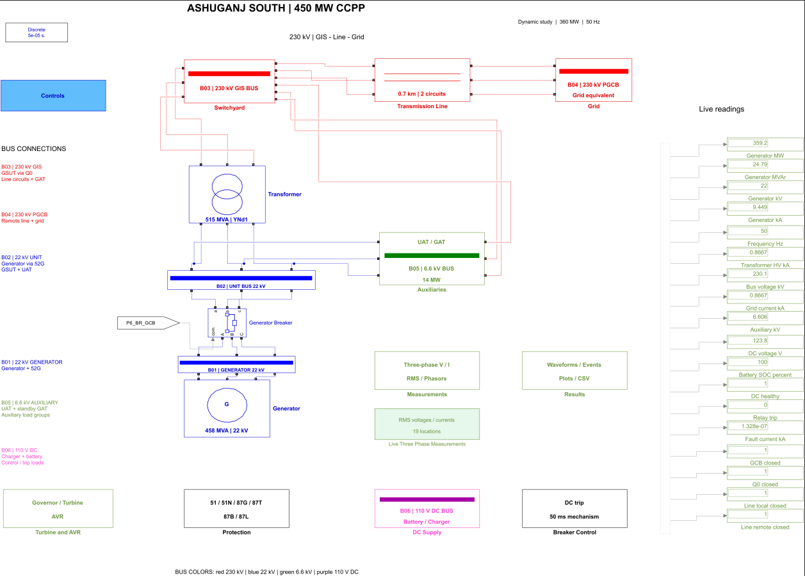

Figure 1 — Annotated overview of the plant in the simulation model of MATLAB, showing the generator, step-up transformer, 230 kV switchyard, line connection, grid equivalent and auxiliary supply

3.Design

3.1 Problem Formulation (PO(b))
PO(b) focuses on identifying, formulating, researching, interpreting data, and analyzing complex electrical and electronic engineering problems using mathematical, scientific, and engineering principles. In this study, these activities were followed throughout the design process. The problem was first identified from the available plant drawings and equipment data, relevant technical information was studied, the electrical system and fault-analysis problem were formulated, and the collected data was then analyzed to obtain meaningful results.
The main problem was to use the as-built drawings and manufacturer data of the Ashuganj South 450 MW combined cycle power plant to determine the fault currents at important points in the generator–transformer system, develop suitable protection settings for selective fault clearing, and check whether the installed switchgear can safely handle the calculated fault currents. The study also separates the results into actual plant data, calculated values, engineering assumptions, and information that could not be determined from the available documents.

3.1.1 Identification of Scope
The system boundary. The study covers one complete generator–transformer unit and everything electrically attached to it, from the generator neutral earthing resistor out to the point where the 230 kV
connection meets the national grid.

Inside the boundary:
Element | What was modelled
Generator | Siemens SGen5-2000H, 360 MW / 458 MVA / 22 kV / 50 Hz, rated current 12.02 kA, inertia constant H = 5.287 s, short-circuit ratio 0.601, with full positive-, negative- and zero-sequence data
Generator earthing | High-resistance neutral earthing through the 10BAB11 neutral earthing transformer and resistor, effective value 1750.773 Ω, giving 3·Z_N ≈ 5252.32 Ω (1085.19 per unit on the 4.84 Ω base at 22 kV)
Generator circuit breaker | 10BAC10, 24 kV class, 12 400 A continuous, 100 kA breaking, 274 kA peak withstand
Step-up transformer | 10BAT10, 515 MVA, 22/230 kV, YNd1, 16.0 % impedance on 515 MVA, cooling stages 355 ONAN / 460 ODAN / 515 ODAF MVA
230 kV switchyard | Siemens 8DN9 gas-insulated switchgear, 245 kV class, double busbar with bus coupler, 50 kA for 3 s short-time withstand, 125/135 kA peak, busbars and coupler 3150 A, bays 2000 A
Transmission connection | 0.7 km two-circuit 230 kV connection: R = 0.0277725 Ω, X = 0.1425655 Ω, B = 3.297996 µS
Grid | Thevenin equivalent at 230 kV: R_th = 0.268 Ω, X_th = 2.94 Ω, X/R = 15, short-circuit level ≈ 17.93 GVA, zero-sequence ratio Z_0/Z_1 = 1.5
Unit auxiliary transformer | 10BBT10, 25 MVA, 22/6.9 kV, Dyn11, 10.5 % (zero-sequence ≈ 9.3 %), stages 19 ONAN / 25 ONAF MVA
Generator auxiliary transformer | 10BBT20, 25 MVA, 230/6.9 kV, YNyn0+d11, 12.0 %, stages 19 ONAN / 25 ONAF MVA
Auxiliary board | The 6.6 kV bus as a lumped load, with the 6.9 kV winding nominal handled through the tap ratio 6.9/6.6 = 1.045454545
Station DC | 110 V DC trip supply, modelled in the dynamic phase as a gating condition on every trip
Protection | The functions installed: line differential (87L), busbar differential (87B), generator differential (87G), transformer differential and restricted earth fault (87T, 87N), overcurrent and earth fault overcurrent (51, 51N), and generator earth fault (64G)

Outside the boundary, and deliberately so:

• The thermal cycle. Gas turbine combustion, heat recovery, the steam cycle and everything to do with efficiency are outside an electrical protection study.
• Low-voltage distribution below 6.6 kV. The auxiliary board is a lumped load. The motor control centers, their feeders and their individual protection are not modelled.
• Motor contribution to fault current. No induction-motor infeed was modelled, which means the auxiliary-side fault currents reported here are conservative in the non-protective direction and are flagged as such in the limitations register.
• Current transformer saturation and harmonic blocking. The project document set contains no CT knee-point voltage or excitation characteristic, so saturation could not be modelled rather than was chosen not to be.
• Switching transients, transient recovery voltage and travelling waves. These need an electromagnetic-transient tool and a different model of every component.
• The sister plant. Ashuganj has other units; only the South plant unit is studied.

Fault locations
Five fault locations were selected:
Location | Where | Why it was chosen
F1 | 22 kV generator terminals | The lowest impedance point in the plant; sets the generator circuit breaker duty
F2 | 22 kV step-up transformer LV terminals | Electrically the same mode as F1, included as a consistency check — the solver must return identical results, and it does
F3 | 230 kV gas-insulated busbar | The point where the switchgear short-time withstand rating is tested
F4 | A sliding point at fraction m along the 0.7 km connection | Tests the line model; must reproduce F3 exactly at m = 0 and F5 exactly at m = 1
F5 | Remote end of the connection, at the grid interface | The point where the plant's contribution and the grid's contribution separate

F1 is important for generator breaker duty, F3 checks the GIS duty, F4 tests whether the line model behaves correctly, and F5 represents the grid interface. Four fault types were studied: LLL, LG, LL and LLG. Two auxiliary-transformer switching conditions were also considered.
One important scope point is that the plant does not have directional overcurrent protection (67) or instantaneous earth-fault overcurrent protection (50N). Therefore, the study does not artificially introduce these functions. Differential protection is used where appropriate instead

3.1.2 Literature Review
The literature used in the study can be divided into three groups.
First are the plant's own documents: as-built drawings, Siemens equipment data, generator sequence data and SIPROTEC relay documentation. These are the main sources for actual plant values.
Secondly, the standards such as IEC 60909 for short-circuit calculations, IEC 60255 for relay characteristics, IEC 62271-100 for circuit-breaker duties and IEC 61869 for instrument transformers. IEEE guides were also used for generator, transformer and general protection concepts.
Third are textbooks and research literature covering symmetrical components, fault analysis, power-system analysis and protective relaying.
An important point is that the study uses concepts from these standards but does not claim formal compliance with them. In particular, the IEC 60909 voltage factor c was not applied. Instead, the study used the actual 1 p.u. pre-fault voltage obtained from its own power-flow calculation.
The literature helped in three important ways:
- It showed that an LLG fault can sometimes be larger than an LLL fault depending on the relationship between Z0 and Z1.
- It motivated the derivation of a direct mathematical relation between the fault currents and Z0/Z1.
- It confirmed that very small generator earth-fault current is expected when high-resistance grounding is used.

3.1.3 Formulation of Problem
The overall goal was turned into ten specific questions, each with a stated acceptance criterion, so that at the end of the study it would be possible to say whether each had been answered rather than merely investigated.
# | Question | Acceptance criterion | Answered in
Q1 | Is the per-unit network model internally consistent? | Base impedances and currents reproducible by hand; transformer ratios and vector-group shifts verified | 3.2.1, 5.3.2
Q2 | Does the plant power flow converge, and at what points? | Convergence at every dispatch in the range with tolerance ε; generator inside its capability curve | 5.3.1, 5.3.3
Q3 | How are the transformers loaded, and against which rating? | A loading figure reported against each named cooling stage, never a bare percentage | 5.3.3
Q4 | What is the fault current for all four fault types at all five locations? | All 5 × 4 × 2 table with sequence components and peak values | 5.3.3
Q5 | Why did the three-phase fault appear smaller than the double-line-to-ground fault? | A general closed-form criterion plus a numerical check against the project's own results | 3.2.6
Q6 | Why is the fault-point voltage zero in a three-phase fault? | A step-by-step derivation plus independent evidence from the code and result files | 3.2.7
Q7 | Can the installed switchgear interrupt the calculated currents? | A duty comparison per breaker, reported as margins and never as a compliance verdict | 5.3.3
Q8 | Do the derived protection settings grade selectively? | Every gradable relay pair assessed against a stated coordination time interval, with zero failures | 5.3.3
Q9 | Does a complete trip sequence actually work end to end, in time? | A closed-loop dynamic run showing fault, relay pickup, trip request, DC coil energization and contact separation with timestamps | 3.4, 5.3.3
Q10 | Which questions cannot be answered from the available documents? | A register of missing data, each item naming what is missing and what it would change | 5.4

1. Main Constraints
- Limited data: The study mainly relied on as-built drawings and OEM datasheets. Important parameters such as the line’s zero-sequence data, tower/soil information, and measured grid Thevenin equivalent were unavailable.
- Software limitations: The load-flow tool only handles balanced positive-sequence analysis, so separate models were needed for fault analysis and the protection trip sequence.
- No field testing: No relay injection tests, staged faults, or actual plant measurements were available. Validation was therefore done using calculations, hand checks, and theoretical/invariant checks.
- Time limitation: The whole study had to be completed within a 13-week course schedule by a five-person team.

2. Main Conflicting Requirements
- Speed vs. selectivity: Faults should be cleared quickly, but the correct downstream relay must get the first chance to operate. Hence, the study uses a 0.30 s coordination interval.
- Sensitivity vs. stability: Protection must detect the very small 7.272 A earth fault, while avoiding unwanted operation due to 5.9 MW circulating power between auxiliary transformers.
- Model accuracy vs. practicality: A highly detailed model is more realistic but harder to run and verify. Therefore, the study uses three separate models with different purposes.
- Conflicting documents: Some project documents give different values for the same parameter. The study therefore records both values, explains the selected value, and gives the reason for choosing it.

3.1.4 Analysis

The Four Fault Types
The fault study considers four common fault conditions. Instead of solving them directly in the phase domain, the system is converted into sequence networks and the required boundary conditions are applied.
- LLL fault: Only the positive-sequence network is involved. The three phase currents have equal magnitude and are 120° apart.
- LG fault: Positive, negative and zero-sequence networks are connected in series. Because the generator has high-resistance grounding, the earth-fault current becomes very small.
- LL fault: Positive- and negative-sequence networks are involved, while the zero-sequence network is absent.
- LLG fault: Positive sequence interacts with the negative- and zero-sequence networks through a parallel connection.
The main fault solver uses one coupled nodal matrix rather than directly using the closed-form equations. The analytical equations are then used as an independent check. The maximum difference between the two methods was only about 3 × 10⁻¹⁴, which is essentially numerical round-off.

Why LLL Is Larger Than LLG
The initial presentation suggested that the three-phase fault current was lower than the double-line-to-ground fault current. After checking the actual results, it was found that the values were correct but had been placed in the wrong rows of the slide.
At the 230 kV bus:
LLL current = 50.53 kA
LLG current = 48.50 kA
LG current = 45.74 kA
LL current = 43.76 kA
So, the correct order is:
LLL > LLG > LG > LL
The reason comes from the relationship between the sequence impedances. At F3:
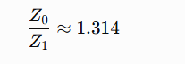
So, the zero-sequence impedance is greater than the positive-sequence impedance.
A higher zero-sequence impedance makes the ground-fault path more difficult for current to flow through. As a result, the LLG fault current becomes slightly smaller than the LLL current.
The theoretical calculation predicted approximately 48.492 kA for the LLG fault, while the numerical solver gave 48.5037 kA. The difference was only about −0.025%.
A useful rule from the analysis is:
For this plant, Z₀>Z₁, so the LLL fault is the most severe.
At the generator bus, the difference becomes much more dramatic because of the high-resistance neutral grounding. The calculated LLL current is about 126.21 kA, whereas the LG current is only 7.272 A. The LLG and LL currents become almost identical, around 109.25 kA, because the very large zero-sequence impedance makes the earth path practically unavailable.

Why the Voltage Is Zero During an LLL Fault
For a bolted three-phase fault, the fault impedance is zero:
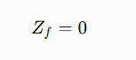
Therefore,
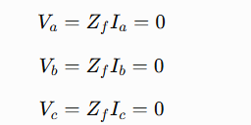

So, the voltage at the fault point is:
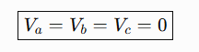
When these phase voltages are converted into symmetrical components:

Only the positive-sequence network supplies current, giving:
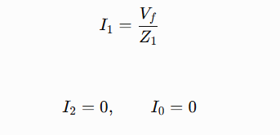
The phase currents therefore become:
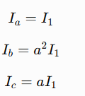

3.2 Design Method

3.2.1 Per-unit system
The entire system is represented using:
- S_{base} = 100 MVA
- V_{base} = 230 kV for the HV system
- V_{base} = 22 kV for the generator
- V_{base} = 6.6 kV for auxiliaries
The main reason is simple: per-unit values make it much easier to connect different voltage levels without repeatedly handling transformer ratios.
All of our calculations are done in the per-unit (p.u.) system. Per-unit means we divide every real quantity by a chosen base quantity, so that a 230 kV network and a 22 kV network can be joined in one single matrix without any turns-ratio bookkeeping.

Base quantity | Symbol | Value chosen | Why
Three-phase power | S_{base} | 100 MVA | Standard study base; keeps numbers near 1
Voltage, HV zone | V_{base} | 230 kV | Nominal voltage of the GIS and the lines
Voltage, generator zone | V_{base} | 22 kV | Actual generator terminal voltage
Voltage, auxiliary zone | V_{base} | 6.6 kV | Plant auxiliary bus

Per-Unit Base and Impedance Conversion
Everything in the system is first converted to a common 100 MVA base so that equipment with different voltage and MVA ratings can be compared consistently.
The base impedance is:
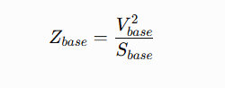
So:
- 230 kV: Z_{base}=529 Ω
- 22 kV: Z_{base}=4.84 Ω
- 6.6 kV: Z_{base}​=0.4356Ω
The base current is:
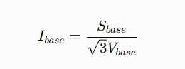

Converting Equipment Impedance
Manufacturers normally provide impedance on the equipment's own MVA and voltage base. To use it in this study, it must be converted to the 100 MVA base:
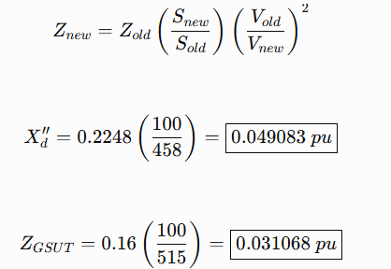
The transformer resistance is obtained from its actual load-loss data:
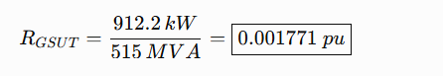
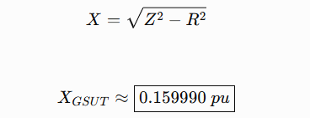

3.2.2 Load-flow formulation
The power-flow calculation determines the voltage magnitude and angle at every bus.
The basic equation is:
Sᵢ = Vᵢ × conjugate(Iᵢ)
and
Iᵢ = ΣYᵢₖVₖ
The bus equations are solved using the Newton–Raphson method through Simscape Electrical powergui.
There are three main bus types:
- B01: generator terminal — PV bus
- B02: 230 kV GIS — PQ bus
- B03: grid — slack bus
- B04–B10: remote buses — PQ
- B11: 6.6 kV auxiliary bus — PQ
Every power-flow case converged in two iterations. The study also checks power balance and KCL rather than simply trusting the solver status.

Very important: two different solvers
The power flow uses Newton–Raphson because the equations are nonlinear.
The fault calculation does not use Newton–Raphson.
Once the pre-fault voltage is frozen, the fault network is linear. Therefore:
[Y][V] = [J]
and
V = Y⁻¹J
or, in MATLAB form, V = Y\J.
So, the fault calculation is solved directly using the assembled sequence admittance matrix. This separation is intentional and important.
The pre-fault reproduction check gave a residual of 3.3%, below the 10% limit. For the 6.6 kV auxiliary bus, the residuals were 2.57% and 2.88% for the two auxiliary-transformer configurations.
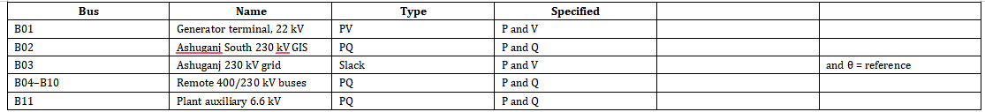

3.2.3 Symmetrical Components
For unbalanced faults, the three-phase system is converted into three simpler networks:
- Positive sequence: normal phase rotation and the only sequence containing sources.
- Negative sequence: reverse rotation, created by unbalanced faults.
- Zero sequence: three currents in phase and requires an earth-return path.
The transformation uses:
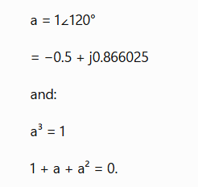
The phase currents can then be reconstructed using:
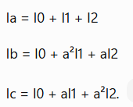

3.2.4 Sequence Networks
The positive, negative and zero-sequence networks were built separately.
The important sequence data are:
- Generator Xd″ = 0.2248 pu on machine base.
- Generator X2 = 0.2242 pu.
- Generator X0 = 0.128 pu.
- GSUT impedance = 16%.
- Unit auxiliary transformer impedance = 10.5%.
- 230 kV line: R = 0.0277725 Ω and X = 0.1425655 Ω.
- Grid Thévenin impedance: R = 0.268 Ω and X = 2.94 Ω.
- Grid zero-sequence ratio k0g = 1.5.
The transformer vector group is important. The YNd1 transformer introduces a 30° phase shift, which was represented using a complex tap. When the phase shift was removed, the pre-fault reproduction error became 31%; when included, the error dropped below 5%.
Element | Positive (Z1) | Negative (Z2) | Zero (Z0)
Generator | Norton source E' behind R_a + jX"_d; source impedance X"_d = 0.2248 pu (reactance base), X'_d = 0.2242 pu | R_a + jX_d, X2 = 0.2242 pu | X0 = 0.128 pu series with 3·Z_N to earth
GSUT 22/230 kV YNd1 | Z = 16.0 % on 515 MVA with ±30° complex tap | Same Z, conjugate (−30°) tap | Delta on LV blocks zero sequence; HV neutral not solidly earthed, so a zero-sequence leg to earth appears at the 230 kV bus only
Unit auxiliary transformer | Z = 10.5 % on 25 MVA nominal 6.9/6.6 tap | Z2 = Z1 (static equipment) | Z0 ≈ 9.3 % plus bounded neutral leg
230 kV line, 0.7 km, 2 circuits | R = 0.0277725 Ω, X = 0.1425655 Ω (lumped) | Z2 = Z1 (short line) | Zero-sequence band LOW / MID / HIGH, MID adopted as base
External 230 kV grid | Thevenin R = 0.268 Ω, X = 2.94 Ω from 45.01 kA / X/R = 10.99 | Z2 = Z1 within the same dataset | Z0 = k0·Z1, with k0 = 1.5 as base

Two modelling points deserve emphasis because they are the usual source of mistakes:
(a) The transformer vector group matters. The GSUT is YNd1, so the HV side leads the LV side by 30°. We stamped this as a genuine complex tap a = e^(jπ/6) in the positive-sequence matrix and its conjugate in the negative sequence. The effect is not cosmetic: with the phase shift omitted, the pre-fault reproduction gate fails at 31%; with it included, the residual falls below 5%. The gate therefore independently proves that the phase-shift sign is right.

(b) The generator is high-resistance earthed, not solidly earthed. A neutral earthing resistor (NER, equipment tag 10BAB11) sits between the generator star point and earth. In the zero-sequence network a neutral impedance always appears multiplied by three:
On the 22 kV base of 4.84 Ω this is 3·Z_N = 5252.32 / 4.84 = 1085.19 pu, compared with a positive-sequence Thevenin impedance at the same bus of only about 0.0211 pu. The zero-sequence path is therefore about fifty thousand times larger than the positive-sequence path. That single fact explains the most striking number in the whole report, and it is derived, not guessed:

The computer solution gives 7.272 A, i.e. 1.002 times the hand estimate. The small difference is the network impedance that the hand calculation ignores. A single-phase-to-earth fault on the generator therefore draws only about 7.3 amperes, not kilo-amperes. This is exactly the intended behavior of high-resistance earthing: it limits earth-fault current so that stator iron is not burnt, at the cost of needing a sensitive earth-fault relay rather than an overcurrent relay to detect it.

Generator earth-fault calculation
This is one of the most important calculations in the whole study.
The generator is grounded through high resistance.
The effective neutral resistance is:
ZN = 1750.773 Ω
For zero-sequence current, the neutral impedance appears three times:
3ZN ≈ 5252.32 Ω
On the 22 kV base:
3ZN / Zbase
= 5252.32 / 4.84
= 1085.19 pu
This is extremely large compared with the positive-sequence impedance.
The phase voltage is:
Vphase = 22000/√3
= 12,701.71 V
For the simplified earth-fault calculation:
I0 = I1 = I2
= 12,701.71 / 5252.32
= 2.41830 A
The actual faulted phase current is:
Ifault = 3I0
= 3 × 2.41830
= 7.25491 A
The simulation result is 7.272 A.
So, the hand calculation and simulation are very close. The report gives the fault as about 0.06% of the generator rated current of 12.02 kA.
The important engineering meaning is that a normal phase CT designed to measure kiloampere-level generator current cannot reliably detect a 7.272 A earth fault. Therefore, a dedicated neutral CT and earth-fault protection are required.

3.2.5 Four Fault Types

Three-phase fault, LLL
Only positive sequence is involved:
I1 = Vf/(Z1 + Zf)
For a bolted fault, Zf = 0:
I1 = Vf/Z1
and:
I2 = 0
I0 = 0.
Therefore:
Ia = I1
Ib = a²I1
Ic = aI1.
The three currents have equal magnitude and are 120° apart.

Single-line-to-ground fault, LG
All three sequence networks are connected in series:
I0 = I1 = I2
= Vf/(Z1 + Z2 + Z0 + 3Zf)
For a bolted fault:
Ifault = 3I1.

Line-to-line fault, LL
Only positive and negative sequences participate:
I1 = Vf/(Z1 + Z2 + Zf)
I2 = −I1
I0 = 0
and:
|Ib| = |Ic| = √3|I1|.

Double-line-to-ground fault, LLG
Positive sequence interacts with the parallel combination of negative and zero sequence networks. The resulting equations are used to calculate I1, I2 and I0.
The important point is that the report does not rely only on these simplified equations. The actual solver builds the sequence Y-bus matrices and solves the complete coupled system. The closed-form equations are then used independently as a check. The maximum disagreement was only about 3 × 10⁻¹⁴, which is essentially numerical round-off.

3.2.6 Why Is the LLL Fault Current Higher Than the LLG Fault Current?
The original slide showed the fault currents in the wrong rows. The actual calculations show that LLL is the highest fault current.
At F3 (230 kV GIS bus):
LLL = 50.53 > LLG = 48.50 > LG = 45.74 > LL = 43.76 kA

At F1 (22 kV generator bus):

LLL = 126.21 > LLG ≈ LL ≈ 109.25 >> LG = 0.00727 kA

Step 1: Find the LLG-to-LLL relationship
For this network,
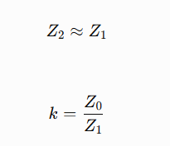
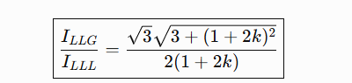

Step 2: Calculate k from the actual results
At F3, the LLG sequence currents are:
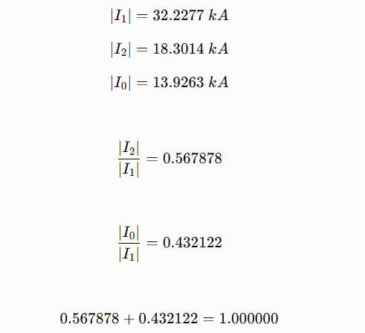
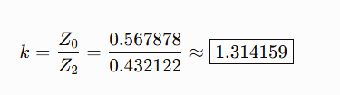

Step 3: Verify Z2≈Z1
Using the LLL and LLG results:
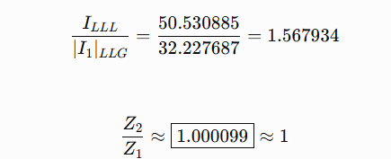
So, the assumption Z2=Z1 is strongly supported by the project's own calculated results.
k = Z0/Z1 | LLG ÷ LLL | LG ÷ LLL | Which fault is worst?
0.00 | 1.73205 | 1.50000 | LLG (73 % above LLL)
0.25 | 1.32288 | 1.33333 | LG
0.50 | 1.14564 | 1.20000 | LG
0.75 | 1.05357 | 1.09091 | LG
1.00 | 1.00000 | 1.00000 | all three equal — the crossover
1.31416 (our F3) | 0.95964 | 0.90521 | LLL
1.50 | 0.94373 | 0.85714 | LLL
2.00 | 0.91652 | 0.75000 | LLL
5.00 | 0.87670 | 0.42857 | LLL
→ ∞ (our F1) | → 0.86603 = √3/2 | → 0 | LLL

3.2.7 Why is the voltage zero during an LLL fault?
This can be understood by the following calculation.
For a bolted fault:
Zf = 0.
Therefore:
Va = ZfIa = 0
Vb = ZfIb = 0
Vc = ZfIc = 0.
So, the fault-point voltage is zero by the boundary condition itself.
Then the sequence voltages are also:
V0 = 0
V1 = 0
V2 = 0.
The positive-sequence network is:
V1 = Vf − I1Z1.
Since V1 = 0:
0 = Vf − I1Z1
Therefore:
I1 = Vf/Z1.
So, the familiar fault-current equation:
I = V/Z
already assumes that the fault-point voltage has been forced to zero.
At F3:
I1 = 50.530885 / 0.251021856
= 201.3007 pu.
The calculated Z1 is about:
Z1 ≈ 0.005415 pu.
A hand calculation gives:
Grid side:
0.000270 + 0.005558
= 0.005828 pu.
Plant side:
0.031068 + 0.049083
= 0.080151 pu.
Parallel combination:
Z1 = (0.005828 × 0.080151)/(0.005828 + 0.080151)
= 0.005434 pu.
So:
Hand calculation = 0.005434 pu
Solver = 0.005415 pu
Difference ≈ 0.35%.
That is a very good independent check.

At F1:
I1 = 126.214141 / 2.624319405
= 48.0940 pu.
The hand-calculated Thevenin impedance is:
Generator = 0.049083 pu
External path:
0.031068 + 0.000270 + 0.005558
= 0.036896 pu.
Parallel:
Zth = (0.049083 × 0.036896)/(0.049083 + 0.036896)
= 0.021065 pu.
Then:
I ≈ 1.013/0.021065
≈ 48.09 pu.
Again, it matches the solver.
The project also independently verified that every LLL result has:
I0 = 0
I2 = 0
I1 = Irms.
So, the simulation itself confirms the theoretical explanation.

3.2.8 Peak Current and Current Duration Stages
- The RMS symmetrical current Ik does not represent the maximum mechanical stress on a breaker. The first peak current is higher because of the DC offset.
- Peak current is calculated using:
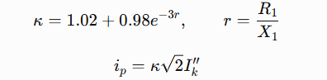
Location | r = R/X | κ | Ik″ LLL (kA) | i_p LLL (kA peak)
F1 / F2, 22 kV generator | 0.0171 | 1.9511 | 126.21 | 348.26
F3, 230 kV GIS | 0.0694 | 1.8159 | 50.53 | 129.76
F4, line at m = 0.5 | 0.0683 | 1.8185 | 51.06 | 131.33
F5, remote 230 kV bus | 0.0635 | 1.8301 | 53.09 | 137.42

Three Current Stages
- Ik — Subtransient current, t=0
  - Highest initial fault current.
  - Used for breaker making duty and instantaneous protection.
- Ib — Breaking current, t=0.06 s
  - Current after the initial subtransient period.
  - Uses Xd′=0.3256X_d'=0.3256.
  - Used for breaker breaking duty.
- Isteady— Sustained current
  - Final steady-state fault current.
  - Uses Xd=1.783X_d=1.783.
  - Used for thermal withstand and backup protection.
For the F3 LG fault:
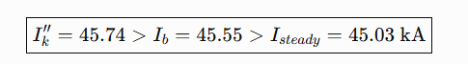

3.2.9 Protection Mathematics

1. Inverse-Time Overcurrent Protection
- The relay operating time depends on the fault current:
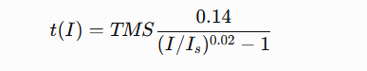
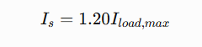
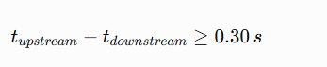

Biased Differential Protection
- Differential protection checks the difference between the current entering and leaving the protected equipment.
- Operating current:

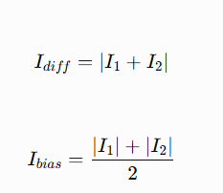
- The relay has a rising characteristic, meaning the required differential current increases as the bias current increases.
- This helps prevent unwanted operation caused by CT errors, transformer tap changes, and magnetizing current, especially during high through-current.
- Adopted settings:
  - Transformer: 0.30 pu pickup, with 30% and 60% slopes
  - Generator: 0.20 pu pickup

3. Breaker Duty Check
Each breaker is checked against its nameplate rating for three quantities:
- RMS making current → compared with Ik
- Peak making current → compared with ip
- Breaking current → compared with Ib at contact-parting time
The available margin is calculated as:
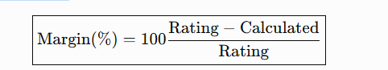

3.3 Circuit Diagram
Section 3.2 gave the equations. This section gives the circuit those equations were written for. It starts with the real plant drawing, then reduces that drawing to the numbered nodes the computer actually solves, then lists the five places where we applied a fault and ends with the protection zones that sit on top of the same circuit.

3.3.1 The real plant single-line diagram
A single-line diagram (SLD) is the standard way to draw a three-phase power system. Instead of drawing three conductors, one line is drawn and every piece of equipment is shown with a standard symbol. Our study is built on the actual as-built drawing of the plant, not on a textbook sketch.
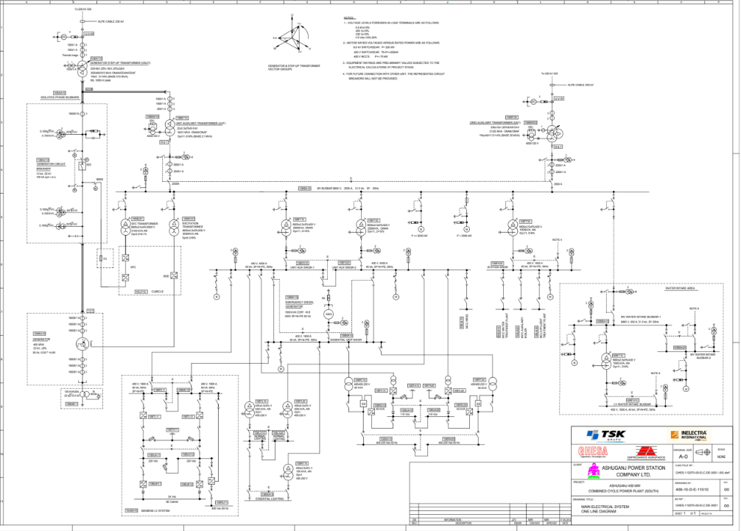
Figure 2 — The master single-line diagram of Ashuganj South 450 MW CCPP: Siemens / TSK / INELECTRA drawing S008-112070-00-ELC-DE-1011, Rev 04 / 04_1, "As-Built Factory". This is the official OEM drawing from which the whole study topology was taken.
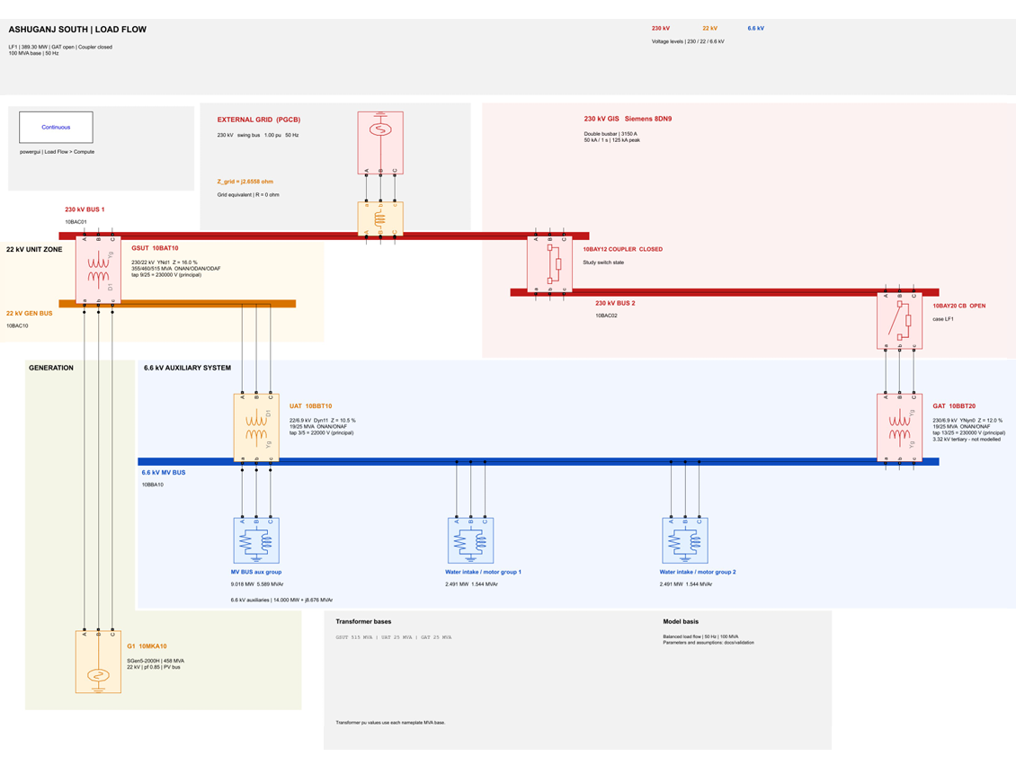
Figure 3 — Redrawn high-resolution single-line diagram of the same plant (project revision 2). Use this version when the OEM scan is too dense to read a tag or a bay number.
Three official drawings are cited for the topology, and one of them is missing:
Drawing | Number | Status
Master SLD | S008-112070-00-ELC-DE-1011, Rev 04 / 04_1, "As-Built Factory" (Siemens / TSK / INELECTRA) | Present — the primary topology source
Companion SLD | INEL-112070-00-ELC-DE-0001-REV3.pdf | Present
Detailed GIS drawing | INEL-112070-00-ELC-DE-0026 | OMITTED from the supplied ZIP

3.3.2 The Power Train –
The electrical power path can be understood from generation → voltage transformation → switchyard → grid, while the auxiliary system supplies power to the plant itself.

1. Prime Movers
- The plant uses two SGT5-4000F gas turbines and one SST-3000 steam turbine.
- Together, they drive the generator shaft.
- In a combined-cycle plant, the gas-turbine exhaust heat is used to produce steam, which drives the steam turbine and generates additional power without extra fuel.

2. Generator
- The shaft drives a Siemens SGen5-2000H synchronous generator.
- Rating: 458 MVA, 22 kV, 50 Hz
- Rated current: 12.02 kA
- The generator neutral is grounded through a high-resistance Neutral Earthing Resistor (NER), 10BAB11.
- This greatly limits generator earth-fault current to about 7.3 A.

3. Generator Circuit Breaker (GCB)
- The generator output first passes through GCB 10BAC10.
- Ratings:
  - Continuous current: 12,400 A
  - RMS breaking current: 100 kA
  - Peak making current: 274 kA

4. Generator Step-Up Transformer (GSUT)
- After the GCB, power enters GSUT 10BAT10.
- Rating: 515 MVA, 22/230 kV
- Vector group: YNd1
- Impedance: 16%
The YNd1 connection is important because:
- It introduces a 30° phase shift between the two sides.
- The delta winding blocks zero-sequence current from passing between the 22 kV and 230 kV systems.

5. 230 kV Switchyard
- The transformer output goes to a Siemens 8DN9 GIS, rated for the 245 kV class.
- Short-time withstand: 50 kA
- It uses a double-busbar system (BB1 and BB2) connected through a bus coupler.
- The drawing includes Q0, Q1, Q2, Q9, Q51, Q52 and Q8.
- In the study:
  - Q0 → circuit breaker
  - Q1, Q2, Q9 → disconnectors
  - Q51, Q52, Q8 → labels without sourced ratings

6. Export to the Grid
- From the GIS, two 230 kV circuits carry power to the PGCB Ashuganj substation.
- The connection is approximately 0.7 km long.

7. Auxiliary Power System
The plant also needs electricity for its own pumps, fans, mills and other equipment.
Two auxiliary transformers supply the common 6.6 kV auxiliary bus:
UAT – Unit Auxiliary Transformer (10BBT10)
- Rating: 25 MVA
- Voltage: 22/6.9 kV
- Vector group: Dyn11
- Impedance: 10.5%
- Normally supplies the auxiliaries when the generator is running.
GAT – Generator Auxiliary Transformer (10BBT20)
- Voltage: 230/6.9 kV
- Vector group: YNyn0 + d11
- Impedance: 12%
- Provides start-up and backup supply from the grid.
The studied auxiliary load is:
14.0 MW at 0.85 pf lagging

Important Voltage Difference
There is a small but important difference between the transformer and bus voltage:
6.9 kV transformer LV ≠ 6.6 kV auxiliary bus
· Transformer LV nameplate: 6.9 kV
· Plant auxiliary bus: 6.6 kV
· Difference: 4.55%
· This is recorded as conflict C13 in the project register.

3.3.3 From Drawing to Solver: Bus and Node Table
The electrical drawing has many labelled points, but the load-flow solver needs them as defined electrical buses/nodes.
Bus | What it is | Load-flow type | What is specified at it
B01 (B22) | Generator terminal, 22 kV | PV | P and V
B02 (B230_1, B230_2) | Ashuganj South 230 kV GIS busbars BB1 / BB2 | PQ | P and Q
B03 (BGRID230) | Ashuganj 230 kV grid boundary | Slack | V and θ = reference
B04–B10 | Remote 400/230 kV buses of the wider network | PQ | P and Q
B11 (B6_6) | Plant auxiliary 6.6 kV bus | PQ | P and Q

What the Bus Types Mean
Slack bus: Voltage magnitude and angle are fixed. It supplies/absorbs the remaining power needed to balance the system.
- V=1.000 pu,θ=0∘V=1.000\ pu,\qquad \theta=0^\circ
- PV bus: Real power PP and voltage magnitude VV are specified. The solver calculates reactive power QQ and voltage angle.
- PQ bus: Real power PP and reactive power QQ are specified. The solver calculates the voltage magnitude and angle.

Additional Solver Nodes
Two additional node names appear in the results:
- GAT_HV → 230 kV terminal of the Generator Auxiliary Transformer.
- B230_REMOTE → far end of the 0.7 km, 230 kV line.

3.3.4 Zero-Impedance Node Merging — Why 8/9 Buses Become 5/6
- In the actual electrical system, points connected by zero impedance are electrically the same node, even if they have different labels in the drawing.
- Therefore, busbar sections, closed disconnectors, and short isolated-phase bus ducts are merged into one solver node.
- Keeping zero-impedance nodes separate would create zero rows/columns in the admittance matrix and could make the matrix singular.
Two topologies are used:
- Generation 1 & 2: 8 drawing buses → 5 electrical nodes
  - The grid equivalent ZGRID connects directly to B230_1.
  - There is no separate transmission-line node.
- Generation 3 (primary result): 9 drawing buses → 6 electrical nodes
  - The 0.7 km line introduces a real impedance:
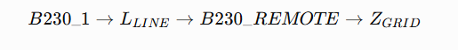
- Therefore, the plant end and remote end of the line must be treated as different electrical nodes.
Result generation | Buses on the drawing | Electrical nodes after merging | Topology
Generation 1 and Generation 2 | 8 | 5 | The grid equivalent ZGRID connects straight on to B230_1; there is no line
Generation 3 (the primary result) | 9 | 6 | B230_1 → [L_LINE, 0.7 km] → B230_REMOTE → [ZGRID] → BGRID230

Validation: With the bus coupler closed, B230_1 and B230_2 have the same voltage:
This confirms that they are correctly treated as one electrical node.

3.3.5 The 0.7 km Dual-Circuit 230 kV Line
The export connection consists of two parallel 230 kV circuits using Mallard 795 MCM ACSR conductors.
Quantity | Per-unit per km | In physical units per km
Series resistance r₁ | 0.00015 pu/km | 0.07935 Ω/km
Series reactance x₁ | 0.00077 pu/km | 0.40733 Ω/km
Shunt susceptance y₁ | 0.001488 pu/km | 2.81285 µS/km

For the 0.7 km dual circuit, the two series paths are in parallel, while their shunt capacitances add:
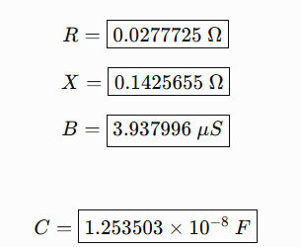
These values form the lumped nominal-π model of the export line.

Important Results

Series voltage drop is only:
- 29.203 V=0.012710%\boxed{29.203\ V=0.012710\%}

Line loss:
- 0.062928 MW\boxed{0.062928\ MW}
- The line's thermal rating is missing from the source documents, so its loading percentage was kept as NaN instead of assuming an ampacity.

Important Correction to the Model
The study uses the measured 0.7 km length instead of two older assumptions:
- 70 km line
- 44 km line
The 44 km value belongs to the Ghorasal–Ashuganj 230 kV line, while the 70 km value was another outdated assumption.
Using the actual 0.7 km length changes the line behavior significantly: because of the relatively important shunt charging effect, the plant-end voltage actually rises by about 24.017 V rather than simply dropping along the line.

3.3.6 The Five Fault Locations
The fault study considers five specific fault locations across the generating unit, switchyard, transmission line, and grid interface.
Fault | Where it is | Tag to look for on the SLD | Voltage | Note
F1 | Generator terminals | Generator 10MKA10, GCB 10BAC10, NER 10BAB11 | 22 kV | The highest fault current in the study, 126.21 kA for a three-phase fault
F2 | GSUT LV terminals | GSUT 10BAT10 LV delta bushings, UAT 10BBT10 tee-off | 22 kV | Electrically the same node as F1. All F2 results are identical to F1
F3 | 230 kV GIS busbar | GIS busbars, GSUT bay 10BAY11 | 230 kV | The switchyard case, 50.53 kA three-phase
F4 | Line at fraction m = 0.5 (the midpoint) | Outgoing line bays | 230 kV | A sliding fault position along circuit 1
F5 | Remote grid boundary | PGCB interface node B230_REMOTE | 230 kV | The highest 230 kV current, 53.09 kA, because it sits closest to the grid source

Why F1 and F2 Are the Same
- F1 is at the generator terminals.
- F2 is at the GSUT low-voltage terminals.
- Between them are only the isolated-phase bus duct and closed GCB.
- These are treated as zero impedance in the model.
- Therefore, according to the node-merging rule, F1 and F2 are actually one electrical node.
So:
F2=F1 electrically
The identical F1/F2 results are therefore not duplicated calculations; they represent the same electrical location.

F4 Sliding-Fault Check
F4 can move along the 0.7 km line using the position parameter mm:
- m=0→ fault at the F3/plant end
- m=0.5 → midpoint
- m=1 → fault at the F5/remote end
The model was checked at both endpoints:
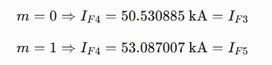
This confirms that the sliding fault is correctly connected between the plant-side and remote-side endpoints.

3.3.7 The protection zones drawn on the same circuit
Protection engineers divide a plant into zones. A zone is a region of the circuit bounded by current transformers, with one protection scheme responsible for everything inside it. Zones are deliberately made to overlap at their boundaries, so that no point of the plant is left unprotected by the gap between two schemes.
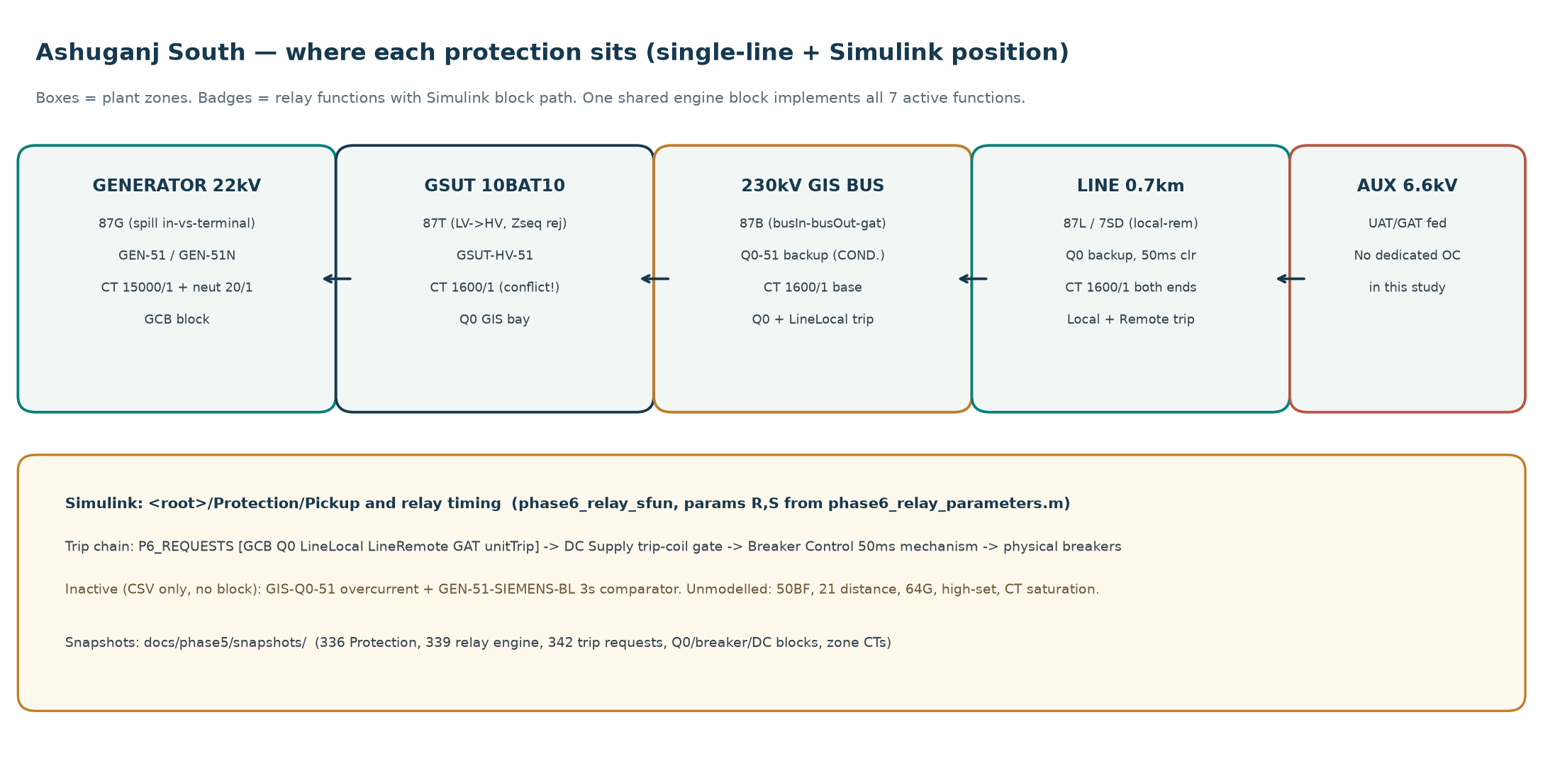
Figure 4 — The protection zone map for Ashuganj South: zones G (generator), T (transformer), B (230 kV busbar) and L (line), with their overlapping boundaries shown at the current-transformer locations.

3.4 Simulation Model —
- This is a dynamic closed-loop Simulink model, unlike the previous static fault study.
- The complete sequence is:
Fault → Measurement → Relay → Trip → Breaker → Fault Clearing
- Software: MATLAB R2024a + Simulink/Simscape Electrical
- Model size: 453 entities
- Electrical time step: 50 µs
- Control/protection time step: 1 ms
- Frequency: 50 Hz
- Fault blocks: 7
- Breakers: 5
- Measurement points: 19
- Level-2 M-S-functions: 5

Five M-S-Functions
- Measurement: extracts voltage/current using DFT and RMS.
- Relay: runs the 7 protection elements.
- DC: models the battery, charger and state of charge.
- Breaker: models trip coil and 50 ms breaker operation.
- Control: models the governor/turbine and AVR
S-function | What it does
phase6_measurement_sfun | Synchronized fixed 50 Hz discrete Fourier transform (DFT) over a 20 ms window, plus a waveform RMS path
phase6_relay_sfun | The seven protection elements
phase6_dc_sfun | Battery Thevenin model, bounded charger, state of charge, alarms
phase6_breaker_sfun | Trip-coil availability, 50 ms mechanism time, open latch
phase6_control_sfun | Discrete governor / turbine model plus the automatic voltage regulator

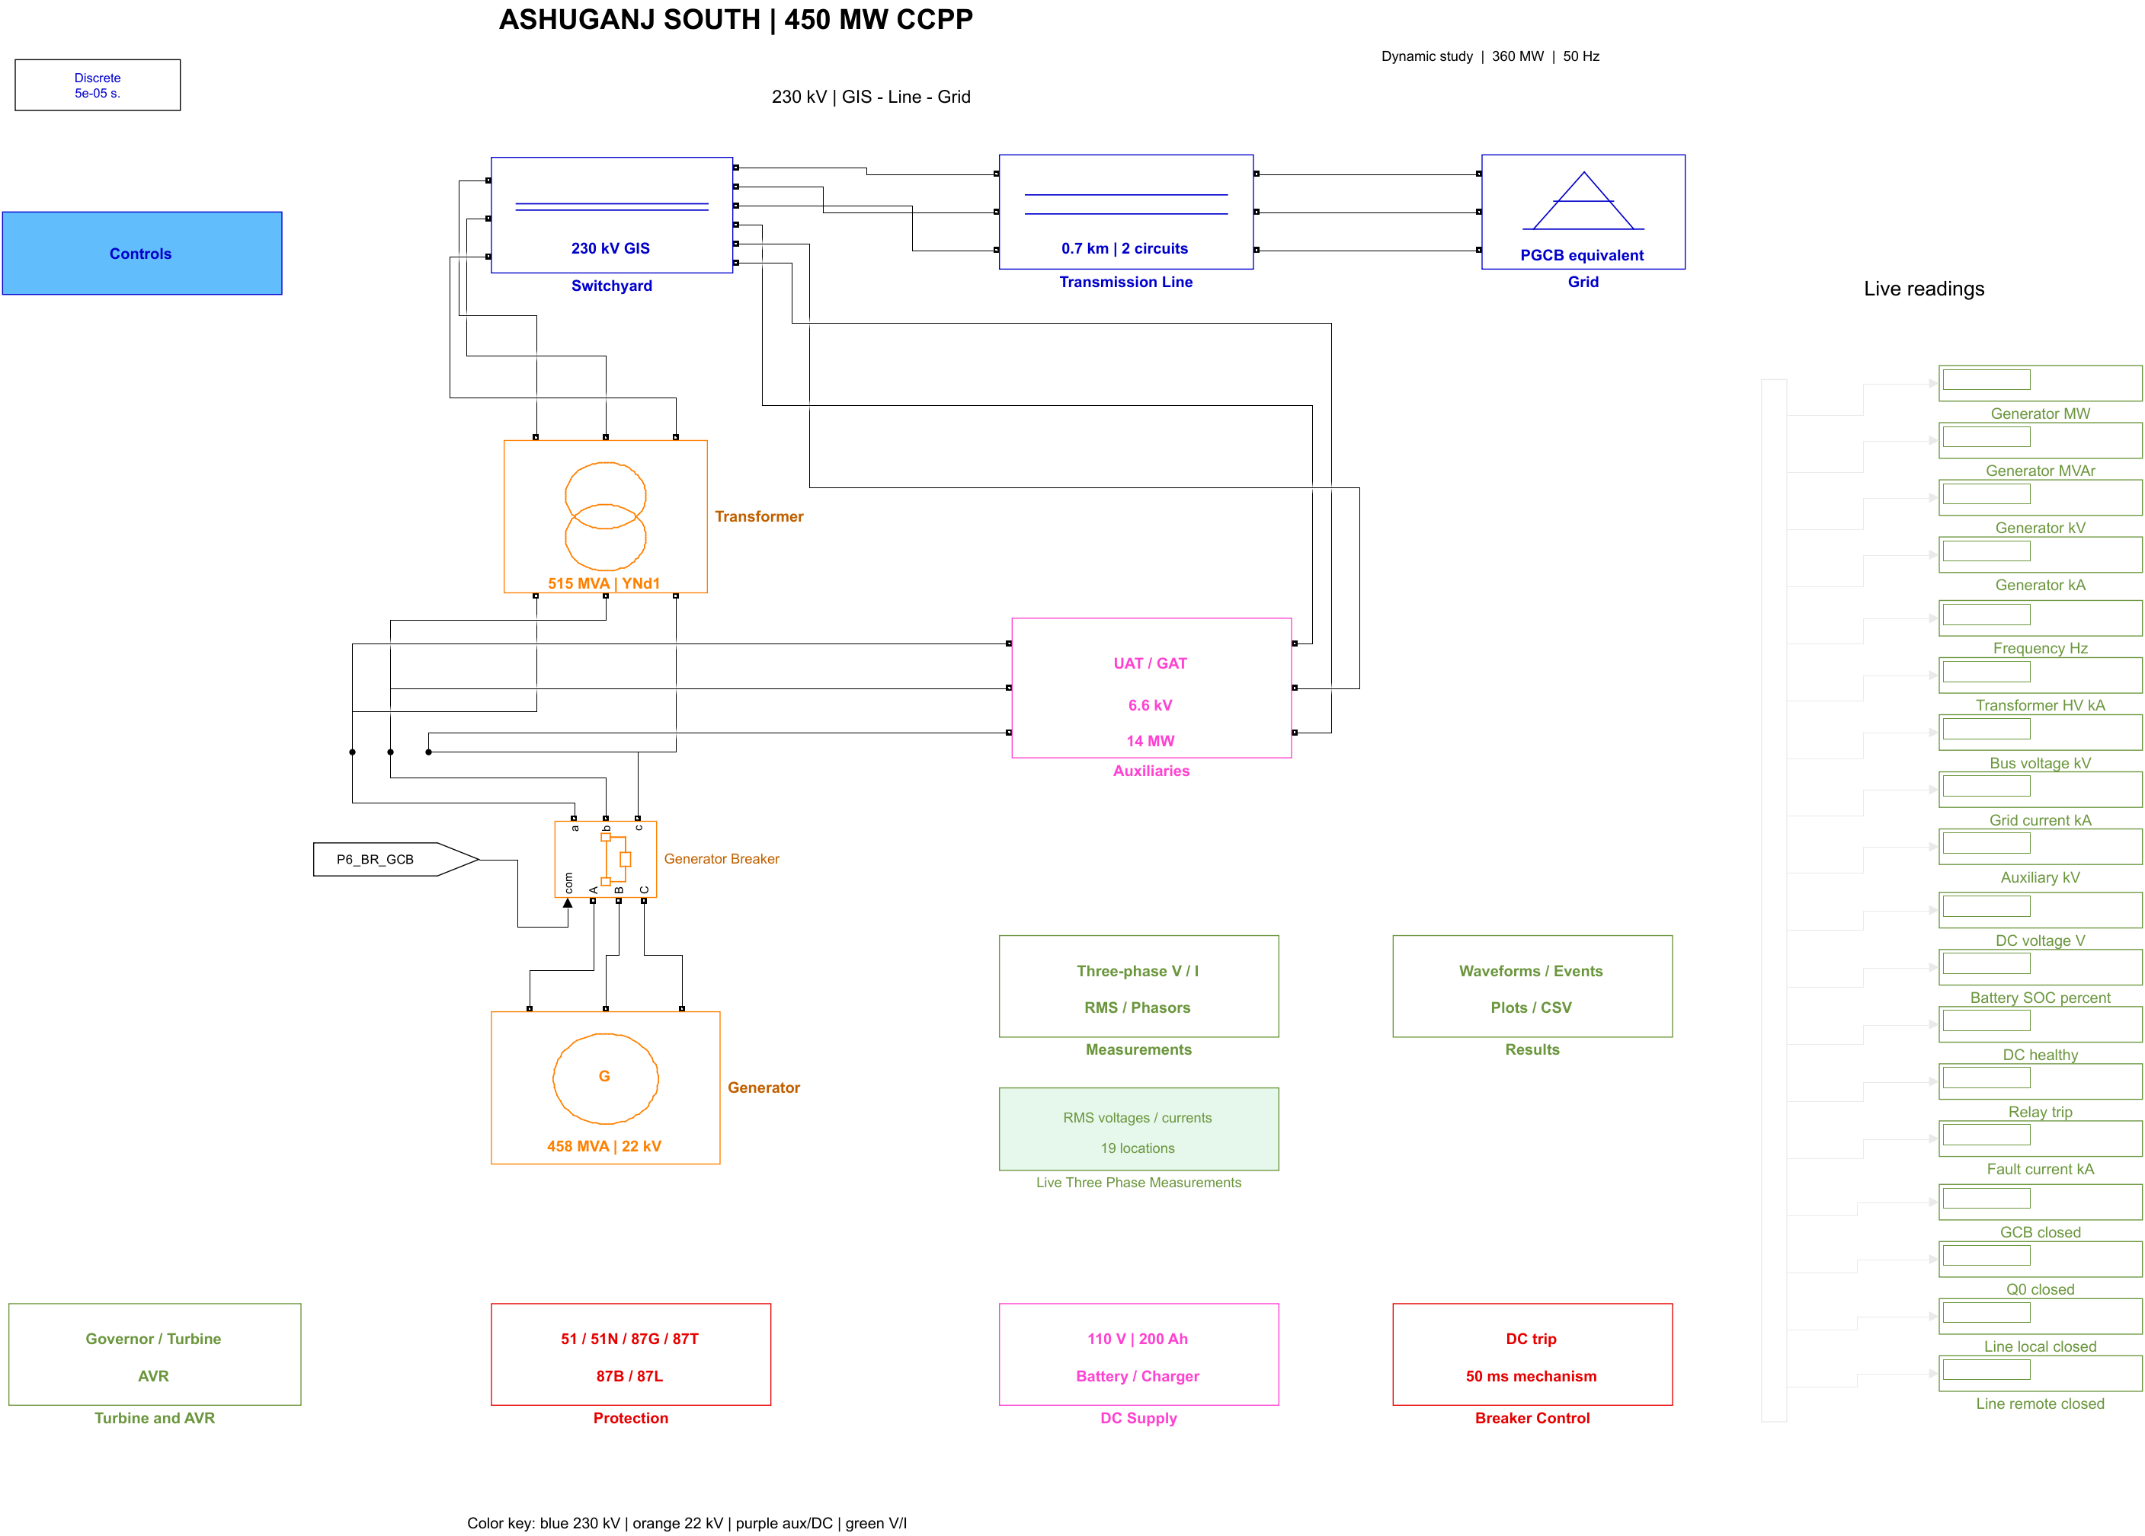
Figure 5 — Verification banner inside the model: the launcher asserts that the open model is this project's copy before it will build or simulate.

3.4.2 Three Solvers Used in the Project
The project uses three different numerical methods, each for a different purpose:
Study | Solver | Iteration? | Main reason
Load Flow | Newton–Raphson | Yes — 2 iterations | Load-flow equations are nonlinear
Fault Study | Direct LU factorization / MATLAB backslash | No | Fault network is linear
Dynamic Model | Time-domain solver + robust trapezoidal method | Time steps forward | System states change with time

In Simple Terms
- Load flow: repeatedly solves until the voltage/power solution converges.
- Fault study: directly solves the linear network once.
- Dynamic model: moves forward in small 50 µs time steps to simulate the machine, governor and protection states.

3.4.3 The Thirteen Main Subsystems
The dynamic model is divided into 13 main subsystems.

(0) Top Level – Closed Loop
This is the main overview of the entire simulation.
- Upper path: represents the actual electrical power system:
Generator → Transformer → Switchyard → Line → Grid
- Lower path: represents the protection and control system:
Measurement → Protection → Breaker Control → DC Supply → Breaker
- The breaker-control output feeds back to the physical electrical system, creating the closed loop.
- The top level also contains:
  - powergui for configuring the simulation
  - Generator circuit breaker
  - B01 and B02 busbars
  - GCB command path
  - 18 Display blocks for showing live simulation values
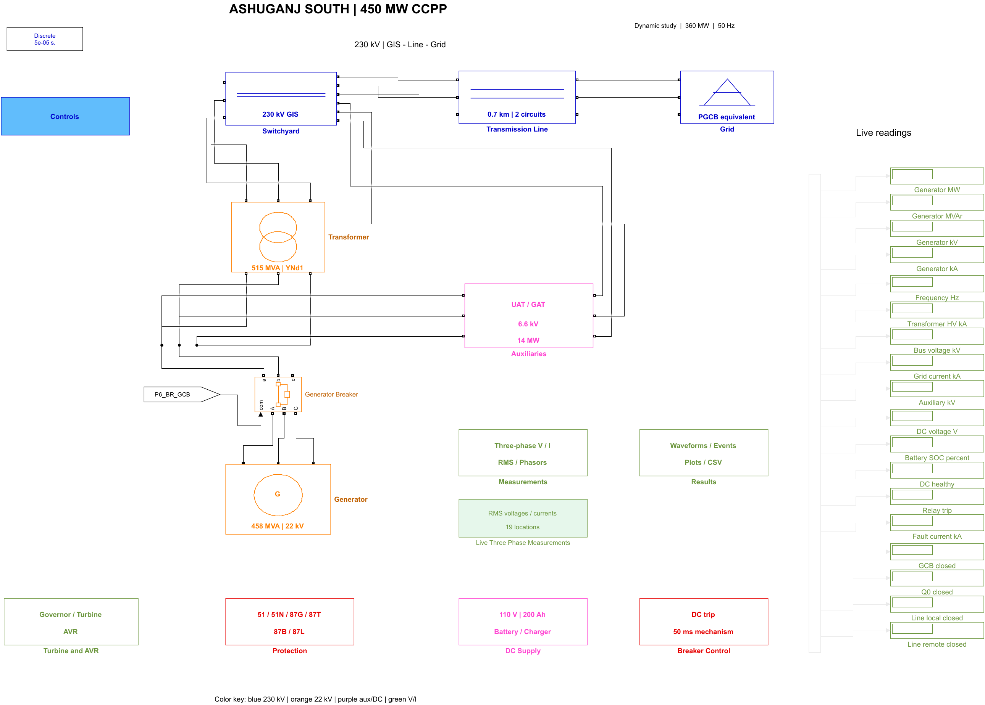
Figure 6 — The top level of the closed-loop trip model. The electrical plant runs left to right; the measurement, protection, breaker-control and DC-supply subsystems form the feedback loop that returns to the breakers.

(1) Generator — 27 Blocks
- The subsystem contains 27 blocks.
- A Synchronous Machine pu Standard block represents the 458 MVA, 22 kV generator.
- It includes:
  - Neutral earthing branch
  - Generator fault block
  - Inner current measurement
  - Terminal current measurement
- The inner and terminal measurements provide the two sides needed for generator differential protection (87G).
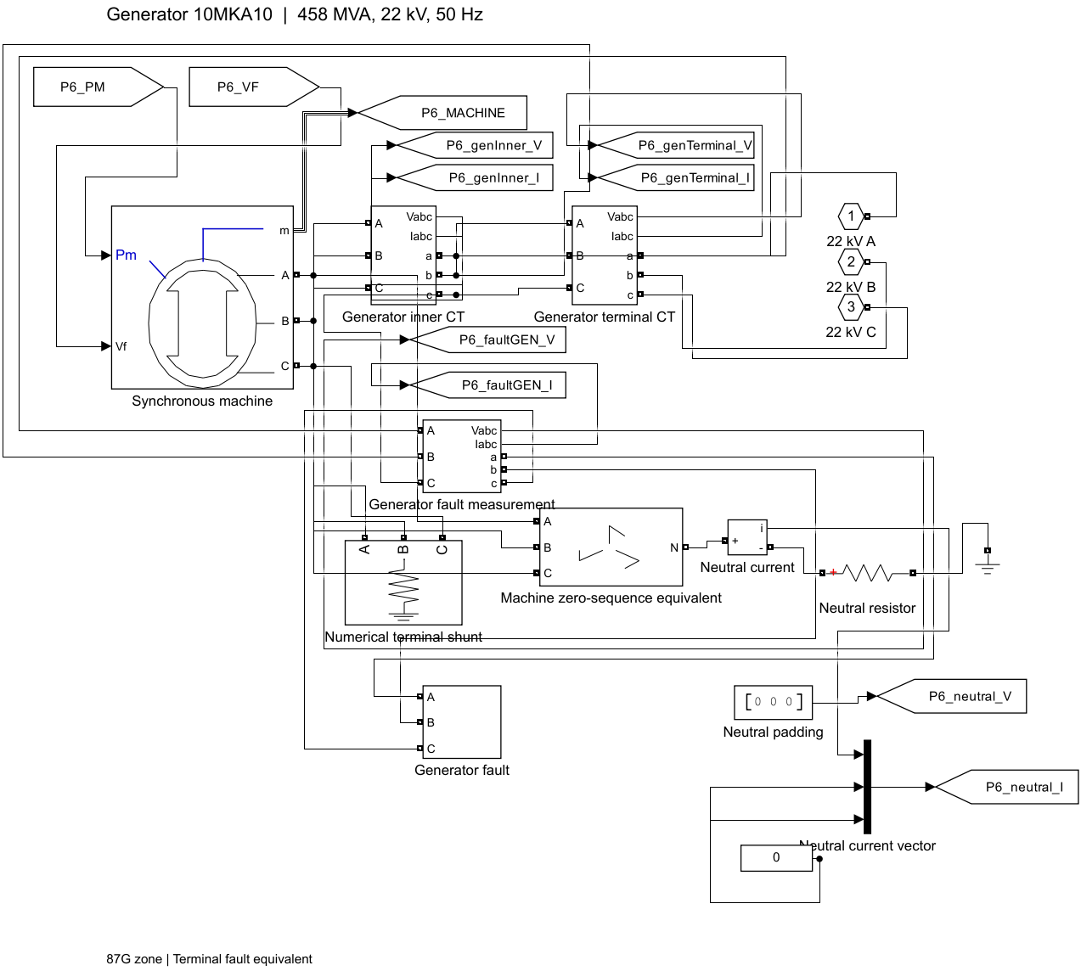
Figure 7 — The generator subsystem: a Synchronous Machine pu Standard block, its neutral earthing branch, the terminal fault block, and the inner and terminal current-transformer measurement points that bound protection zone G.

3.4.3 The Thirteen Main Subsystems —
The dynamic model is divided into 13 main subsystems, each handling a specific part of the power system or protection chain.
- Generator — 27 blocks
  - 458 MVA, 22 kV synchronous generator.
  - Includes NER, fault block and current measurements for 87G differential protection.
Figure 7 — The generator subsystem: a Synchronous Machine pu Standard block, its neutral earthing branch, the terminal fault block, and the inner and terminal current-transformer measurement points that bound protection zone G.

- Turbine & AVR — 14 blocks
  - Provides mechanical power and field voltage to the generator.
  - Uses a 5% governor droop and AVR.
  - Control parameters are engineering assumptions because actual Siemens settings were unavailable.
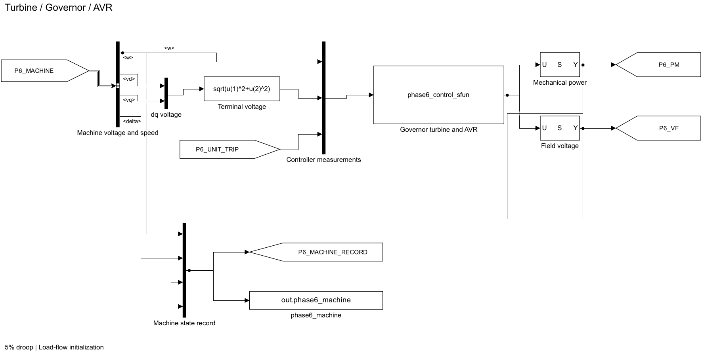
Figure 8 — The turbine and automatic voltage regulator subsystem, driving the machine's mechanical power and field voltage inputs from the discrete governor and AVR code.

- Transformer — 21 blocks
  - Models the 515 MVA, 22/230 kV YNd1 GSUT.
  - Measures LV/HV currents for 87T differential protection.
  - Includes LV and HV fault blocks.
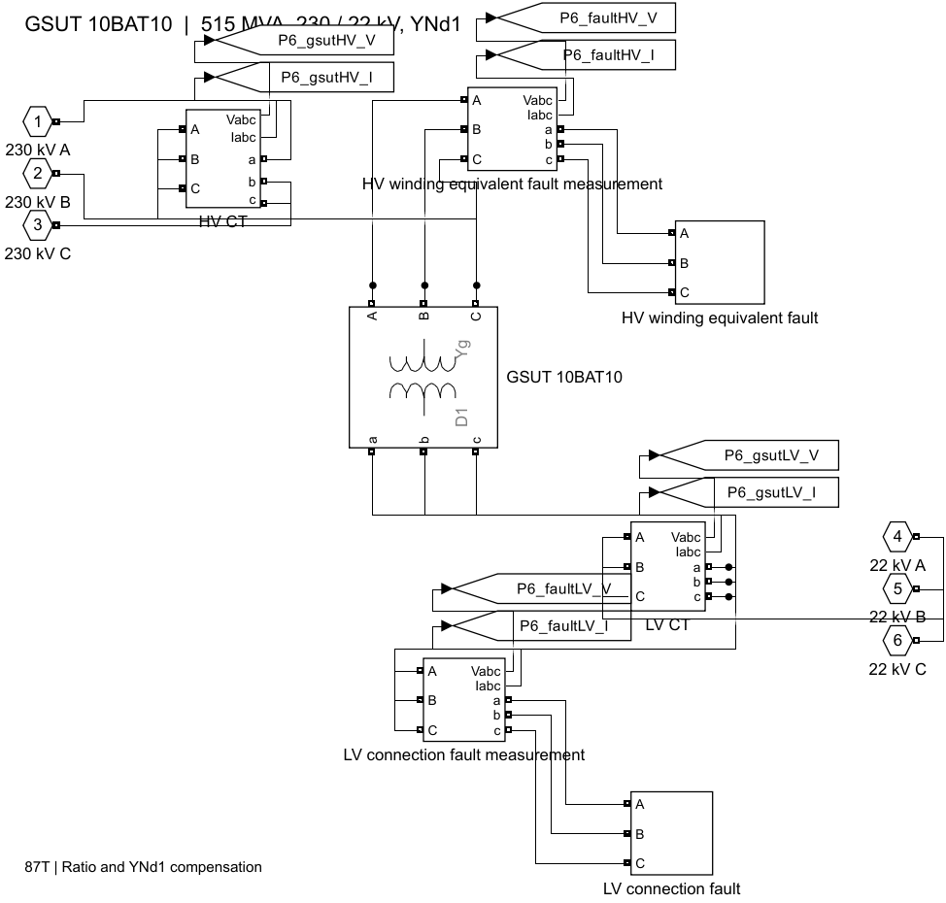
Figure 9 — The transformer subsystem: the 515 MVA YNd1 GSUT with its LV and HV current measurements, plus the fault blocks on both the 22 kV and 230 kV terminals.

- Switchyard — 25 blocks
  - Models the 230 kV GIS and Q0 breaker.
  - Current measurements provide inputs for 87B busbar differential protection.
  - Includes the main GIS fault block.
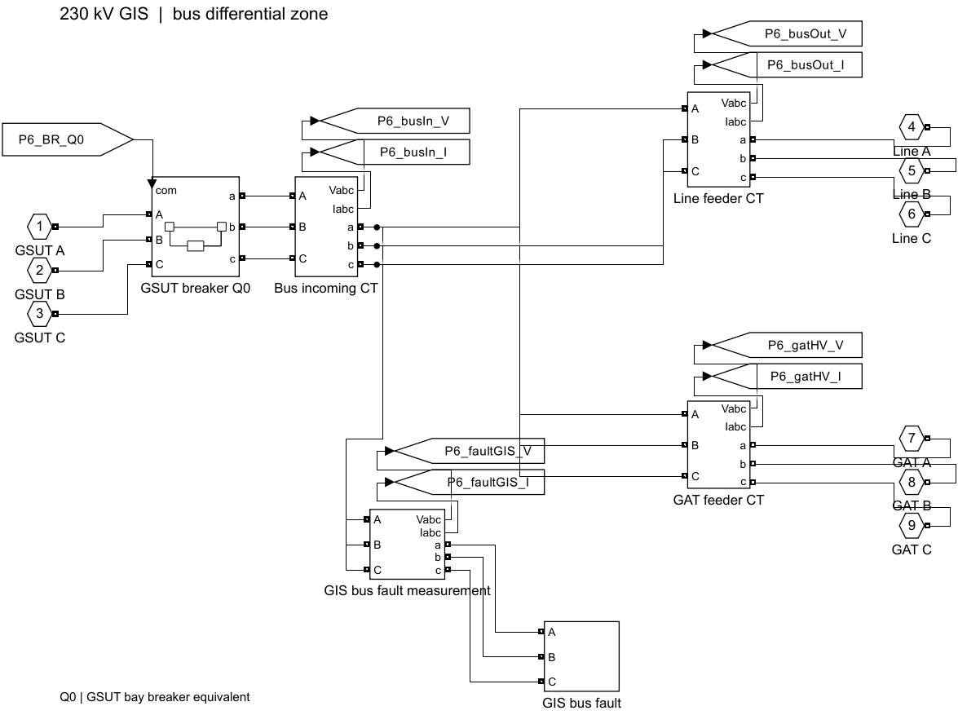
Figure 10 — The 230 kV switchyard subsystem: the GIS busbar, the Q0 breaker, the bus-in and bus-out current measurements that form the 87B differential, and the GIS230 fault block.
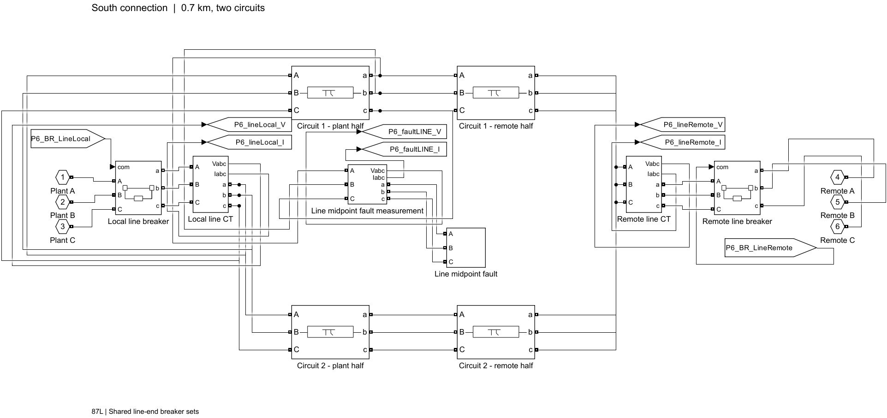
Figure 11 — The transmission-line subsystem: four Three-Phase PI Section Line blocks forming two circuits, each split into a plant half and a remote half so that a fault can be applied at the midpoint.

- Transmission Line — 24 blocks
  - Models the 0.7 km dual-circuit 230 kV line.
  - Each circuit is split into plant and remote halves.
  - This creates the midpoint needed for the F4 line fault and provides measurements for 87L line differential protection.
- Grid — 13 blocks
  - Represents the external grid using a Thevenin equivalent.
  - Separate positive- and zero-sequence impedances are included.
  - Includes the F5 grid-boundary fault.
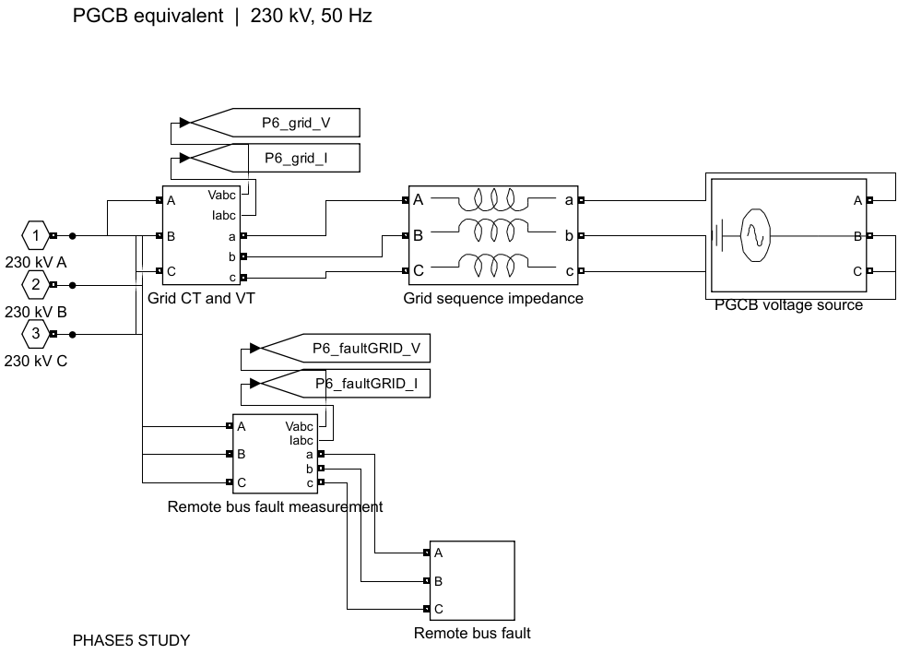
Figure 12 — The external grid subsystem: a Three-Phase Source behind a Three-Phase Mutual Inductance Z1-Z0 block, which gives the grid independent positive- and zero-sequence impedances.

- Auxiliaries — 25 blocks
  - Contains the UAT, GAT, 6.6 kV bus and 14 MW load.
  - Includes the GAT incomer breaker and auxiliary fault.
  - GAT can be switched in/out to represent different operating topologies.
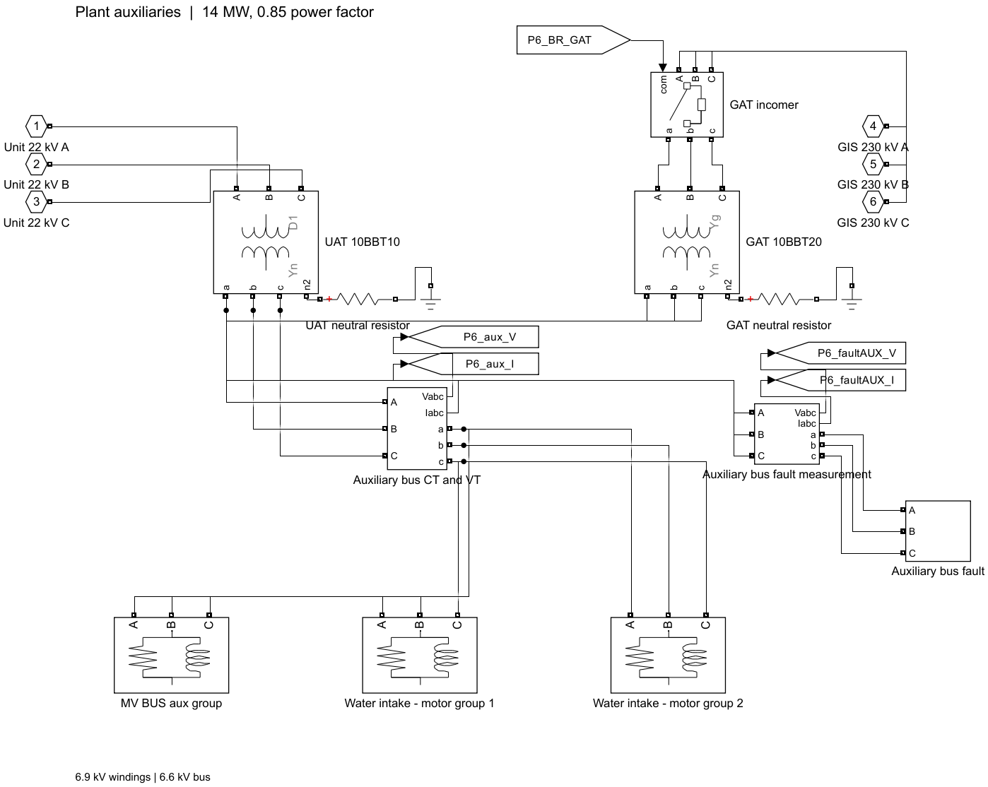
Figure 13 — The auxiliary subsystem: the UAT and GAT transformers, the 6.6 kV auxiliary bus with its static load, the GAT incomer breaker and the AUX66 fault block
- Measurements — 14 blocks + child subsystems
  - Contains 19 voltage/current measurement points.
  - Uses a 20 ms, 50 Hz synchronized DFT to obtain relay phasors.
  - Also provides waveform RMS measurements.
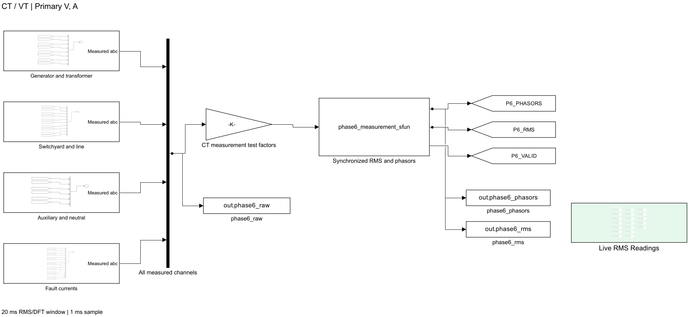
Figure 14 — The measurement subsystem: nineteen three-phase voltage-current measurement points feeding the synchronized DFT, plus the live RMS reading displays.

- Protection — 7 blocks
  - Contains all seven protection elements inside one relay S-function.
  - Produces pickup, timing, differential/restraint and trip signals.
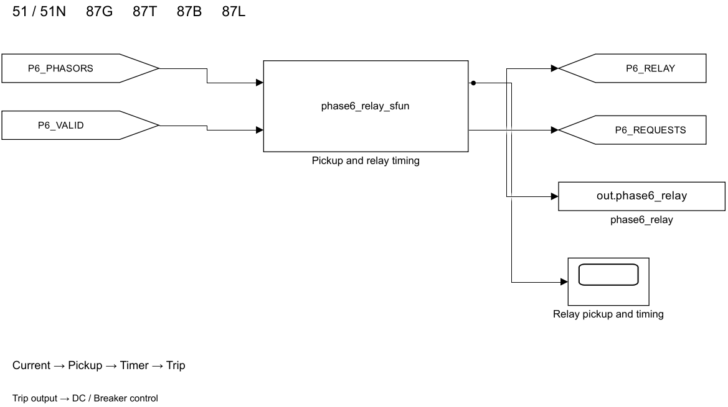
Figure 15 — The protection subsystem: the relay S-function block with its seven elements, taking measured phasors in and issuing pickup, timer and trip-request signals out.

- Breaker Control — 18 blocks
- Converts relay trip requests into breaker operation.
- Requires healthy DC supply.
- Uses 50 ms breaker operating time and latches breakers open.
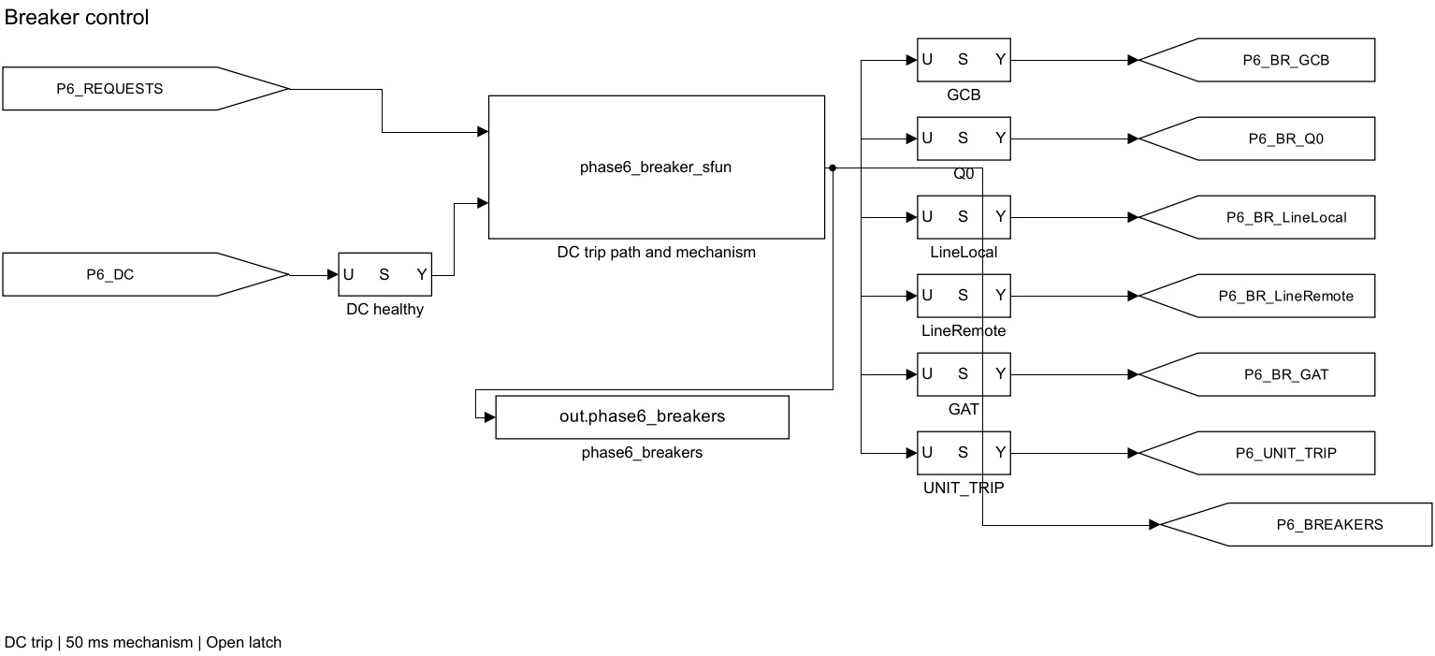
Figure 16 — The breaker-control subsystem: trip requests are combined with DC health, timed against the 50 ms mechanism delay, and latched open.

- DC Supply — 9 blocks
- Models the 110 V station battery, charger and trip-coil load.
- Includes an 88 V trip-permission threshold.
- Demonstrates that a relay cannot trip the breaker without sufficient DC power.
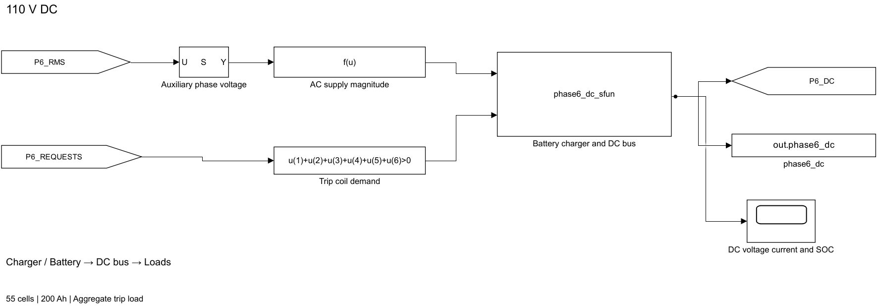
Figure 17 — The station DC subsystem: the 110 V battery Thevenin model, the bounded charger, the trip-coil load and the 88 V trip-permission gate.

- Results — 9 blocks
- Records simulation results.
- Each scenario produces 17 CSV files, 5 figures and 1 MAT file.
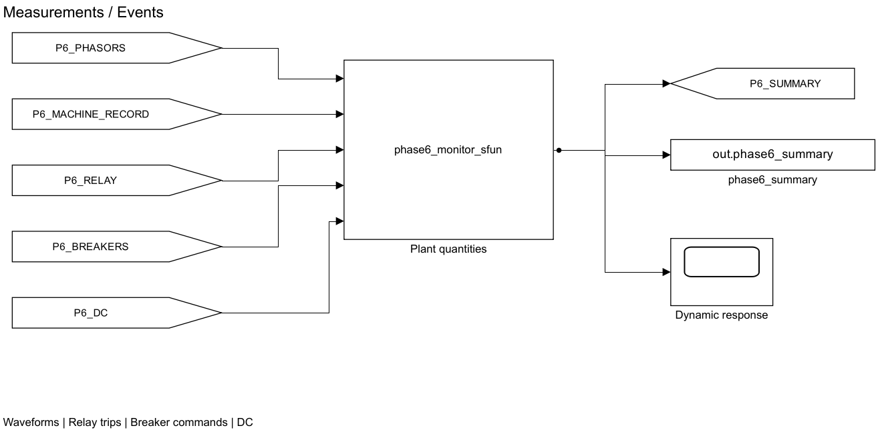
Figure 18 — The results subsystem: signal logging for the seventeen exported CSV tables and the five exported figures per scenario.

- Top-level/overall model integration
- These subsystems work together as the complete closed-loop protection system.
Also: the root level contains a Live Meter Signals subsystem with 37 blocks for displaying important values during simulation.

3.4.5 The Seven Relay Elements — Student Version
The simulation uses 7 protection elements:
GEN51 → GSUT51 → GEN51N → 87G → 87T → 87B → 87L

1. Overcurrent Protection
The first three are inverse-time overcurrent relays:
- GEN51 → protects the generator from overcurrent.
- GSUT51 → protects the GSUT.
- GEN51N → detects generator earth faults using the neutral current.
The relay operating time is:
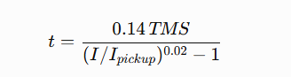
The relay does not simply wait for one fixed time. It continuously checks the current and accumulates its operating time until it reaches the trip point.

2. Differential Protection
The other four relays compare currents entering and leaving their protected zones:
- 87G → Generator differential
- 87T → Transformer differential
- 87B → 230 kV busbar differential
- 87L → Transmission-line differential
If the current difference becomes too large, the relay assumes there is an internal fault and sends a trip signal.

87T Transformer Protection
Because the GSUT is YNd1, the LV and HV currents have different magnitudes and phase angles.
Therefore, the model:
- Converts the LV current using a cyclic-delta transformation.
- Removes HV zero-sequence current because the delta winding blocks it.
This prevents false operation of 87T during external earth faults.

87L Line Protection
87L compares currents at both ends of the transmission line.
Because the two measurements need communication, the model adds:
5 ms communication delay.
So, the total effective delay is:

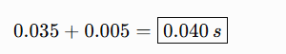

Important Point About Settings
The relay settings used in the simulation come directly from the Phase-5 settings file. Phase 6 does not change or recalculate them.
Some settings are:
- Derived → calculated from study results.
- Assumed → engineering assumptions.
- Study proxy → used to represent protection behavior because actual relay settings were unavailable.
Two additional settings, GIS-Q0-51 and GEN-51-SIEMENS-BL, are excluded from the dynamic trip system because their documentation status is not sufficient.

3.4.6 The Trip Matrix
The relay signals are connected to five breakers using a fixed trip logic.

Trip Logic
- Unit trip = GEN51 OR GSUT51 OR GEN51N OR 87G OR 87T
- GCB = Unit trip
- Q0 = Unit trip OR 87B
- Line Local = 87B OR 87L
- Line Remote = 87L
- GAT = 87B

In Simple Words
- Any fault detected inside the generator/unit trips the GCB.
- Unit faults or 230 kV busbar faults trip Q0.
- A busbar fault or line fault trips the local line breaker.
- A line fault also trips the remote line breaker.
- A busbar fault trips the GAT breaker as well, preventing the grid from feeding the busbar fault through the auxiliary system.

Breaker Operation
Three additional rules apply:
- The breaker mechanism operates only when the station DC supply is healthy.
- After receiving a valid trip command, the breaker opens after: 50 ms
- Once opened, the breaker stays open (latched).
If the DC supply is completely lost, the breaker cannot operate. A pending trip request is retained and executes when DC power returns.

3.4.7 The Station DC System
The station DC system supplies power to the relay and breaker trip circuits.
Parameter | Value
DC voltage | 110 V
Battery | 55 lead-acid cells
Capacity | 200 Ah
Charger | 20 kW, 123.75 V
Internal resistance | 0.05 Ω
Trip permission | VDC≥88 V

How It Works
The important condition is:
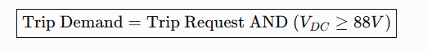
So even if the relay sends a trip signal, the breaker will not operate if the DC voltage is too low.

Simulation Results
- DC voltage normally stays between 114–124 V.
- When the trip coil operates, the voltage drops by about 1 V, to around 109 V.
- This is still safely above the 88 V trip-permission limit.
- Therefore, normal simulated faults are not blocked by the DC system.
- When the battery is deliberately removed, the model can demonstrate a trip request being delayed until DC power returns.

Important Data Source Point
Only the 110 V nominal voltage came directly from the source documents.
The following were study assumptions/additions:
- 55-cell configuration
- 200 Ah capacity
- 0.05 Ω internal resistance
- 20 kW charger and float voltage
- 88 V trip-permission threshold

3.4.8 Model Verification
The dynamic model was checked using specific tests, not just by looking at whether the waveforms seemed reasonable.
- Steady-state comparison: 14/14 tests passed.
- The dynamic model matched the frozen Phase-3 load-flow operating point.
- Scenario checks: 11/11 passed.
- Relay settings: 7 settings were checked against the frozen Phase-5 file.
- Saved simulations: 26 scenario folders were generated, each containing CSV results, figures and a MAT file.
The most important check is the 14/14 operating-point match, showing that the dynamic model starts from the same electrical condition established by the earlier static study.

3.4.9 Model Limitations
Some differences and limitations are intentionally reported:
- Phase 6 does not exactly reproduce Phase-4 fault currents because the two models work differently.
  - Generator 3-phase fault: −12.273%
  - Transformer LV line-to-line fault: −9.411%
- After the generator breaker opens, a generator-side fault branch can still carry about 27.1–27.5 kA because the generator can continue feeding its internal fault while its flux decays.
- The model does not include:
  - CT saturation
  - 2nd/5th harmonic inrush blocking
  - Detailed winding faults
  - Most installed backup protection
  - Extra communication delays beyond the 5 ms for 87L
  - Individual trip-coil DC measurements
- Several parameters are engineering assumptions, including controller settings, some relay characteristics, 50 ms breaker delay and the battery model.
- Phase 6 is not declared fully complete because two validation gates remain open.

3.5 CAD / Hardware Design
- No physical CAD model or mechanical enclosure was designed.
- The project studies an existing power plant, so the actual generator, GIS, transformer and breakers already exist.
- Instead, the project designed their electrical and simulation representation.
Examples include:
- Bus/node topology
- Sequence networks and NER
- Simulink block model
- Physical and signal connections
- Measurement and relay structure
So, the Simulink model and system representation are the project's main design outputs, rather than a mechanical CAD model.

3.6 PCB Design
- No PCB was designed or fabricated.
- The closest equivalent is the software implementation of:
  - Relay trip matrix
  - Breaker trip logic
  - 110 V DC trip system
  - 88 V DC interlock
- These functions are implemented inside phase6_breaker_sfun.
- The logic was verified in simulation, but actual installed wiring was not inspected.

3.7 Firmware / Source Code
- There is no embedded firmware, because the project has no microcontroller or physical electronic device.
- The main software deliverable is the MATLAB/Simulink codebase.

Why the Code Matters
- Reproducibility: Results are generated automatically; tables are not manually edited.
- Phase separation:
Phase 3 → operating point → Phase 4 → fault currents → Phase 5 → relay settings → Phase 6 → dynamic simulation
- Testing: The code contains automated tests to verify that the calculated results are reliable.

3.7.2 File and Function Inventory
The code is organized phase-wise and function-wise, so each part of the project has a specific job.
Directory | Files | Main purpose
matlab/data/ | 15 | Main system data and engineering assumptions
matlab/build/ | 9 | Builds the electrical Simulink/model systems
matlab/analysis/ | 11 | Processes results and performs validation
matlab/studies/ | 10 | Runs different load-flow and study cases
matlab/phase4/ | 20 | Fault calculation and validation
matlab/phase5/ | 51 | Protection coordination and relay settings
matlab/tests/ | 78 | Automated testing of the project
Phase6/scripts/ | 32 | Dynamic model, protection, breaker, DC and result generation

Main Roles
- Data: Stores the project's main input data and assumptions — the single source of truth.
- Build: Creates the generator, transformer, 230 kV system, auxiliaries and grid model.
- Analysis: Processes load-flow results and creates plots/checks.
- Studies: Runs the different system studies.
- Phase 4: Calculates and validates fault currents.
- Phase 5: Performs protection coordination and generates relay settings.
- Tests: Contains automated tests to check that the code works correctly.
- Phase 6: Builds and runs the dynamic closed-loop protection model.

Important Coding Design
The Phase 6 algorithms are divided into two files:
- *_sfun.m → Simulink wrapper; defines inputs, outputs, sample time and states.
- *_step.m → Contains the actual algorithm as normal MATLAB code.
This separation is useful because the algorithm can be tested independently outside Simulink.

3.7.3 The main program
The listing below is Phase6/scripts/phase6_relay_step.m. It is reproduced complete, not as an excerpt — all 99 lines — because this single function contains both relay element types used in the study and is the closest thing the project has to a "main program" in the firmware sense. It is the code that decides, on every 1 ms control step, whether the plant should be tripped.
Reading it, four things in the brief are visible directly in the source:
• the accumulated-duty implementation of the IEC Standard Inverse curve (state.inverseDuty(k) = state.inverseDuty(k)+dt/Y.operatingTime_s(k), trip at duty ≥ 1, reset to zero on dropout);
• the YNd1 cyclic-delta compensation and the HV zero-sequence removal (lvHV = R.lvToHv*[lv(1)-lv(2),lv(2)-lv(3),lv(3)-lv(1)]/sqrt(3) and hvWithoutZero = M.IgsutHV-mean(M.IgsutHV));
• the dual-slope restraint threshold; and
• the trip matrix of §3.4.6 as the final two statements.
The input assertions at the top are not decoration. They are the reason a malformed measurement produces an error instead of a plausible-looking wrong answer, and the 'Phase6:RebuildRequired' assertion specifically refuses to run if the loaded parameter set predates the 87L communications allowance.
Source Code for the main program:

function [Y,state] = phase6_relay_step(M,state,dt,R,enabled)
%PHASE6_RELAY_STEP Measured-current protection; no scenario/fault flag input.
% Complex RMS phasors use the directions in docs/RELAY_TASK_REPORT.md.
% Relay order: GEN51 GSUT51 GEN51N 87G 87T 87B 87L.
% Breaker order: GCB Q0 LineLocal LineRemote GAT. DC gating is downstream.
% Empty state resets; disabling does not erase an already latched trip.
assert(isnumeric(dt) && isscalar(dt) && isfinite(dt) && isreal(dt) && dt > 0, ...
'phase6:timeStep','dt must be a positive finite interval in seconds.');
if isscalar(enabled), enabled = repmat(logical(enabled),1,7); end
assert(isequal(size(enabled),[1 7]),'phase6:enableShape', ...
'enabled must be scalar or a seven-element row.');
enabled = logical(enabled);
names = {'IgenInner','IgenTerminal','IgsutLV','IgsutHV','IbusIn', ...
'IbusOut','IgatHV','IlineLocal','IlineRemote'};
for k = 1:numel(names)
I = M.(names{k});
assert(isnumeric(I) && isequal(size(I),[1 3]) && all(isfinite(I)), ...
'phase6:phasor','%s must contain three finite RMS current phasors.',names{k});
end
assert(isnumeric(M.Ineutral_A) && isscalar(M.Ineutral_A) ...
&& isreal(M.Ineutral_A) && isfinite(M.Ineutral_A) && M.Ineutral_A >= 0, ...
'phase6:neutralRMS','Ineutral_A must be a nonnegative physical RMS current.');
if isempty(state)
state = struct('trip',false(1,7),'timer_s',zeros(1,7), ...
'inverseDuty',zeros(1,3),'differentialTimer_s',zeros(4,3));
end

primary = [max(abs(M.IgenTerminal)),max(abs(M.IgsutHV)),M.Ineutral_A];
Y.currentSecondary_A = primary./R.ctRatio(1:3);
Y.pickup = false(1,7);
assert(isfield(R,'communicationDelay_s') && isscalar(R.communicationDelay_s) ...
&& isfinite(R.communicationDelay_s) && R.communicationDelay_s>0, ...
'Phase6:RebuildRequired','Rebuild v4 to load the finite line communications allowance.');
effectiveDelay=R.delay_s;
effectiveDelay(4)=effectiveDelay(4)+R.communicationDelay_s;
Y.operatingTime_s = [inf(1,3) effectiveDelay];
for k = 1:3
multiple = primary(k)/R.pickup_A(k);
if multiple > 1
Y.operatingTime_s(k) = R.iecK*R.tms(k)/(multiple^R.iecAlpha-1);
Y.pickup(k) = enabled(k);
end
if ~state.trip(k)
if Y.pickup(k)
state.inverseDuty(k) = state.inverseDuty(k)+dt/Y.operatingTime_s(k);
state.timer_s(k) = state.timer_s(k)+dt;
state.trip(k) = state.inverseDuty(k) >= 1-16*eps;
else
state.inverseDuty(k) = 0;
state.timer_s(k) = 0;
end
end
end

% YNd1: unlike a fixed angle rotation this delta matrix also compensates
% negative sequence correctly. HV zero sequence has no LV line counterpart.
lv = M.IgsutLV;
lvHV = R.lvToHv*[lv(1)-lv(2),lv(2)-lv(3),lv(3)-lv(1)]/sqrt(3);
hvWithoutZero = M.IgsutHV-mean(M.IgsutHV);
spill = [M.IgenInner-M.IgenTerminal; lvHV-hvWithoutZero; ...
M.IbusIn-M.IbusOut-M.IgatHV; M.IlineLocal-M.IlineRemote];
restraint = R.restraintFactor*[abs(M.IgenInner)+abs(M.IgenTerminal); ...
abs(lvHV)+abs(hvWithoutZero); ...
abs(M.IbusIn)+abs(M.IbusOut)+abs(M.IgatHV); ...
abs(M.IlineLocal)+abs(M.IlineRemote)];
differential = abs(spill);
Y.differential_A = zeros(1,4);
Y.restraint_A = zeros(1,4);
Y.threshold_A = zeros(1,4);
for k = 1:4
relay = k+3;
threshold = max(R.pickup_A(relay), ...
R.slope1(k)*min(restraint(k,:),R.knee_A(k)) + ...
R.slope2(k)*max(restraint(k,:)-R.knee_A(k),0));
margin = differential(k,:)-threshold;
phasePickup = margin > 0 & enabled(relay);
Y.pickup(relay) = any(phasePickup);
% Report a single coherent operating point; never combine the maximum
% differential of one phase with the restraint of a different phase.
[~,phase] = max(margin);
Y.differential_A(k) = differential(k,phase);
Y.restraint_A(k) = restraint(k,phase);
Y.threshold_A(k) = threshold(phase);
if ~state.trip(relay)
state.differentialTimer_s(k,~phasePickup) = 0;
state.differentialTimer_s(k,phasePickup) = ...
state.differentialTimer_s(k,phasePickup)+dt;
state.timer_s(relay) = max(state.differentialTimer_s(k,:));
state.trip(relay) = any(state.differentialTimer_s(k,:) ...
>= effectiveDelay(k)-16*eps(effectiveDelay(k)));
end
end
Y.trip = state.trip;
Y.timer_s = state.timer_s;
activeTrip = state.trip & enabled;
Y.unitTrip = any(activeTrip(1:5));
Y.breakerRequest = logical([Y.unitTrip, Y.unitTrip || activeTrip(6), ...
activeTrip(6) || activeTrip(7), activeTrip(7), activeTrip(6)]);
end

The companion function that converts those requests into breaker positions is short enough to give in full as well. It is the code behind every timing number in 4.1: the mechanism timer only accumulates when healthy is true, the breaker opens at C.breakerDelay_s, and x(6:10) is the latch.

function [Y,x]=phase6_breaker_step(request,healthy,t,x,C,S)
%PHASE6_BREAKER_STEP Trip-coil availability, mechanism delay and open latch.
% request=[GCB Q0 lineLocal lineRemote GAT unit]; Y=[closed(1:5) unitTrip].
% Interface limit: healthy represents bus service, not individual coil power.
% Manual commands and later separate trips need per-coil demand wiring for
% full energy gating; the aggregate DC pulse covers the pending initial trip.
if isempty(x),x=[zeros(1,5) 1 1 1 1 double(S.GAT_in) 0];end
assert(isequal(size(request),[1 6]));
manual=S.manualOpen & t>=S.manualOpenTime_s;
demand=(logical(request(1:5))|manual)&logical(healthy);
x(1:5)=double(demand).*(x(1:5)+C.Ts);
open=demand & x(1:5)>=C.breakerDelay_s-16*eps & ~S.breakerFailed;
x(6:10)=x(6:10).*double(~open);
if healthy && (request(6)>0.5 || t>=S.generatorTripTime_s),x(11)=1;end
Y=x(6:11);
end

The comment in its header is itself a declared limit: healthy represents bus service, not individual coil power, which is the per-coil DC metering limitation listed in 3.4.9(c).

3.7.4 How to Reproduce the Results
The study results can be reproduced by running the MATLAB scripts in the specified order:
- ashuganj_setup – Sets MATLAB paths and loads the master data.
- run_all_tests – Checks and verifies the codebase before running the studies.
- run_load_flow_study – Calculates the Phase 2/Phase 3 operating points.
- make_load_flow_plots – Regenerates the load-flow figures.
- Phase-5b protection study – Run using a single MATLAB batch command to generate the final engineering results.
- Phase 6 dynamic model – Started through Phase6/START_PHASE6.m.

3.7.5 Test Counts
The project has four separate test suites, each covering a different part of the codebase. Their results are kept separate because the suites have different scopes and may test some assertions more than once.
Test Suite | Result | Scope
Phase 3, final REV3.1 | 1388 passed / 0 failed — 18 suites | Data integrity, base conversion, and load-flow validation
Phase 4 | 161 passed / 0 failed — 17 files | Fault analysis engine
Phase 5b | 528 passed / 0 failed | Protection coordination and artifact integrity
General regression (run_all_tests.m) | 434–447 assertions across 12 files | Overall regression testing
Important: These four numbers must not be added together because they represent different test scopes.
The tests confirm that the code performs its intended calculations, the data is internally consistent, and generated artifacts match their sources. However, passing these tests does not certify the performance of the physical relays installed at Ashuganj.

4 Implementation

4.1 Description

4.1.1 Implementation
Implementation in this project means turning the designed protection model into a working simulation that behaves like a real power system, rather than just being a theoretical circuit or block diagram.
The implemented system follows this sequence:
- A fault is applied to the energized network at a selected time.
- The measurement system detects the resulting current using a one-cycle Fourier window, without being directly informed that a fault has occurred.
- The relay algorithms process these measurements and compare them with the fixed Phase-5 protection settings.
- If a trip is required, the relay decision is sent to the appropriate breakers through the trip matrix.
- The station DC system determines whether the breaker trip coils receive the required power.
- The breakers then operate with a 50 ms mechanical delay.
- Once the breakers open, the affected branches are disconnected and the fault current is reduced/cleared naturally.
So, the important point is that the entire process is calculated step-by-step. No trip or fault-clearing event is manually scheduled in advance; each stage depends on the result of the previous stage.

4.1.2 Baseline Operating Condition
Before testing faults, the system is first checked under normal operating conditions. The baseline case runs for the full 0.6 s simulation period without applying any fault.
The demonstration operating point is:
- Power: 360 MW
- Voltage: 22 kV
- Frequency: 50 Hz
- GAT: Out
This baseline ensures that the model behaves correctly under normal conditions before introducing any fault scenarios.
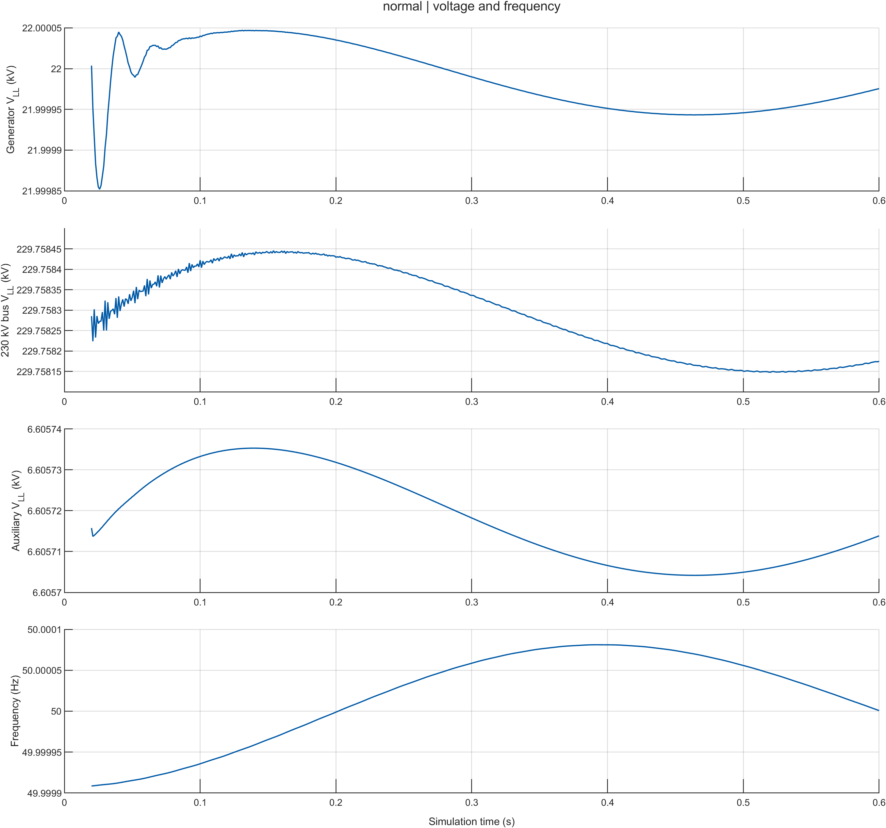
Figure 19 — Baseline scenario: terminal voltage and system frequency over the full 0.6 s run with no fault applied. Both hold flat, which is the precondition for trusting anything that happens in a fault run.

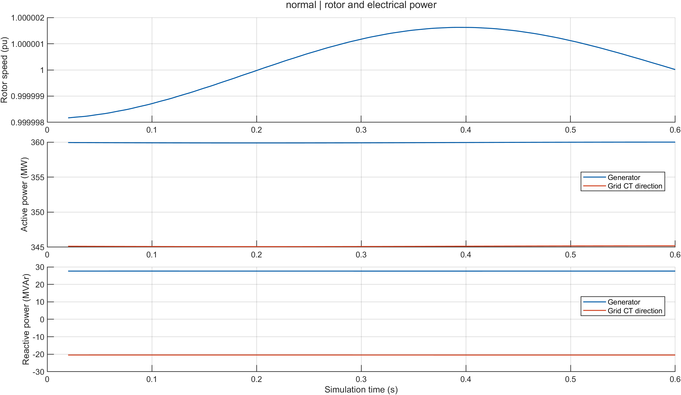Figure 20 — Baseline scenario: shaft speed and electrical power. Speed stays at 1.0 pu and power stays at the 360 MW dispatch, so the governor and AVR are in balance rather than drifting.
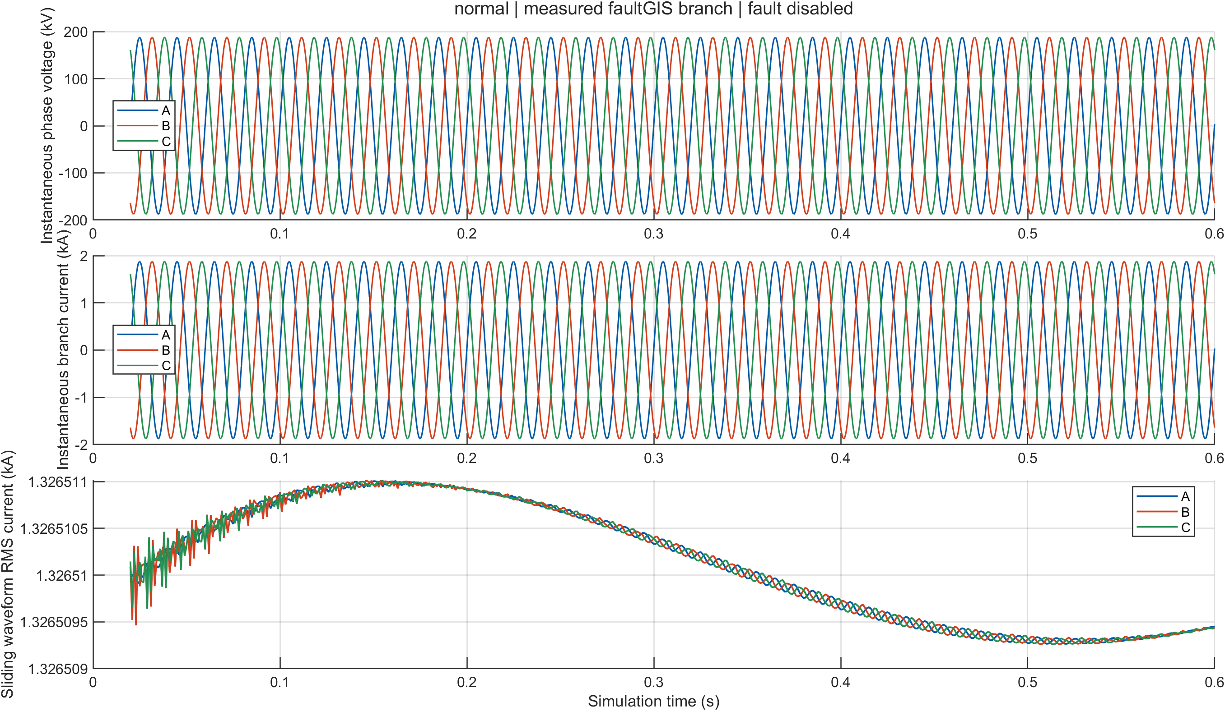
Figure 21 — Baseline scenario: three-phase current waveforms. Balanced sinusoids at rated magnitude, confirming the network carries load current and not an artefact.

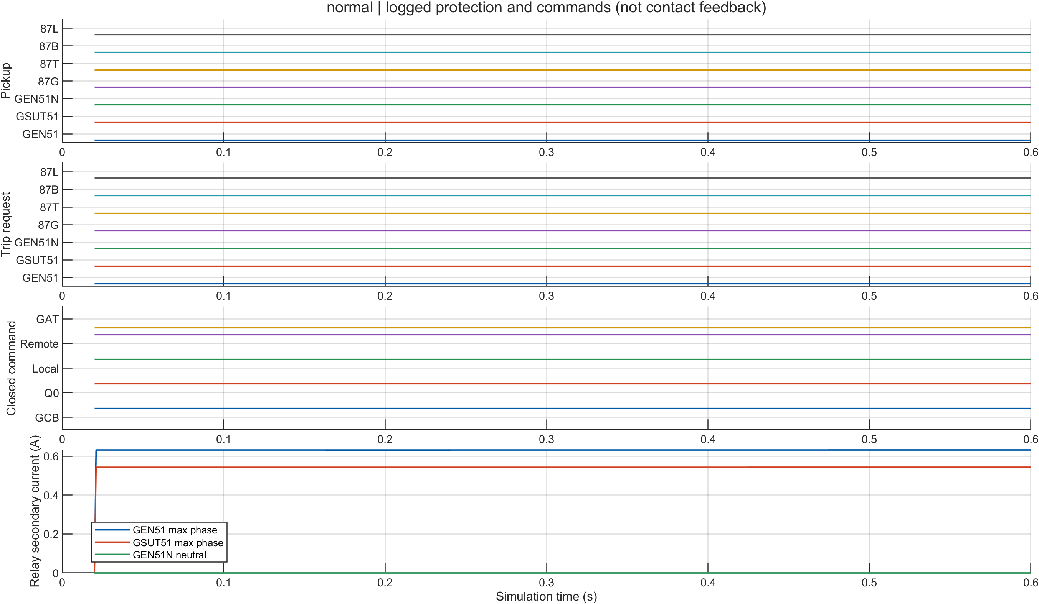
Figure 22 — Baseline scenario: protection and breaker states. Every relay element stays at zero and all five breakers stay closed for the whole run — the protection does not trip a healthy plant.
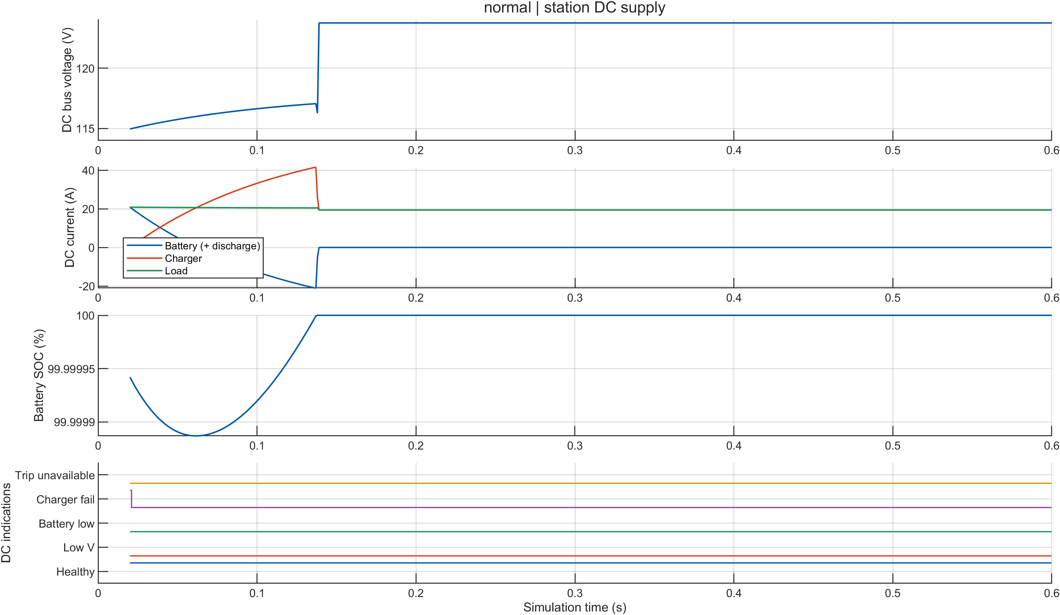
Figure 23 — Baseline scenario: station DC bus voltage and charger state. The bus floats steady with no trip-coil demand.

4.1.3 Primary Verified Event
The main verified implementation result is the three-phase fault at the 230 kV GIS busbar (bus_3ph). The fault is applied at 0.150 s, and the simulation shows the complete protection sequence from fault detection to breaker opening and current interruption.

Event Timeline
Time | Event
0.150 s | Three-phase fault applied at the 230 kV GIS busbar
0.153 s | 87B relay picks up
0.156 s | GSUT-51 picks up
0.157 s | GEN-51 picks up
0.187 s | 87B issues the trip request
0.188 s | Trip coils are energized
0.237 s | Q0 and LineLocal breakers open
0.2372–0.2476 s | Fault current ceases in the individual phases
0.263–0.268 s | Relay elements drop out
0.388 s | Trip coils de-energize
0.450 s | Fault is removed
0.600 s | Simulation ends
The overall fault clearance time is approximately 87 ms, from 0.150 s to 0.237 s. This consists mainly of the relay operating time followed by the 50 ms breaker mechanical delay.

Important Observations
- The 3 ms pickup delay is a result of the modeled Fourier measurement window and the time required for the measured current to cross the relay threshold. It is therefore a result of the simulation rather than a manually imposed delay.
- The breakers open 50 ms after the trip command, matching the breaker mechanism delay used in the model.
- The three phases do not stop carrying current at exactly the same instant. Their current-zero points occur at slightly different times, giving a clearing range of 0.2372–0.2476 s.
- The station DC voltage remained between 114 V and 124 V, well above the 88 V permission threshold, so the trip operation was not prevented by insufficient DC supply.
- Relay elements drop out later, between 0.263 and 0.268 s, as the fault current disappears.

Handling the Different Reported Values
Two project documents reported slightly different current-clearing and relay-dropout ranges. To avoid relying on a narrative summary, the raw Phase-6 CSV outputs were used as the reference.
The breaker data gives:
- Q0: 0.2412, 0.2466, 0.2476 s for phases A, B, C
- LineLocal: 0.2474, 0.2450, 0.2372 s for phases A, B, C
Therefore, the complete current-clearing range is 0.2372–0.2476 s.
Similarly, the relay time-series data shows the first dropout samples as:
- GEN-51: 0.263 s
- GSUT-51: 0.265 s
- 87B: 0.268 s
Therefore, the reported relay dropout range is 0.263–0.268 s.

4.1.4 The five scenario figures, read in order
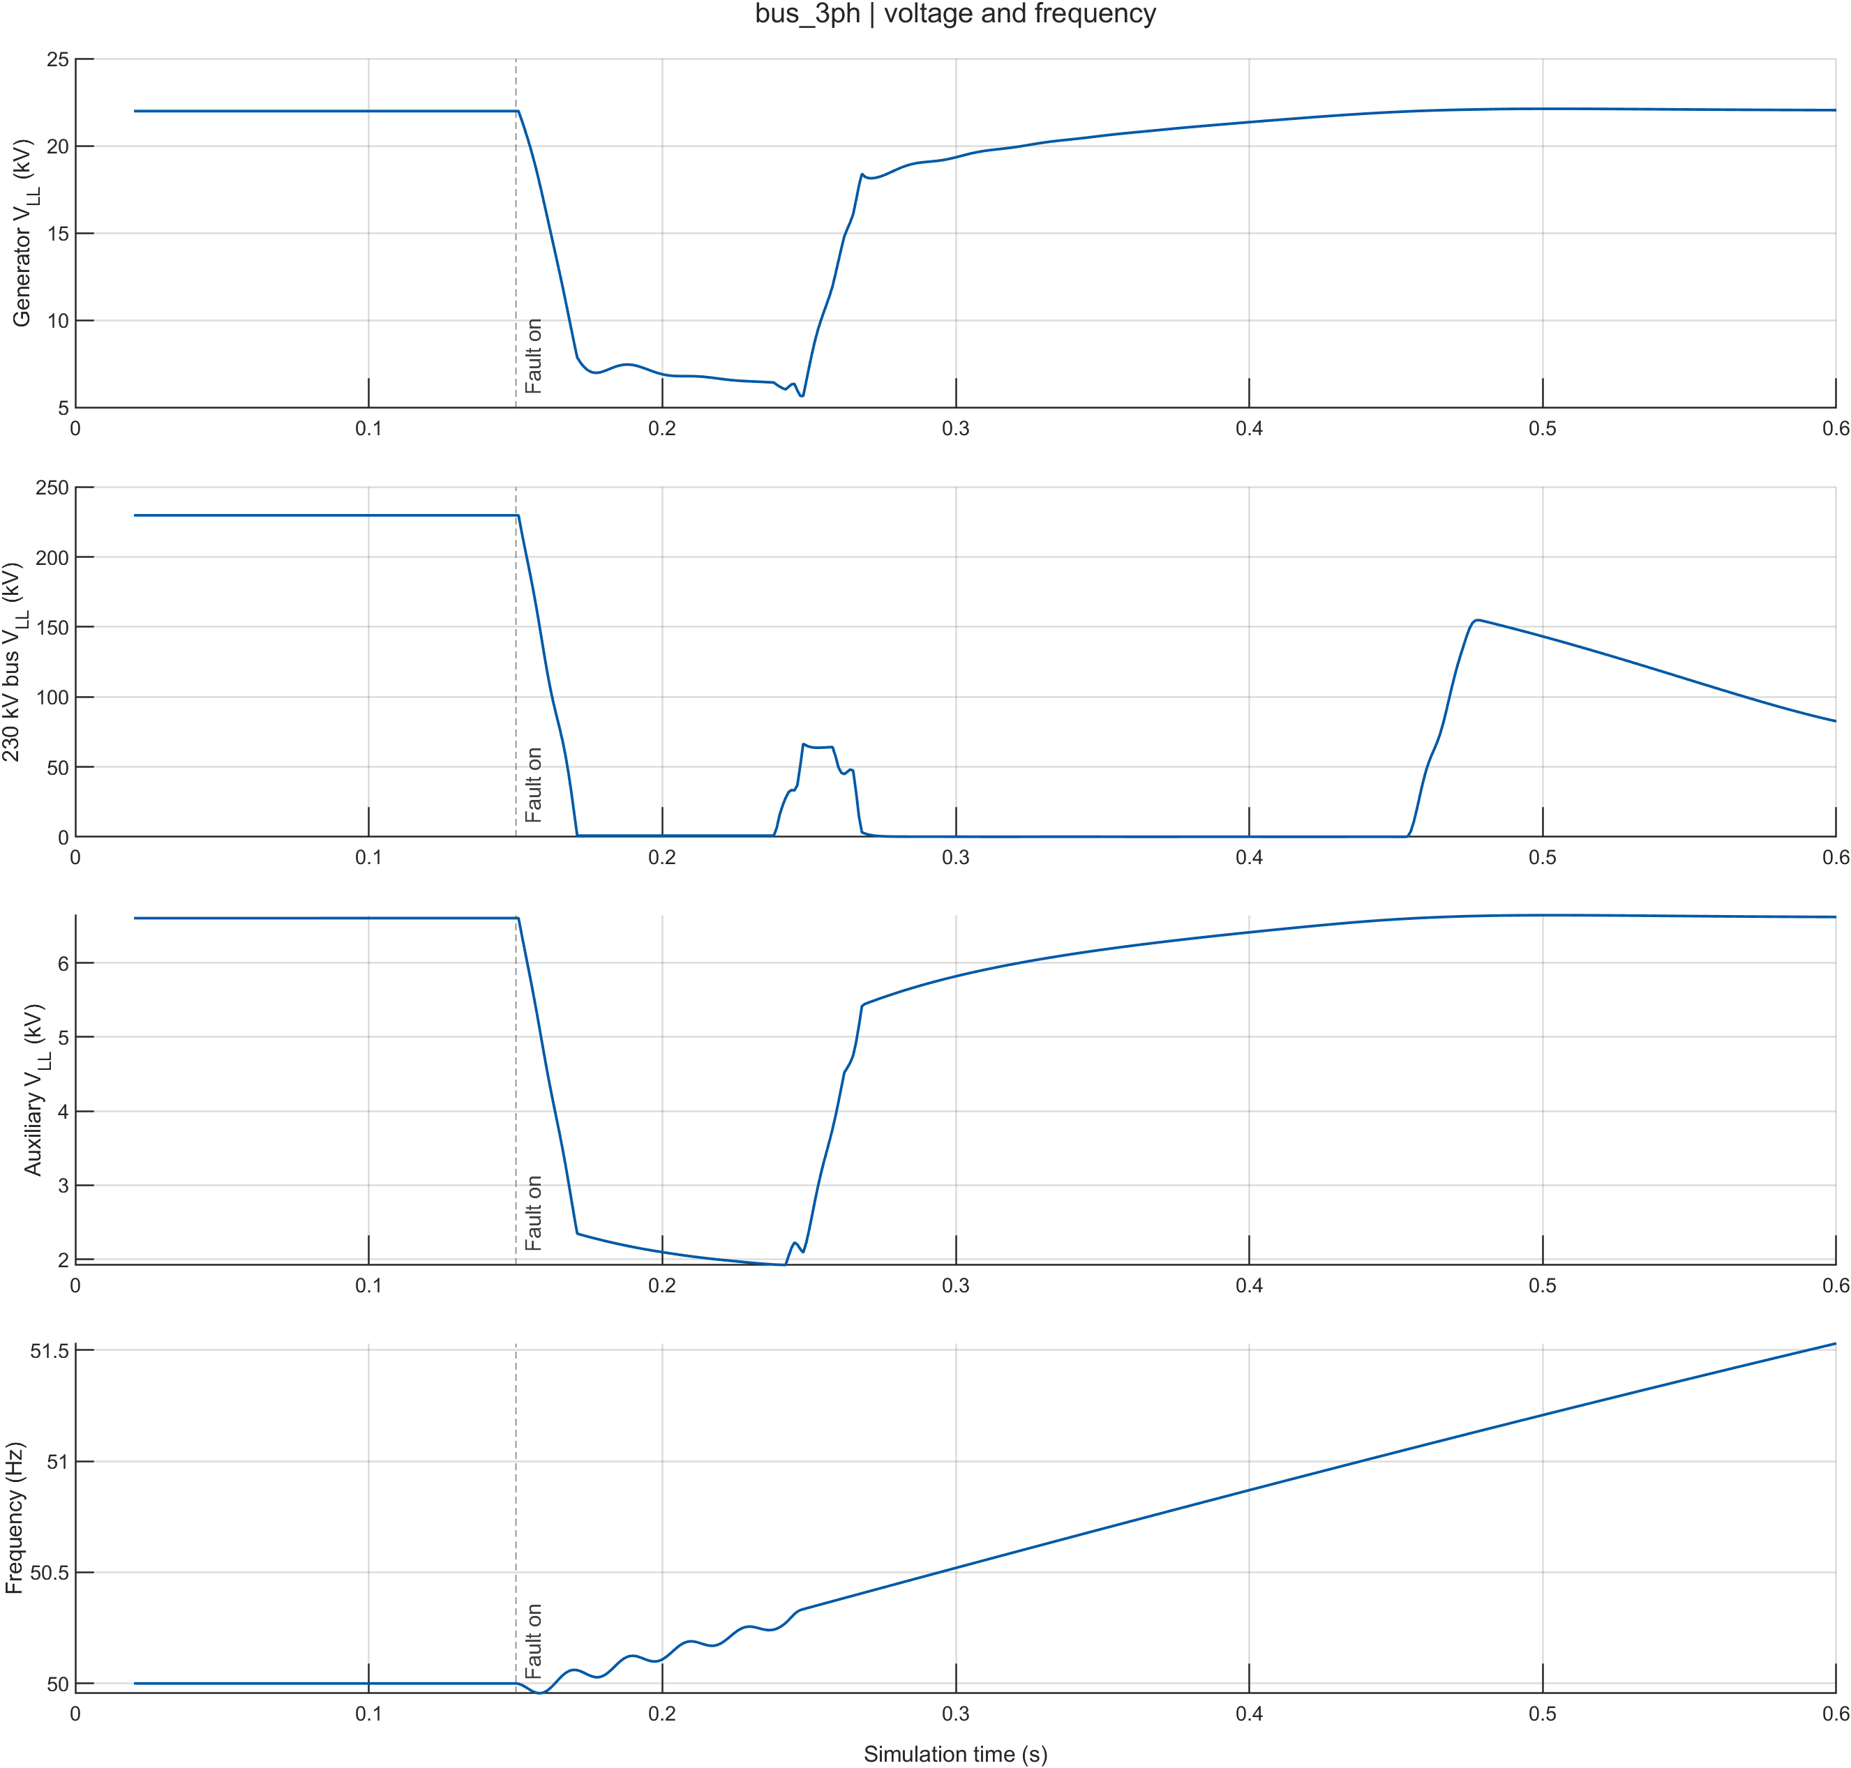
Figure 24 — Busbar three-phase fault: terminal voltage and system frequency. Voltage collapses at 0.150 s, recovers after the breakers open at 0.237 s, and frequency is disturbed but bounded.
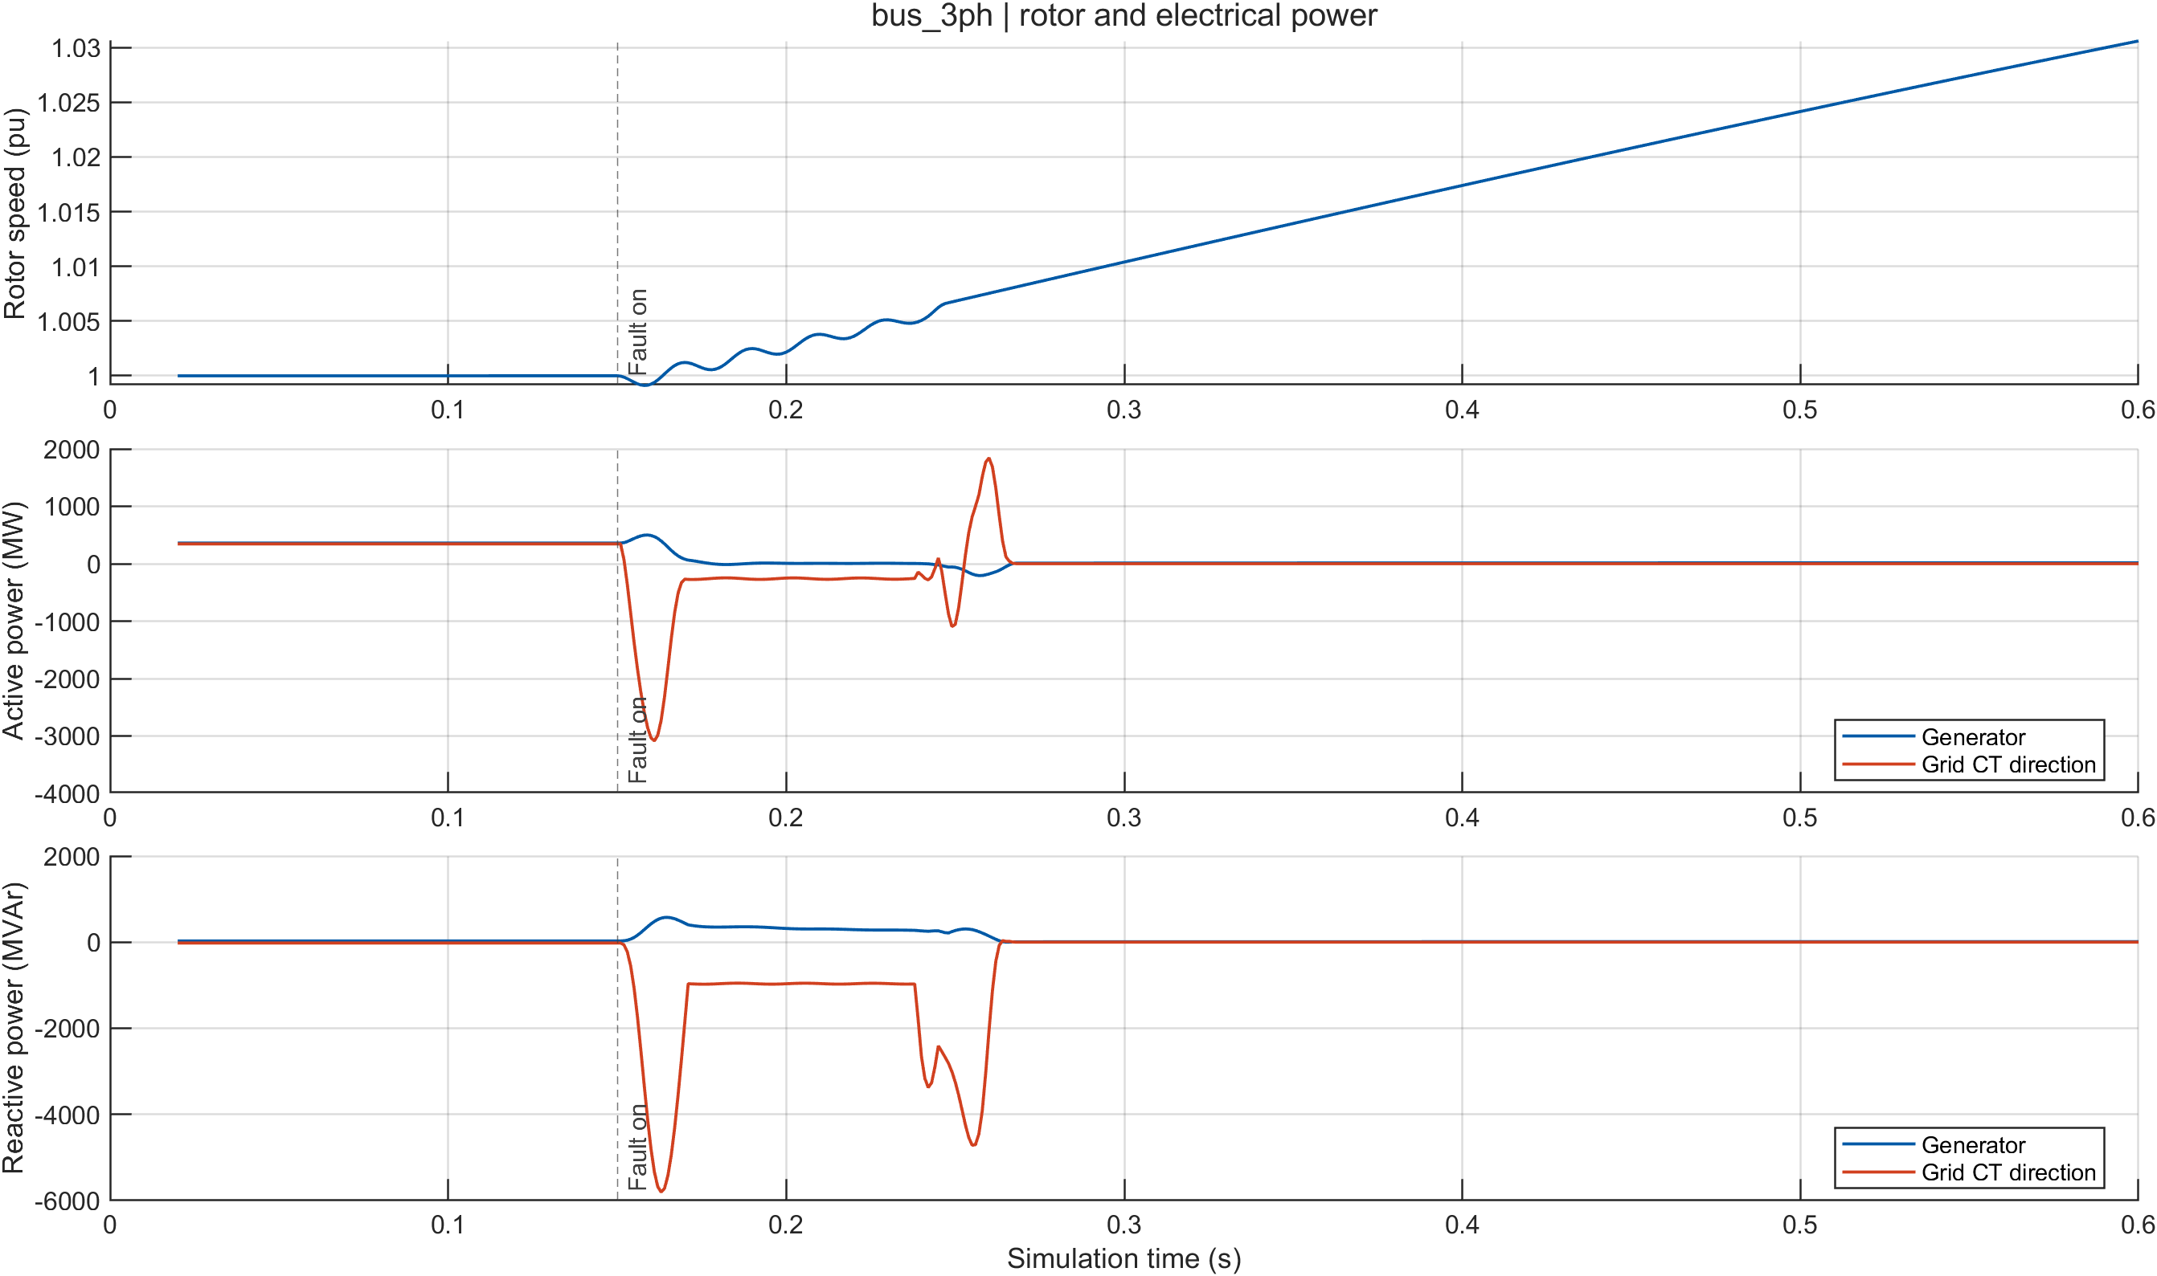
Figure 25 — Busbar three-phase fault: shaft speed and electrical power. Electrical power drops as the fault is cleared and the machine accelerates slightly, which is the mechanical consequence of losing the electrical load path.
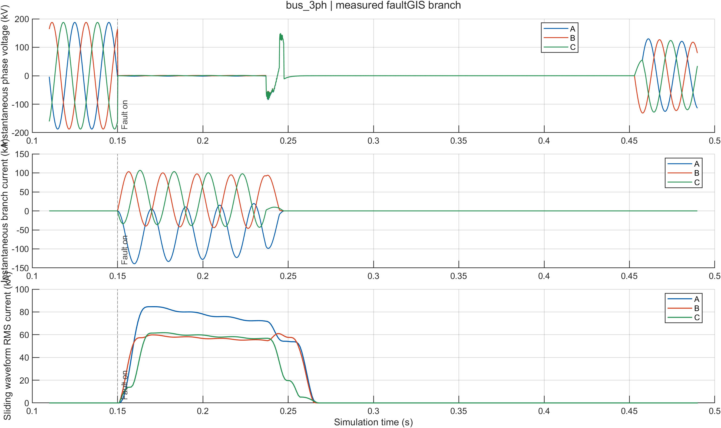
Figure 26 — Busbar three-phase fault: three-phase current waveforms through the fault. The subtransient peak at inception decays, and each phase stops at its own current zero between 0.2372 s and 0.2476 s.

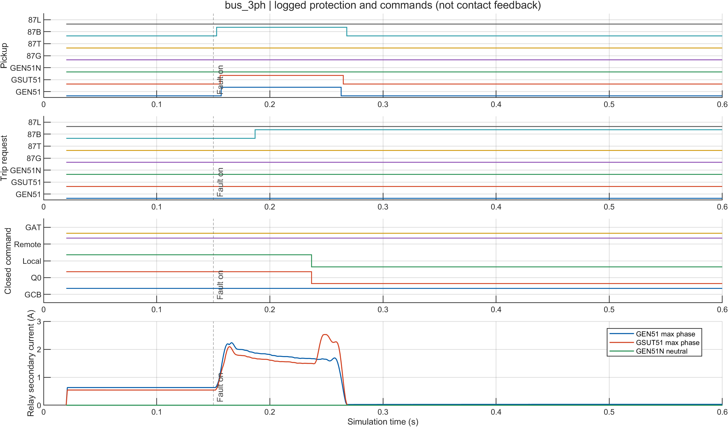
Figure 27 — Busbar three-phase fault: protection element states and breaker positions. The causal staircase is visible — pickup, then trip request, then breaker open, each separated by its own delay
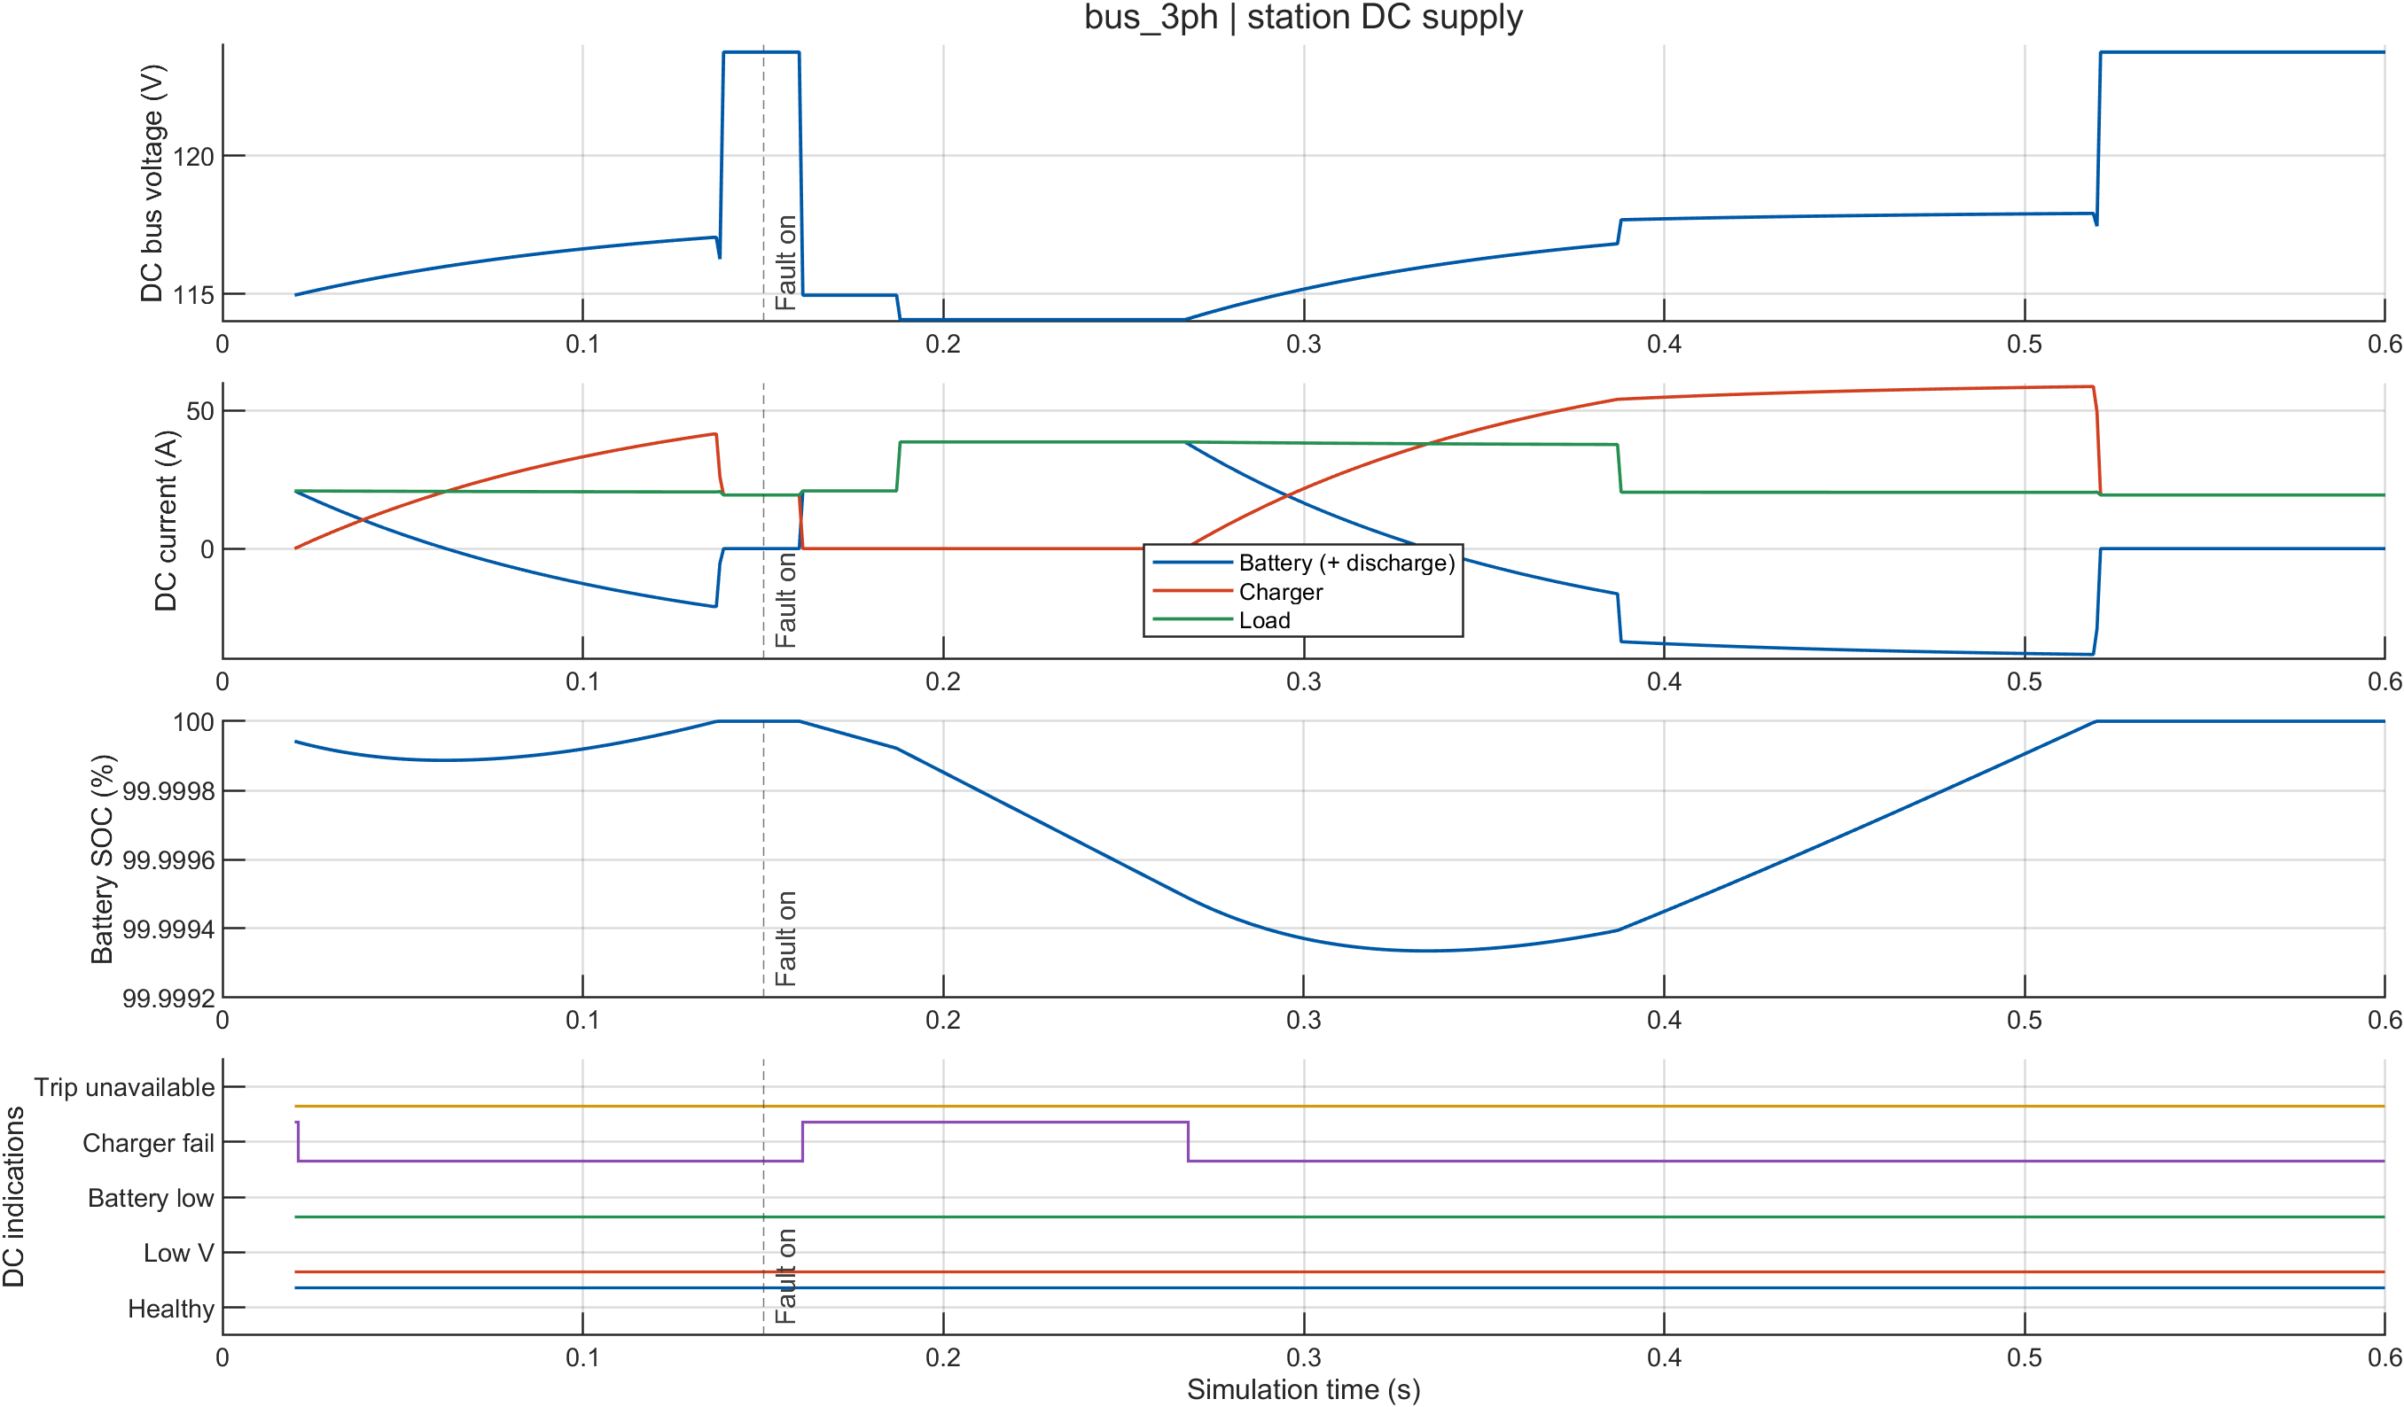
Figure 28 — Busbar three-phase fault: station DC bus voltage and trip-coil current. The bus dips by about 1.0 V when the coils energize and stays far above the 88.0 V permission threshold.

4.1.5 Relay and breaker detail views
These views come from the protection study and show the internals behind the timeline.
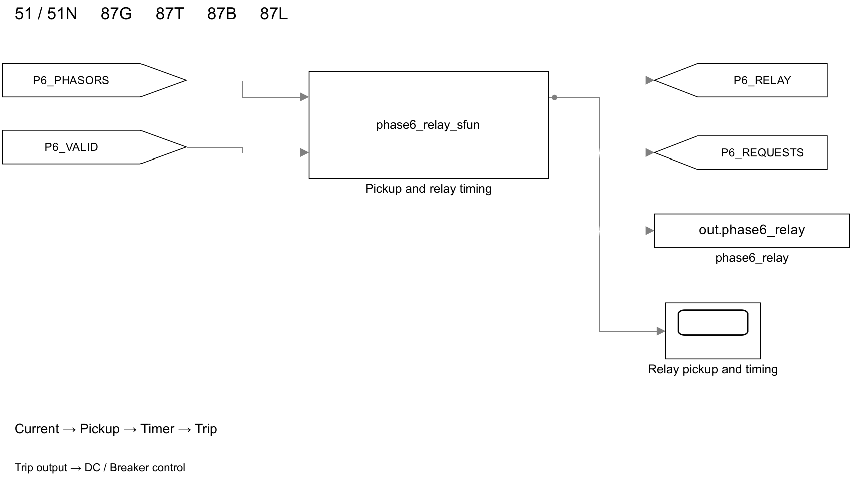
Figure 29 — The relay block as implemented, with its measured-phasor inputs, the frozen setting inputs and its pickup, timer, trip and breaker-request outputs.

4.1.6 Why GEN-51 and GSUT-51 correctly never trip — and why that is the result
For a fault on the 230 kV busbar, the two inverse-time overcurrent elements both pick up, at 0.157 s and 0.156 s. Neither trips. Their computed operating times at the fault current are:

Element | Operating time at this fault current | Outcome
GEN-51 | 4.92 s | Picks up at 0.157 s, drops out at 0.263 – 0.268 s — never reaches 4.92 s
GSUT-51 | 25.4 s | Picks up at 0.156 s, drops out at 0.263 – 0.268 s — never reaches 25.4 s
The results show that protection coordination is working correctly. The 230 kV busbar fault is primarily handled by the 87B busbar differential relay, while the generator and transformer overcurrent elements act as backup protection and therefore wait longer before operating.
- 87B clears the fault in about 87 ms.
- GEN-51 would require about 4.92 s to operate.
- GSUT-51 would require about 25.4 s.
- This large time difference demonstrates the coordination margin between primary and backup protection.
- If GEN-51 operated immediately, the healthy 458 MVA generator could be unnecessarily disconnected for a fault that should be cleared by the busbar protection.
The relay timing is also implemented using an accumulated-duty method. Each relay element accumulates dt/t while it is picked up and resets when it drops out. Therefore, the conclusion that a backup relay does not reach its operating time comes from the actual time integration during the simulation, rather than simply looking at a single calculated value.

4.1.7 Timing-Chain Verification
To prove that the timing results are genuinely produced by the relay logic and are not hard-coded, a setting-change experiment was performed.
The 87B definite-time delay was changed:
0.035 s → 0.070 s
Only this setting was changed, increasing the delay by 0.035 s. The downstream events were then checked to confirm that the protection timeline changed accordingly.
Quantity | Baseline (0.035 s) | Modified (0.070 s) | Change
87B trip request | 0.187 s | 0.222 s | +0.035 s
Breakers open | 0.237 s | 0.272 s | +0.035 s

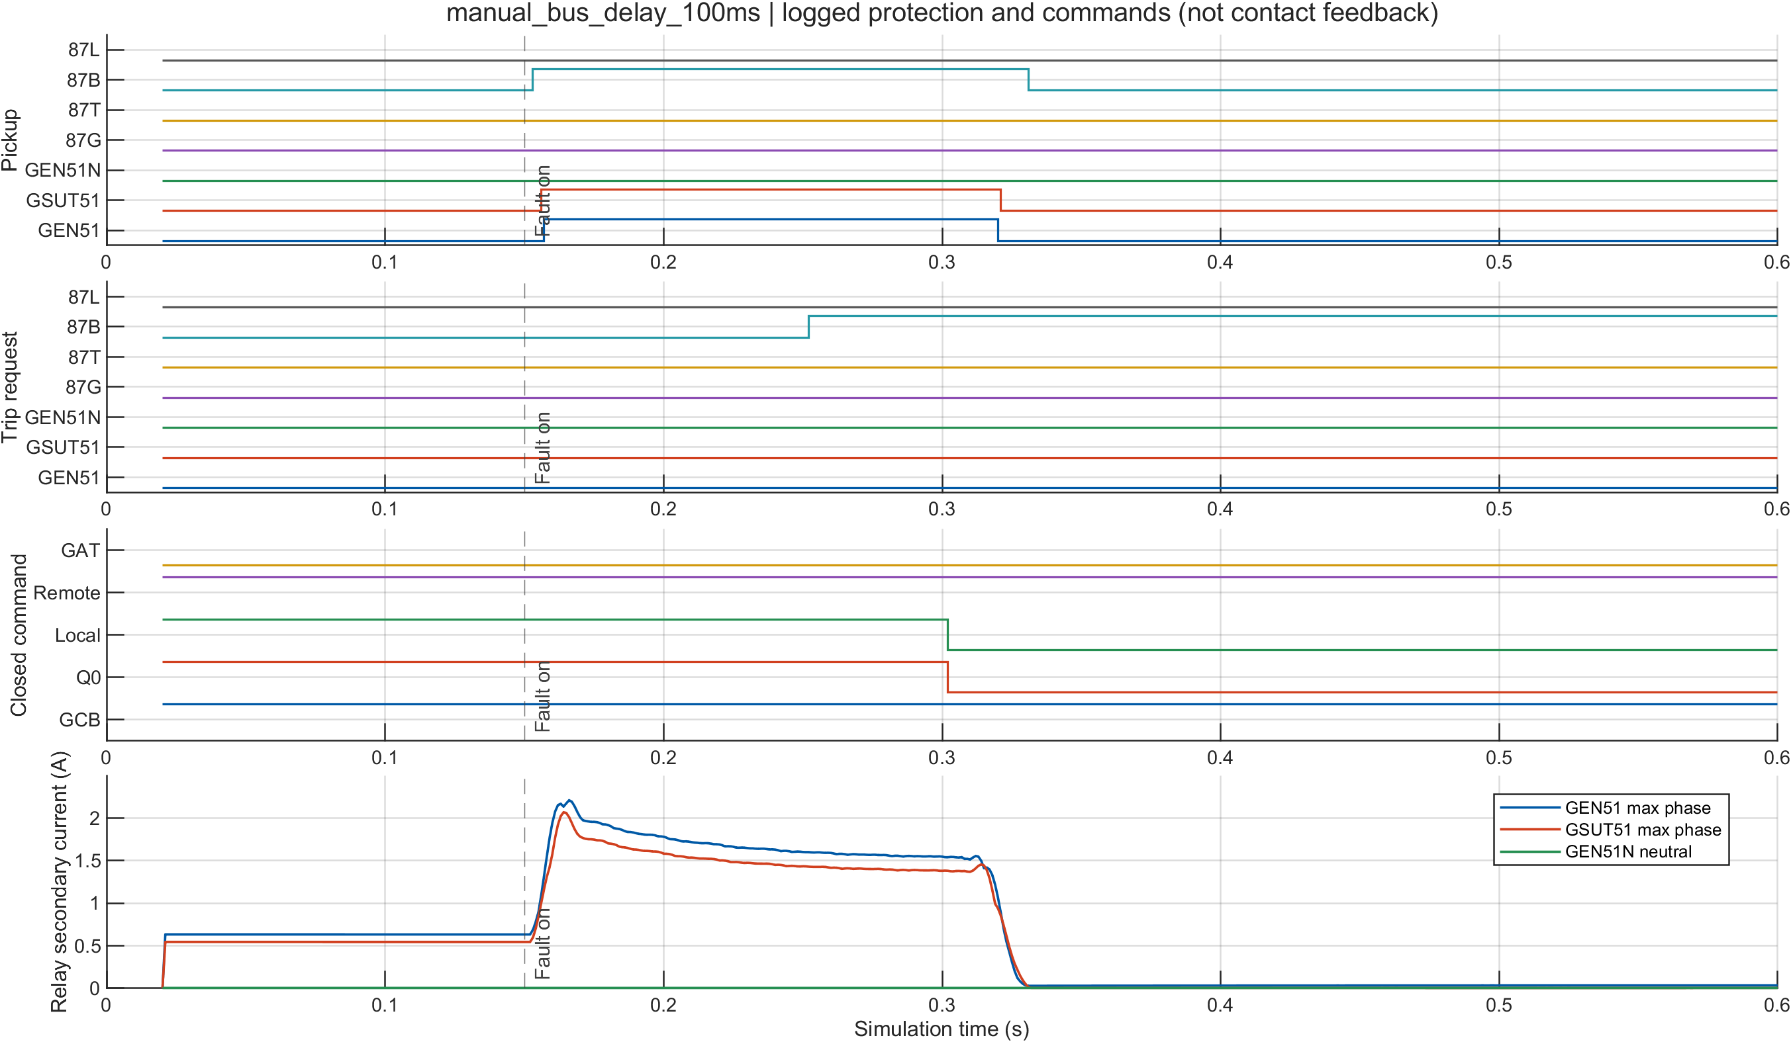
Figure 30 — Setting-change demonstration: with the 87B definite time increased to 0.070 s, the trip request moves to 0.222 s and the breaker opening to 0.272 s. Both shift by exactly the setting change, which is only possible if the timing chain is computed.
Both downstream events moved by exactly the setting change, and the 0.050 s mechanism gap between them was preserved. A hard-coded timeline cannot do this.
A twin scenario, manual_bus_delay_100ms, repeats the experiment at a different operating condition and gives a trip request at 0.252 s and current cessation at 0.3102 s, consistent with the same chain.

4.1.8 Proving the DC interlock is a real gate: the DC-loss experiment
The second experiment removes the station battery while a genuine fault is in progress. The relay still decides correctly. The breaker still does not move, because the trip coil has no energy.
Two runs were made, losing DC at 0.080 s — before the fault — and restoring it at two different instants.

Run | DC lost | DC restored | Breakers open | Delay after restoration
A | 0.080 s | 0.300 s | 0.351 s | +0.051 s
B | 0.080 s | 0.500 s | 0.551 s | +0.051 s

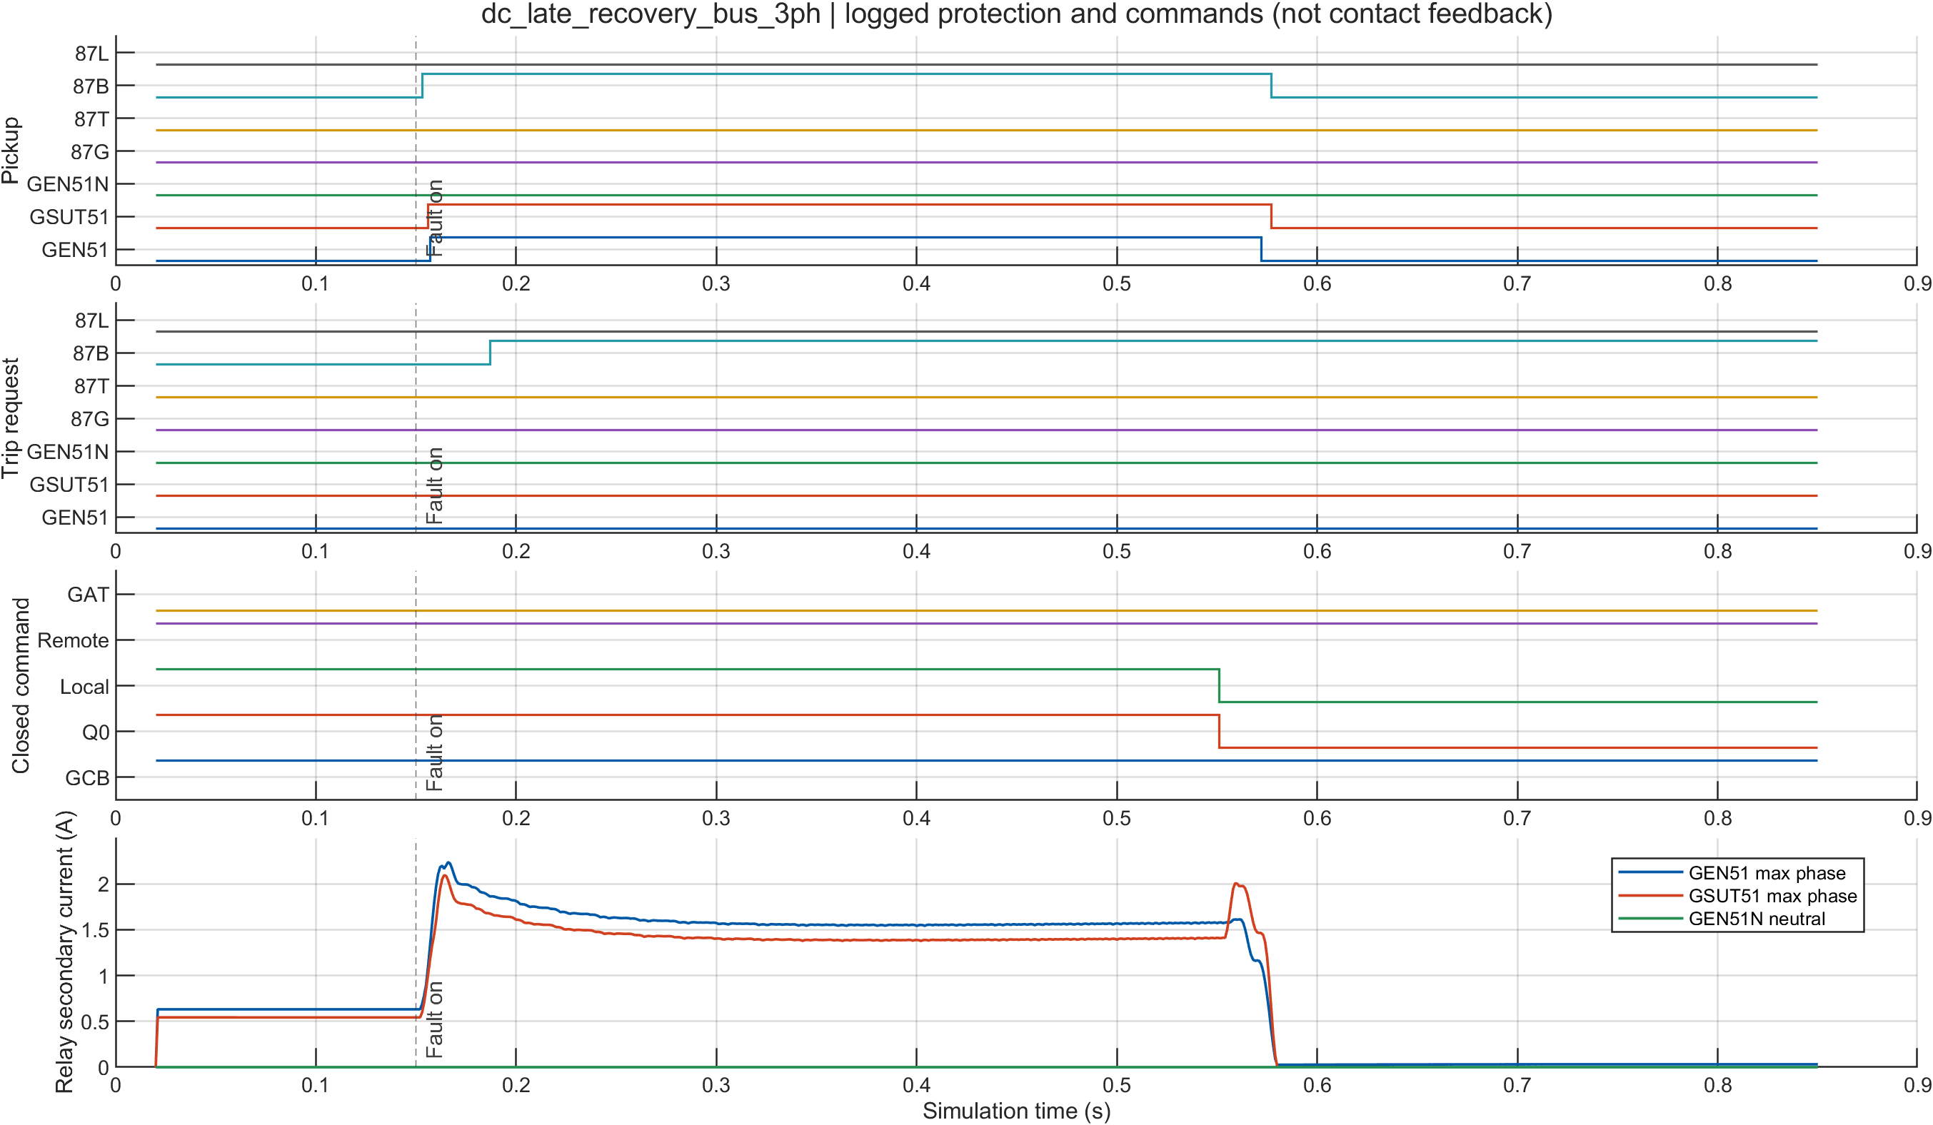
Figure 31 — DC-loss demonstration, protection and breakers: a valid trip request exists but the breakers stay closed while the DC bus is dead, then open 0.051 s after DC is restored.
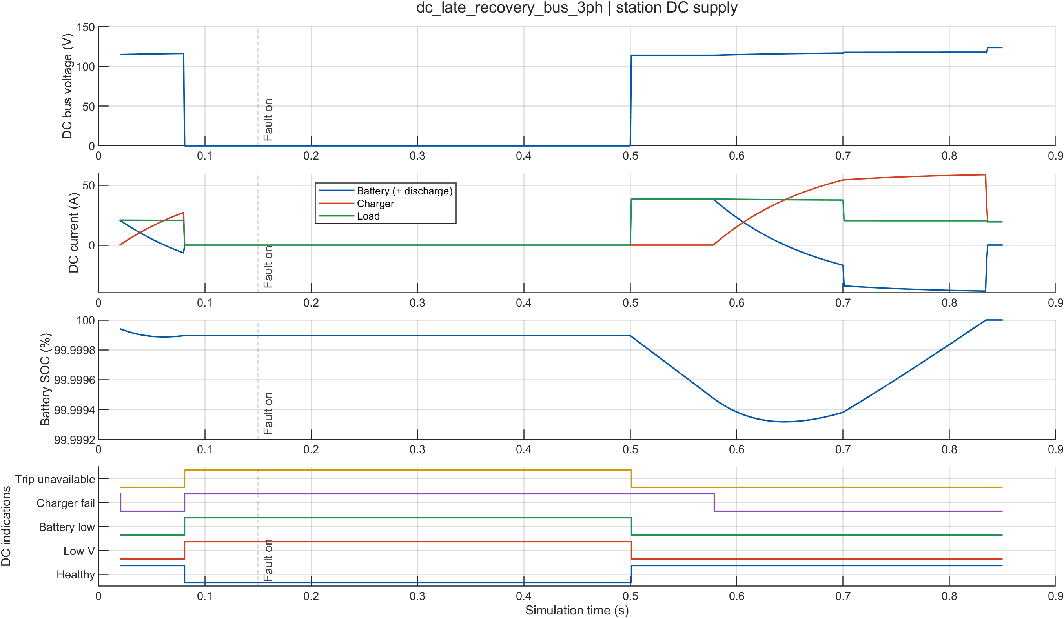
Figure 32 — DC-loss demonstration, station DC: the bus collapses at 0.080 s and is restored later in the run. The trip-permission signal follows the 88.0 V threshold.

DC Interlock and Delayed Trip Verification
Three important conclusions come from this experiment:
- The 88.0 V DC interlock is a real protection gate. When the DC bus voltage is below 88 V, even an active trip request cannot operate the breakers. The fault therefore remains uncleared until the DC supply is restored.
- The trip request is latched. Once the relay issues a valid trip request, it remains pending during the DC outage. The relay does not need to detect and issue the trip again after the supply returns.
- The breaker delay remains consistent. After DC restoration, the breakers operate about 0.051 s later in both tested cases. This corresponds to the 50 ms breaker mechanism delay plus one 1 ms control step.

4.1.9 The other fault locations
The same implementation was exercised at three further locations, which together span the protection zones of §3.3.7.
Generator terminals (zone G).
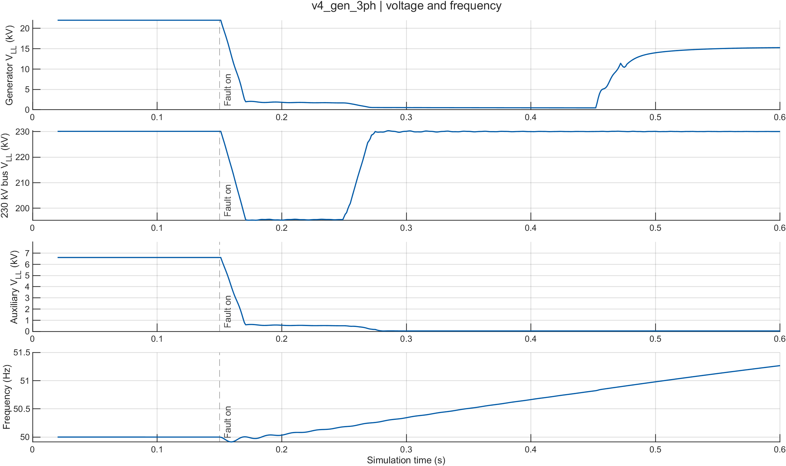
Figure 33 — Generator three-phase fault: terminal voltage and frequency. The voltage collapse is deeper and faster than for the busbar case, because the fault is at the machine terminals.
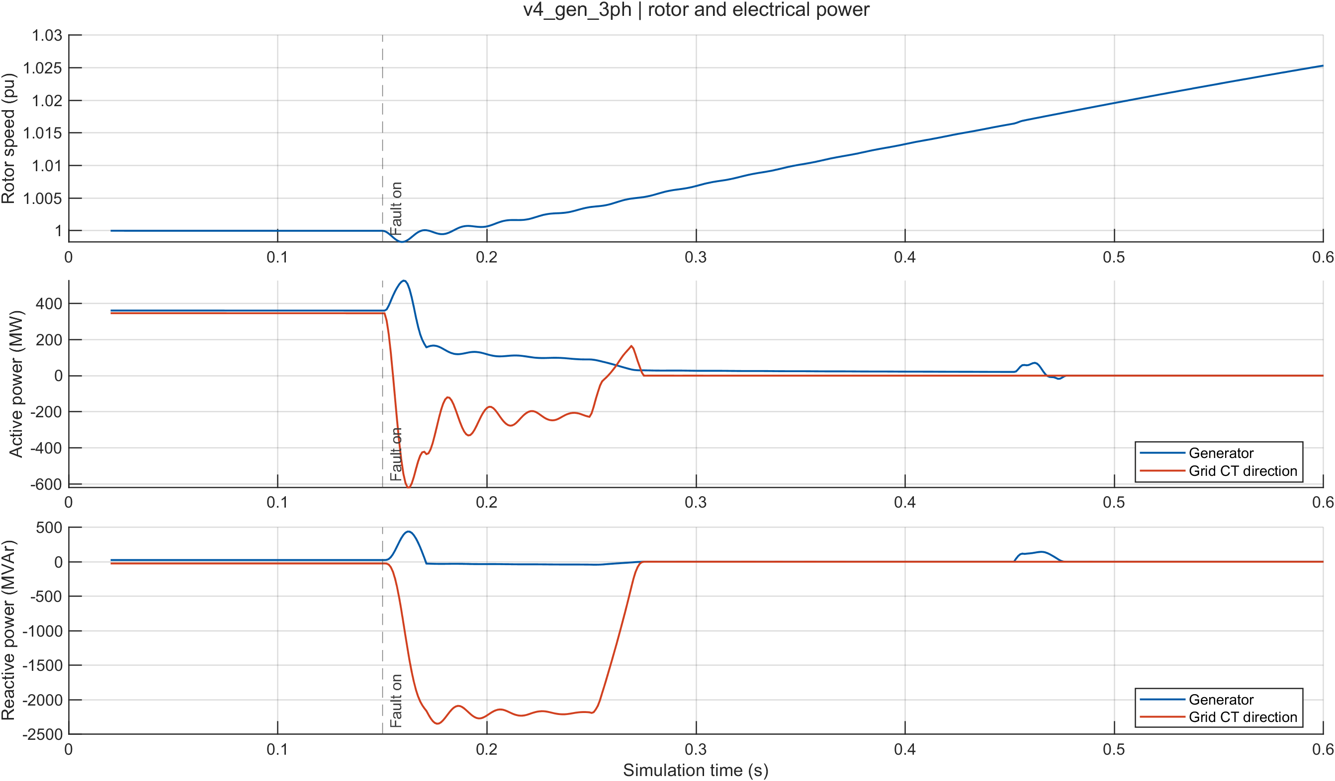
Figure 34 — Generator three-phase fault: speed and power, showing the mechanical response to losing the electrical output path entirely.
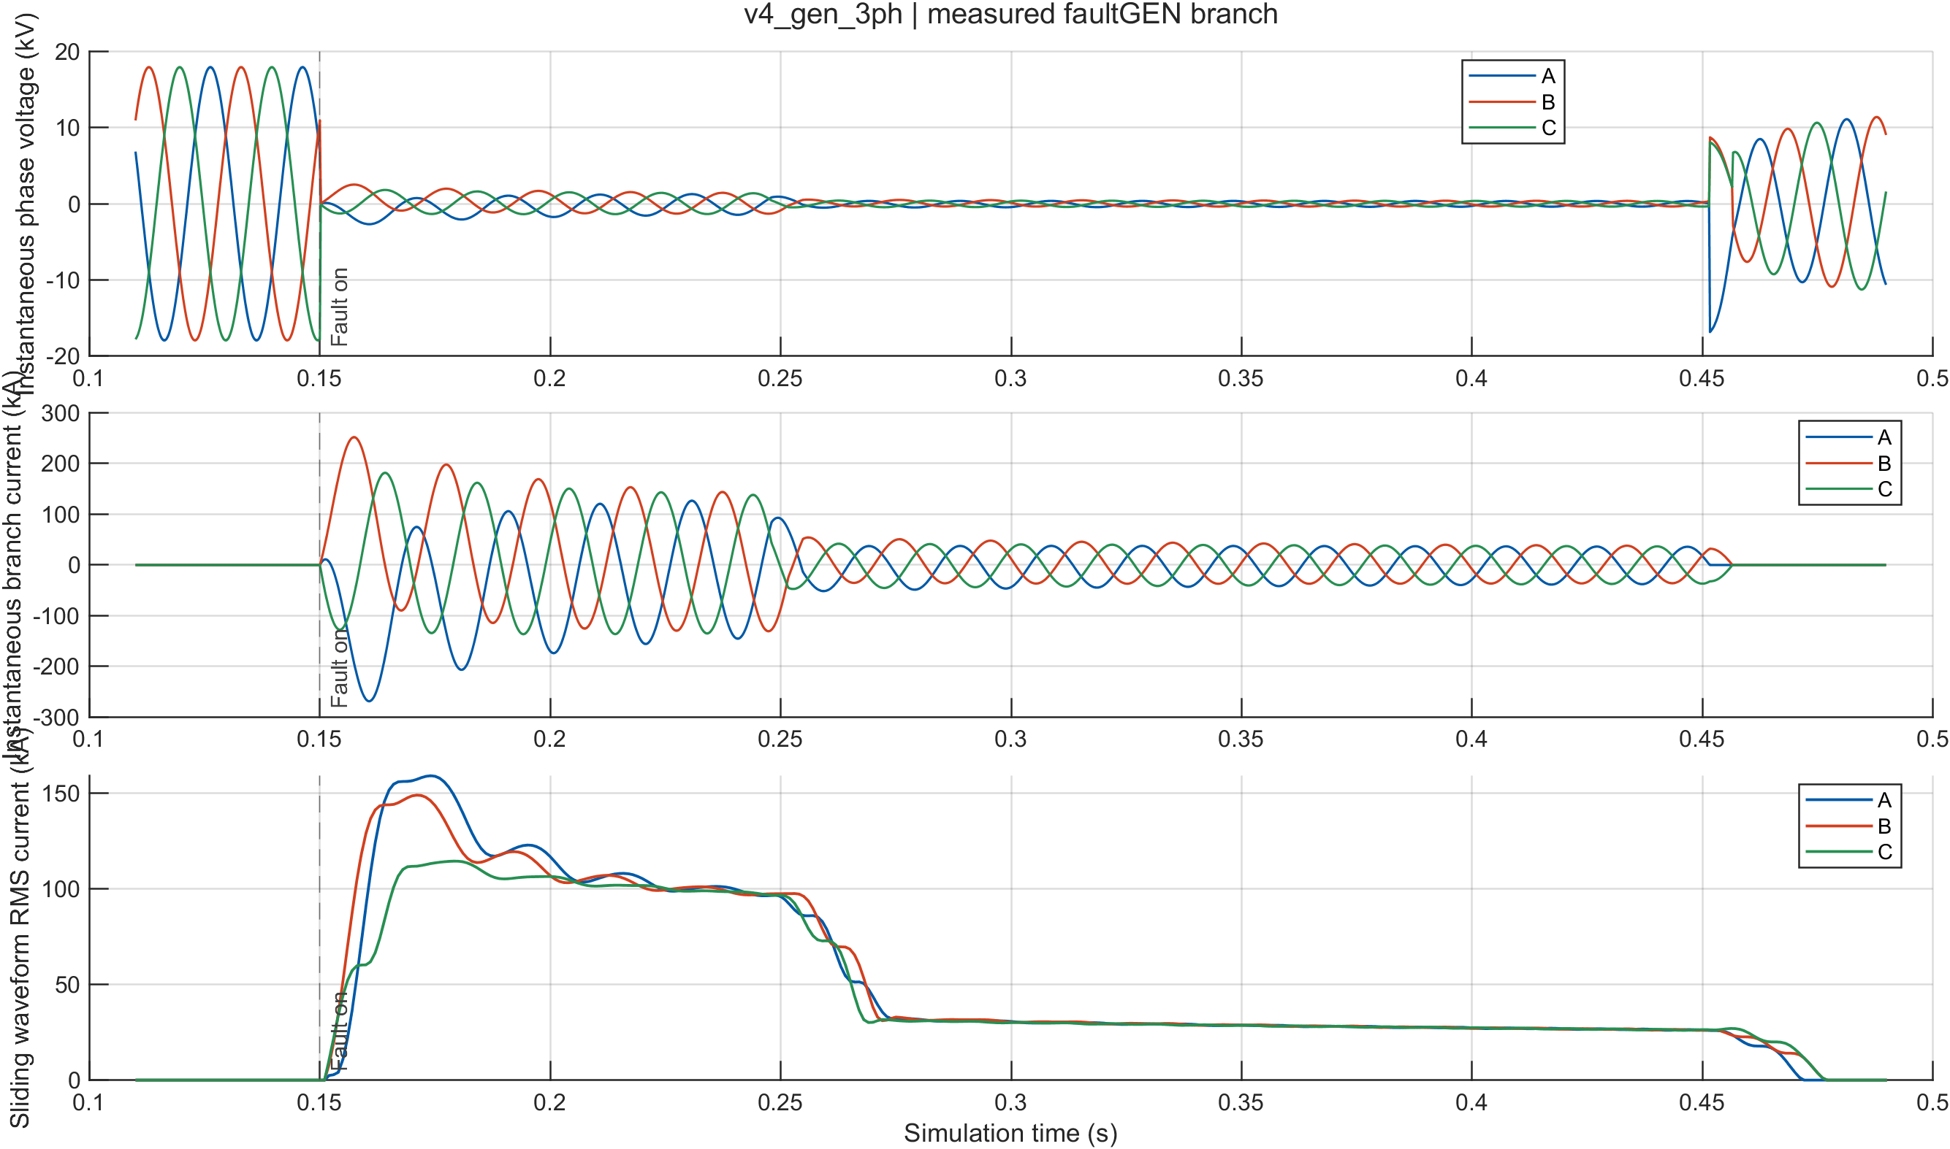
Figure 35 — Generator three-phase fault: current waveforms, with the large sub-transient peak expected at the machine terminals
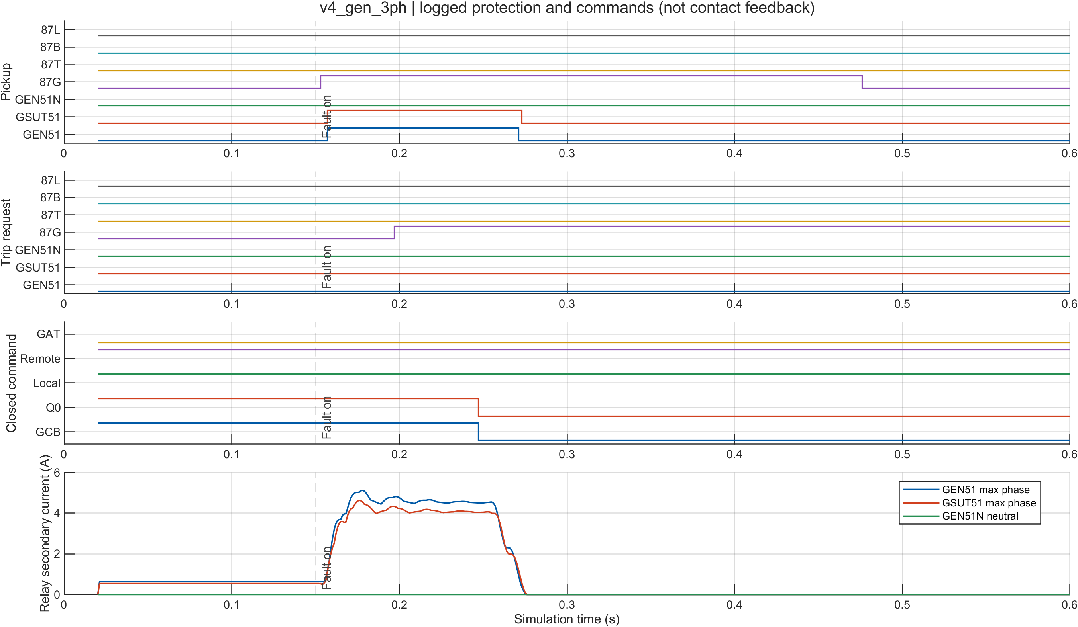
Figure 36 — Generator three-phase fault: protection and breakers. The unit elements trip and the GCB opens, which is the correct zone-G response.
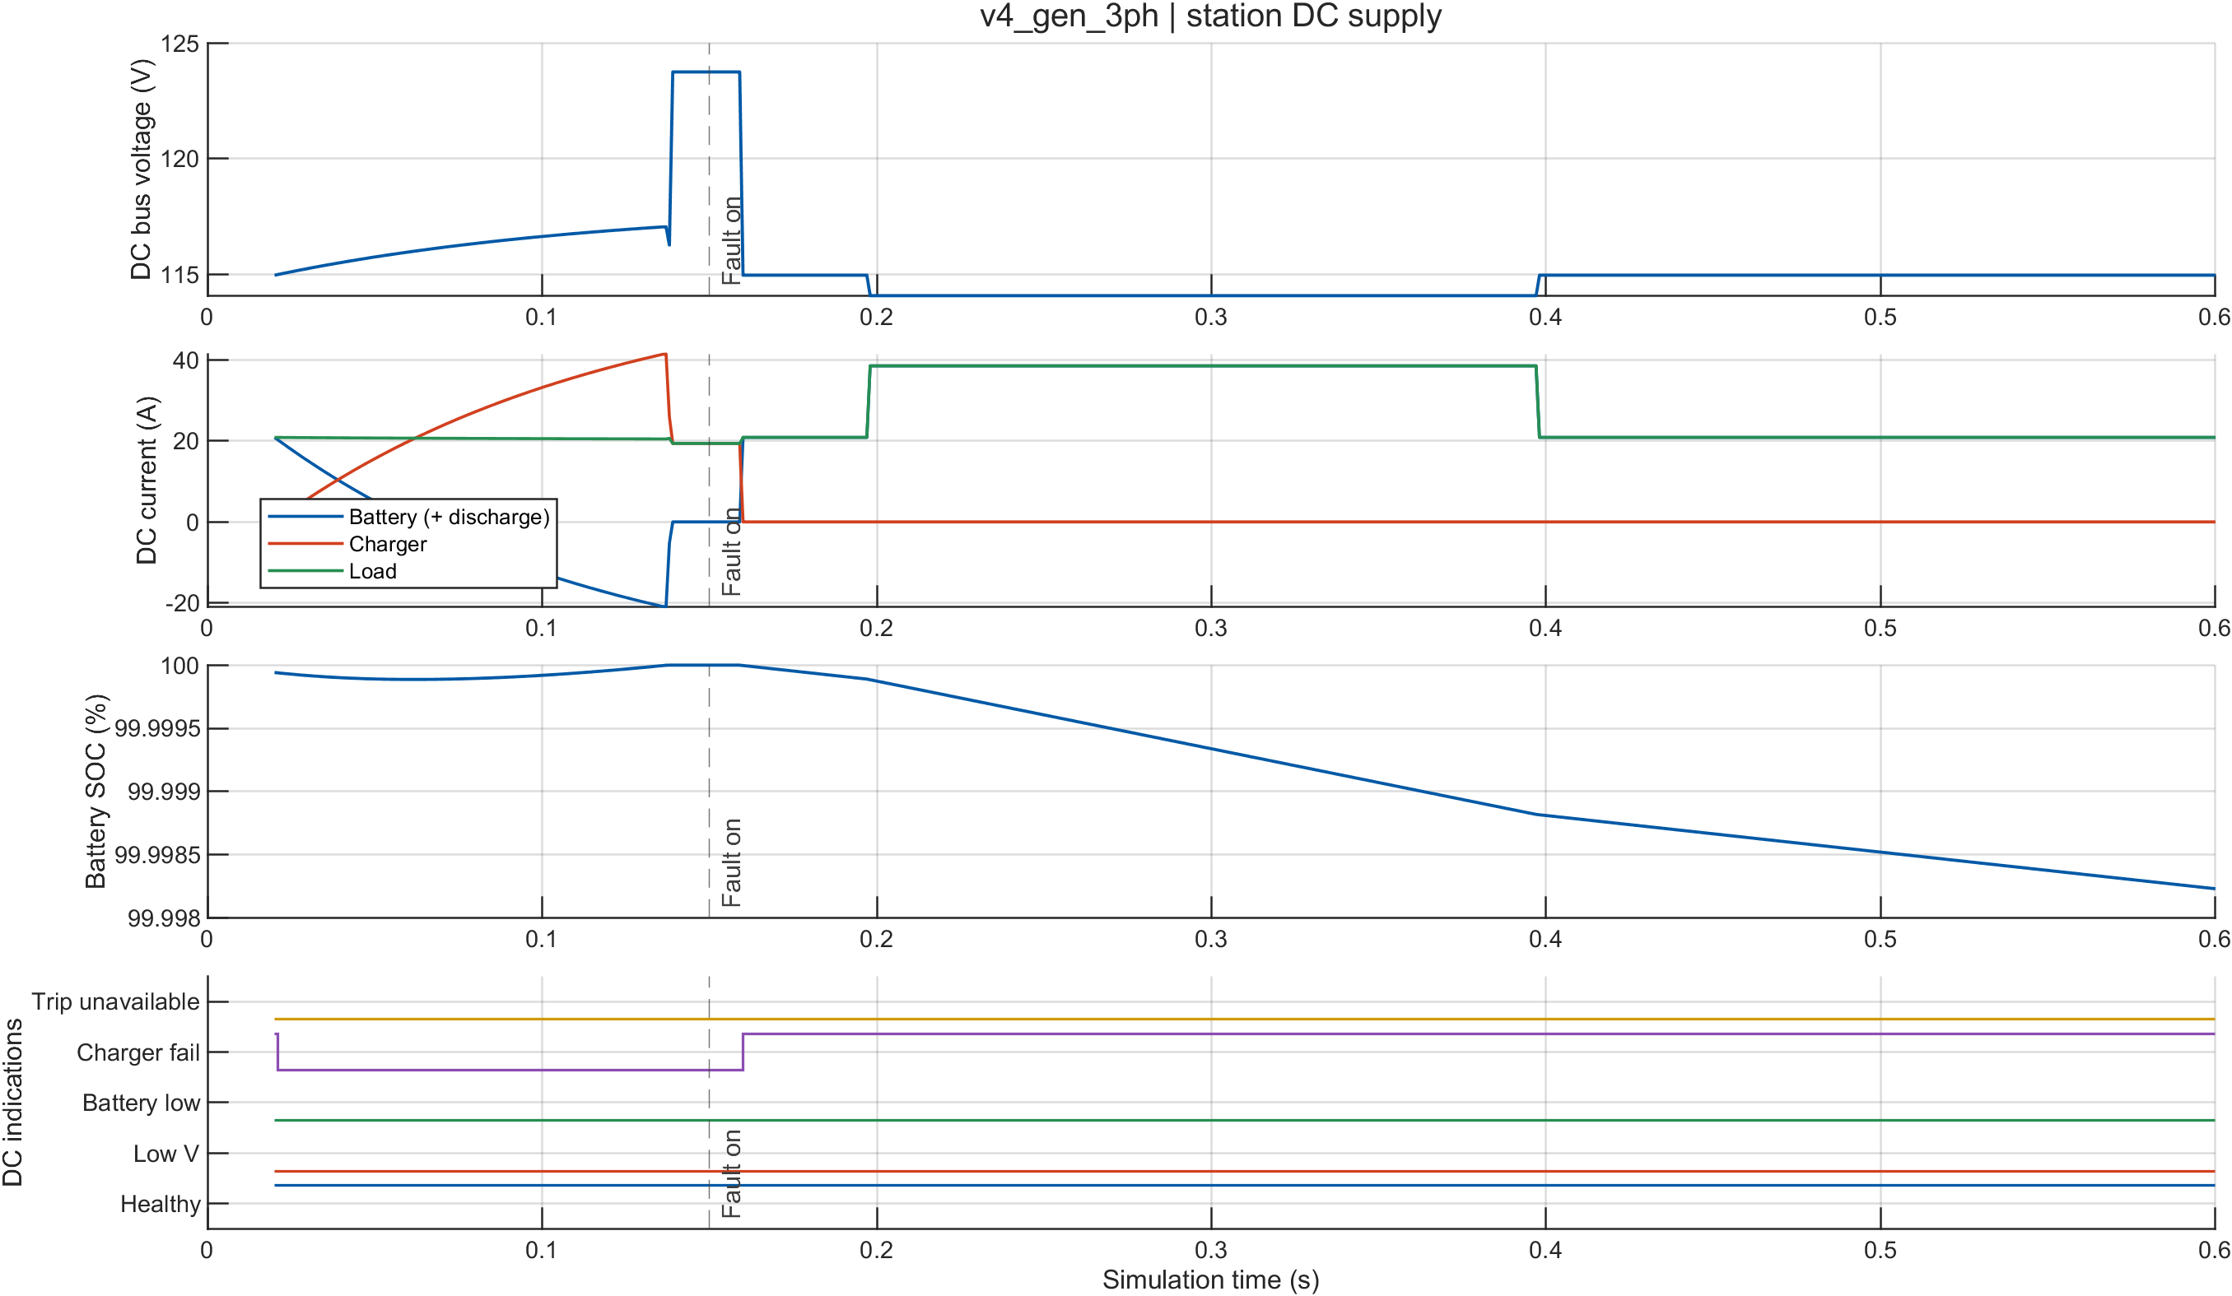
Figure 37 — Generator three-phase fault: station DC, confirming the trip path was powered throughout.
GSUT HV terminals (zone T / zone B boundary).
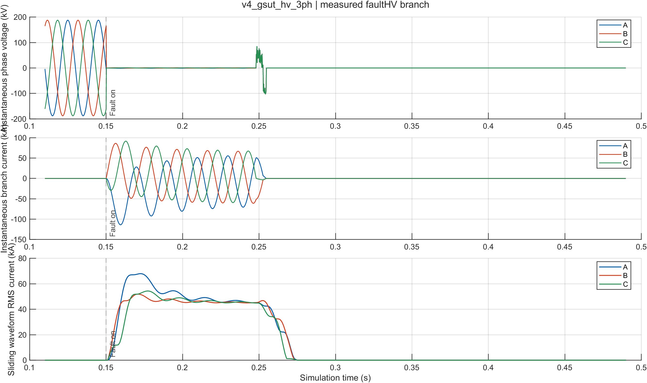
Figure 38 — GSUT HV three-phase fault: current waveforms at the 230 kV transformer terminals.
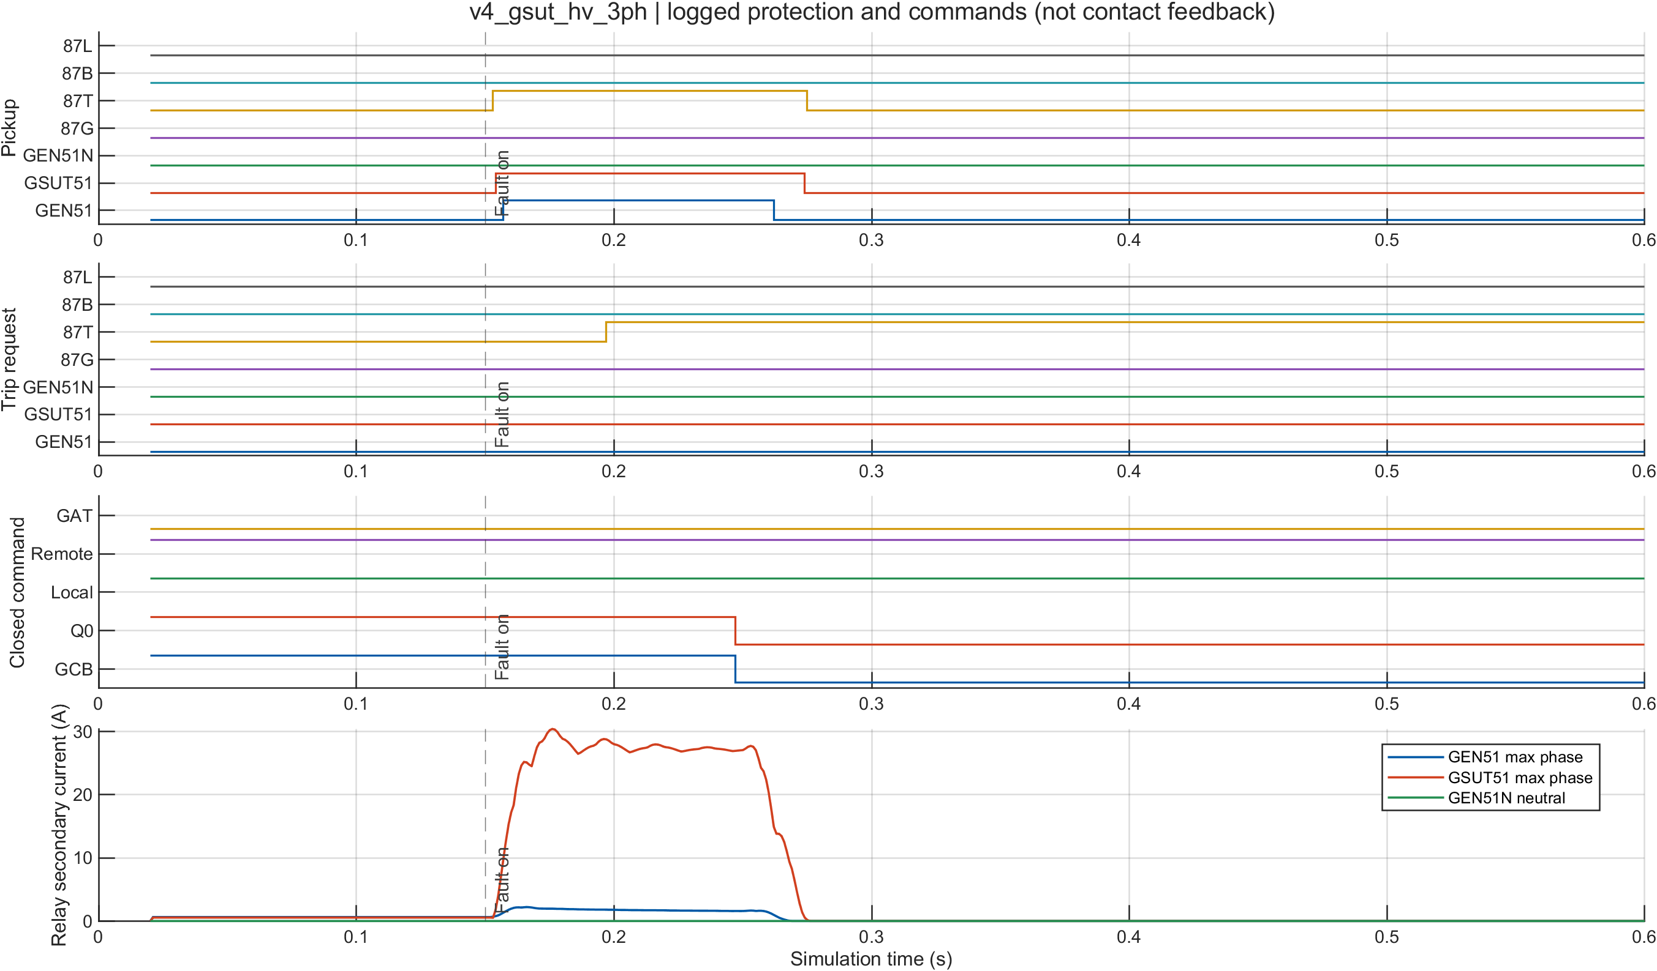
Figure 39 — GSUT HV three-phase fault: protection and breakers, showing which zone claims a fault on the transformer-to-busbar boundary.
230 kV export line (zone L).
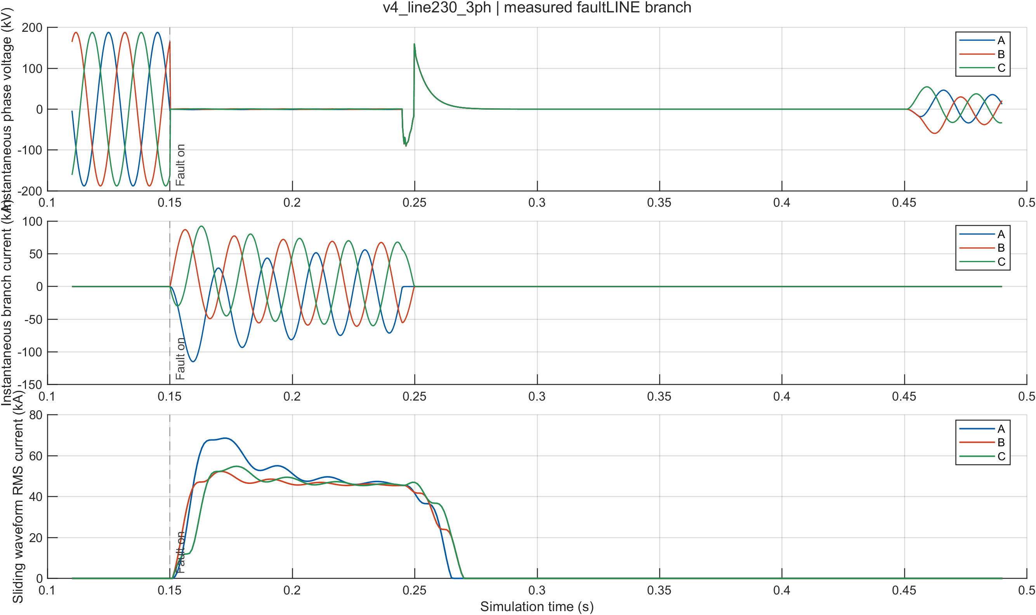
Figure 40 — 230 kV line three-phase fault: current waveforms on the export corridor.
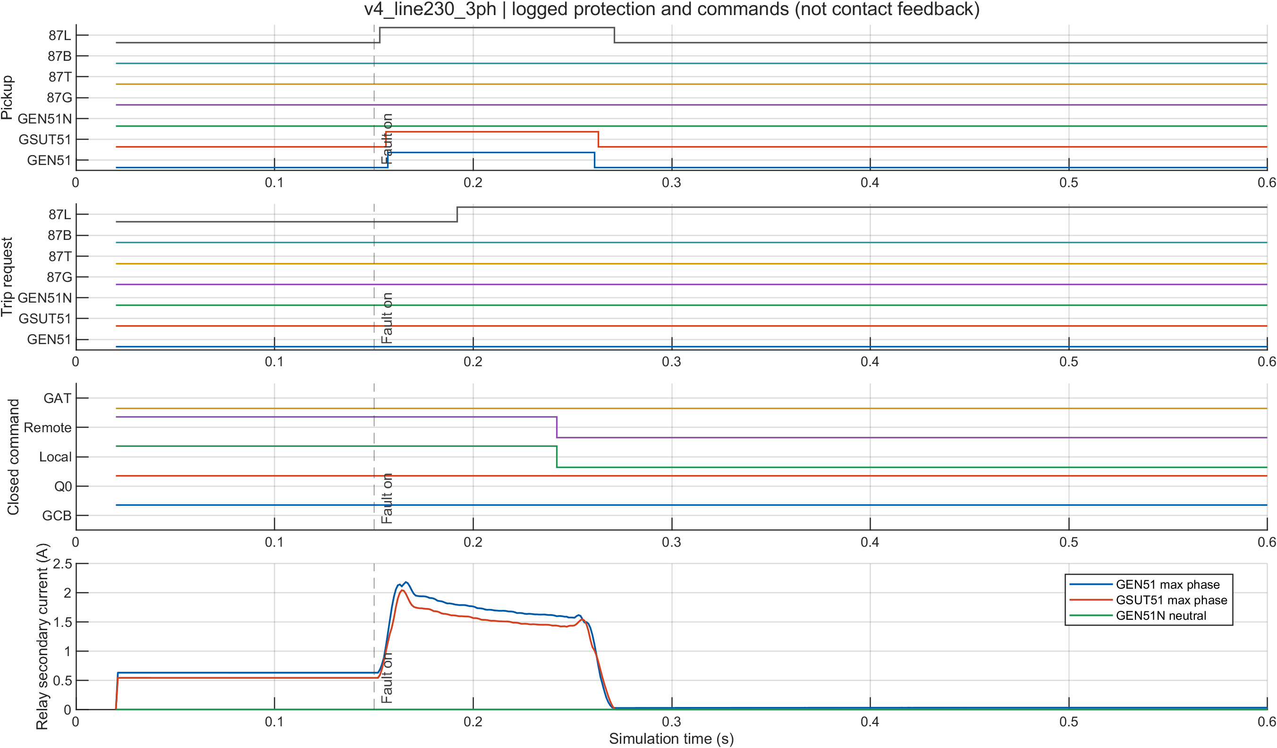
Figure 41 — 230 kV line three-phase fault: protection and breakers. The line differential trips both line breakers, local and remote, as the trip matrix requires.

Line Protection Case
The line protection case must be interpreted carefully because of a limitation in the available source documents.
- The detailed GIS drawing INEL-112070-00-ELC-DE-0026 was not included in the supplied documents.
- Therefore, there was no sourced line-differential protection scheme available for verification.
- The 87L relay used in this scenario was developed as part of the study itself.
- Its settings are classified as STUDY_PROXY, and the 5 ms communication delay is a study assumption.
- Consequently, this scenario demonstrates a proposed/engineered protection scheme, rather than verifying an existing protection scheme installed at the plant.
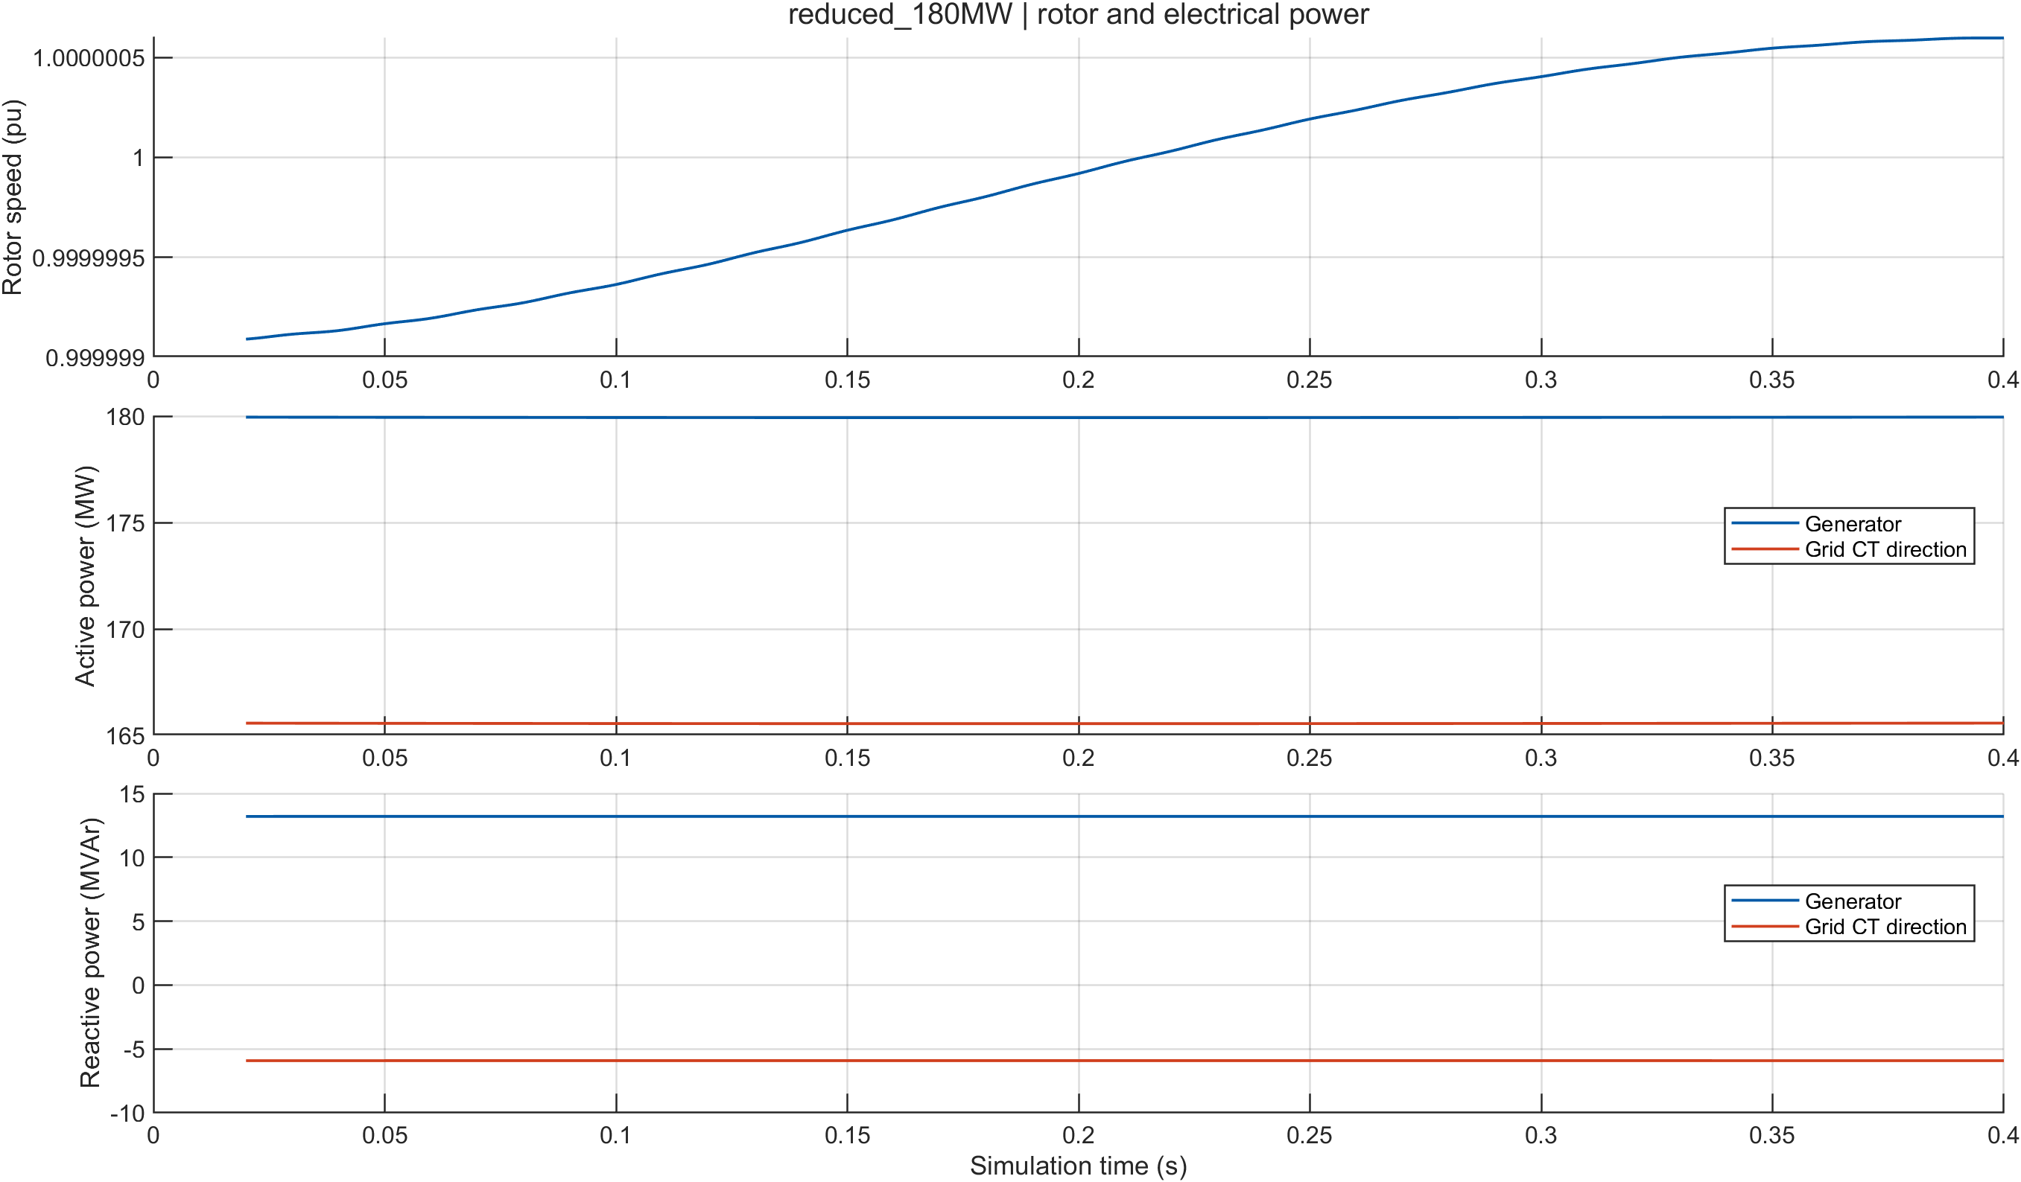
Figure 42 — Reduced-dispatch scenario at 180 MW: shaft speed and electrical power, confirming the model holds a stable operating point away from the 360 MW demonstration point.

4.1.10 Implementation Verification Summary
The implementation was verified using several independent checks to make sure the model, protection settings, scenarios, and output files are consistent.
Evidence | Result | What it establishes
operating_point_comparison.csv | 14/14 PASS | The dynamic model starts from the same operating point as the frozen Phase-3 load-flow case, using an independent solver.
scenario_validation.csv | 11/11 PASS | All tested scenarios behaved according to their defined conditions.
setting_consistency.csv | 7 rows | All seven protection elements use the exact frozen Phase-5 settings.
Saved simulation runs | 26 scenario directories | Each run contains 17 CSVs, 5 figures, and 1 MAT file, providing traceable simulation evidence.
run_phase5b_tests() | 528 passed / 0 failed | Confirms the protection coordination logic and integrity of the generated artifacts.

Important Scope of the Results
The 87 ms fault-clearing time should not be interpreted as a calculated stability margin. A roughly 100 ms critical-clearing-time benchmark may be found in external literature for large thermal units, but that is only provided as context. This project did not perform a transient-stability or critical-clearing-time calculation.
Similarly, the test results—including 528/0 and the other test suites—verify the software model, data consistency, calculations, and generated files. They do not verify the physical relays installed at Ashuganj.

5 Design Analysis and Evaluation
The design developed in Sections 3 and 4 is evaluated here based on its novelty, safety considerations, engineering findings, reliability, and practical limitations. Throughout this section, two important conventions are maintained. First, each parameter is identified according to its source, such as project data, secondary data, engineering assumptions, or derived values. Second, all relay settings, fault levels, and breaker-duty margins are treated as study values, not as commissioned plant settings.

5.1 Novelty
Fault analysis and protection coordination are established engineering techniques, so the project does not claim that these techniques themselves are new. The main contribution is the development of a traceable, reproducible, and provenance-labelled protection study for the Ashuganj South 450 MW unit using the available as-built and manufacturer documents.
A major difficulty was that the supplied documents did not contain complete commissioned relay settings. Therefore, it was necessary to clearly distinguish between information obtained directly from the documents and values introduced through engineering judgement.

5.1.1 Separation of Verified Data and Assumptions
The project separates its parameters into two broad groups.
Group A — Verified/documented information:
This includes generator sequence impedances, transformer impedances and vector groups, breaker ratings, documented CT ratios, and the identified transmission conductor. For example, the generator sequence impedances include X_d''_{sat}=0.2248 pu, X2=0.2242 pu, and X0 = 0.1280 pu. The GSUT impedance is 16.0% on a 515 MVA base with YNd1 vector group, while the UAT is 10.5% on 25 MVA with Dyn11.
Group B — Engineering assumptions and study proxies:
These were introduced where the source documents were incomplete. Examples include the CT accuracy limit factor of 20, the derived 32 kA screening boundary, grid equivalent parameters, magnetizing inductance, relay TMS values, and auxiliary interlock behavior. These values are explicitly identified as assumptions or study proxies rather than plant settings.

5.1.2 Parameter Status Classification
To make the study easier to audit, each numerical parameter is assigned a status. The main classes are:
VERIFIED / YES_DOCUMENTARY — directly available from a supplied document.
DERIVED — calculated from verified data using a stated formula.
ENGINEERING_ASSUMPTION — selected because no corresponding document value was available.
CONDITIONAL_ASSUMPTION — an assumption dependent on another uncertain interpretation.
ENGINEERING_STUDY_PROXY — a temporary stand-in used to allow the simulation to proceed.
ENGINEERING_STUDY_CRITERION — a criterion imposed by the study itself.
MANUFACTURER_DEFAULT_STUDY_VALUE — a relay-family default used where commissioned settings were unavailable.
USER_ASSERTED_PENDING_DOC — information provided by a team member but not yet supported by documentation.
SENSITIVITY — a value deliberately varied to examine its effect.
MISSING — information which is absent from the supplied documents and therefore left as unavailable rather than invented.
This approach makes the results easier to review. For example, the generator-breaker duty calculation is based on a verified 100 kA nameplate rating, whereas the stator-earth operating time depends on an assumed neutral CT ratio. The two are therefore reported with different levels of confidence.
The test system also protects this distinction. Where information is unavailable, important parameters remain ‘NaN’ instead of being filled with plausible but unsupported values.

5.1.3 Protection Functions and Study Gaps
The study identifies the information available and missing for the major protection functions.
For 51 and 87G generator protection, the supplied drawings identify the functions and provide the phase CT ratio, but commissioned pickup, slope, and delay settings are absent. The study therefore derives a 51 pickup of 17,170.8 A and uses a TMS of 0.10, while the 87G function uses dual restraint with k1=20% , k2=50%, a 0.20 pu pickup, and a 0.045 s study delay.
For 51N stator-earth protection, the source documents specify the neutral earthing arrangement but do not provide a neutral CT ratio. A 20/1 A neutral CT was therefore introduced as an engineering assumption, together with a 4 A pickup and TMS of 0.15. The resulting operating time is approximately 1.746 s.
For 87T transformer protection, the source drawings identify the protection function but do not provide all required compensation and inrush-restraint settings. The study therefore implements YNd1 compensation, zero-sequence removal, second-harmonic inrush blocking, a 0.30 pu pickup, 30%/60% slopes, and other parameters as study proxies.
For 87B and 50BF busbar protection, the source drawings identify the functions, but spill thresholds, zone overlaps, and trip routing are not documented. The study therefore implements a three-branch low-impedance differential scheme with a 320 A pickup, 30% slope, and 0.035 s delay, along with 50BF timers.
For 87L line protection, the required GIS drawing was missing from the supplied document set. Consequently, no sourced line-differential scheme was available. The study therefore implements a complete 87L scheme as an engineering study proxy, using a 320 A pickup and an effective 0.040 s operating time including a 5 ms communication allowance. This represents a designed study scheme rather than verification of an installed plant scheme.
The same approach was used for the 110 V DC trip system and the looped auxiliary interlock. The study models a 55-cell, 200 Ah battery, internal resistance of 0.05 Ω, a 20 kW charger, and a trip-permission condition of:
Trip allowed = Trip Request AND Vdc≥88.0V
These values are explicitly treated as engineering assumptions.

5.1.4 Methodological Contributions
Three methodological features are particularly important.
Frozen prefault operating point:
Fault calculations use the converged Phase-3 load-flow solution as the prefault condition. Instead of artificially increasing the driving voltage using an IEC 60909 c-factor, the study uses the actual frozen operating point. The prefault reproduction error is 3.3%, within the 10% acceptance limit.
Reproducibility:
The results are regenerated from the MATLAB data and scripts rather than manually edited. This allows the study to be repeated for changes such as a different operating point, transformer tap, or grid strength.

5.1.5 Important Engineering Findings
The study produced several findings beyond the basic fault calculations.
The generator neutral earthing resistor limits a single-phase earth fault to approximately 7.272 A. At this current, the existing 15,000/1 phase CTs produce only about 0.0005 A secondary current, making them ineffective for detecting the fault. The study's additional 20/1 neutral CT and 4 A pickup can detect it with a margin of approximately 1.8.
The looped auxiliary cases show apparent UAT loading of 109.60%. The study attributes this to approximately 5.9 MW of circulating power around the closed 6.6 kV loop. The calculated powers are consistent with the actual 14 MW auxiliary demand, indicating that the apparent overload is strongly influenced by circulating power rather than simply by the normal load.
The study also deliberately reports negative results. A generator double-line-to-ground fault produces 3.6378 A of 3I0, which is below the 4 A 51N pickup, so the element does not operate. Twelve of the 24 evaluable coordination pairs are classified as CONDITIONAL-PASS, F5 has no mapped primary protection zone, and Phase 6 still contains unresolved validation gates.

5.1.6 Scope of the Novelty
The project is a preliminary engineering simulation study, not a commissioning document. No hardware was constructed, no relay injection testing was performed, and no measurements were taken from the physical plant.
Therefore, the novelty lies in the methodology, traceability, reproducibility, and explicit treatment of missing information, rather than in claiming certification of the installed protection system.

5.2 Design Considerations (PO(c))
PO(c) requires engineering design to consider public health and safety together with cultural, societal, and environmental concerns. The protection design therefore considers not only electrical performance but also the consequences of faults and equipment operation.

5.2.1 Public Health and Safety

Limiting Fault Energy
The neutral earthing resistor is an important safety feature because it limits the current during a generator stator-earth fault.
The effective neutral resistance is:
Reff= 1750.77 ohm
The neutral transformer ratio is approximately 25.4, and the resulting zero-sequence impedance is approximately 5252.32 Ω. On the 22 kV base, this corresponds to approximately 1085.19 pu.
Consequently, the generator earth-fault current is limited to approximately:
If≈7.272 A
This is much smaller than the current associated with a high-energy short circuit. Limiting the earth-fault current therefore reduces the energy released during the fault and contributes to personnel and equipment safety.

Fault-Clearing Time
For faults involving high current, rapid protection operation is important because it reduces the duration for which personnel and equipment are exposed to the fault.
For the 230 kV bus three-phase fault, the modeled sequence is:
Fault inception: 0.150 s
Relay detection: 0.153 s
87B trip request: 0.187 s
Breaker contacts open: 0.237 s
This gives a total clearing time of approximately 87 ms, consisting mainly of about 35 ms relay operation time and 50 ms breaker mechanism time.
The 50 ms breaker delay is an engineering assumption in the model, while the 35 ms relay operating time is a study proxy. Since no plant-specific critical-clearing-time requirement was available, the study reports the modeled protection clearing time rather than claiming a stability margin.

Interrupting Capability
The study also checks whether the devices identified as circuit breakers can handle the calculated fault currents.
A distinction is made between circuit breakers and disconnectors. Q0 and 52G/10BAC10 are treated as circuit breakers with interrupting-duty ratings. Q1, Q2, and Q9 are disconnectors and are therefore not included as fault-interrupting devices.
The duty screening produced 80 duty rows plus one informational note, with zero exceedances. However, the verdicts remain CONDITIONAL-PASS because the identity associated with the Q0 label is not completely resolved across the supplied drawings.
Breaker | Rating | Worst calculated current | Duty ratio | Margin
52G / GCB 10BAC10 | 100 kA rms | 55.05 kA | 0.5505 | 44.95%
Q0 / GIS 8DN9 | 50 kA rms, 3 s | 6.897 kA | 0.1379 | 86.21%
The peak withstand capability was also screened separately. The GCB peak rating is 274 kA, while the GIS peak rating is 125–135 kA. The calculated peak factors are κ = 1.9511 at F1 and κ = 1.8159 at F3.

5.2.2 Overall Design Evaluation
The design analysis demonstrates that the study considers both technical protection performance and practical safety requirements. The use of high-resistance grounding limits generator earth-fault energy, the modeled protection scheme provides a measurable fault-clearing sequence, and breaker-duty screening checks whether the calculated fault currents remain within the available interrupting capabilities.
At the same time, the study clearly identifies where the available documentation is incomplete. Therefore, results based on engineering assumptions or study proxies should be treated differently from results based directly on verified manufacturer or plant data.
The overall contribution is consequently a traceable and reproducible preliminary protection study, with its assumptions, limitations, and unresolved documentation gaps explicitly identified rather than hidden.

5.2.2 Environmental Considerations
The main environmental concerns identified in the study are SF₆ gas in the 230 kV GIS and mineral oil in the transformers. Both require specific measures to reduce environmental risk.

SF₆ Gas
SF₆ is a very strong greenhouse gas, so preventing leakage is important. The study considers:
- Sealed GIS compartments to reduce possible leakage points.
- Gas-density monitoring to detect leaks early.
- Recovery and reclamation of SF₆ during maintenance instead of venting it.
- Recording gas entering and leaving each compartment to track the gas inventory.
An annual leakage target was not specified because it was not available in the source documents.
GIS also has an environmental trade-off. Although it uses SF₆, it requires much less land than an equivalent air-insulated switchyard and is better suited to the local dusty and humid environment. Therefore, the study treats GIS as a practical choice while recognizing the environmental responsibility associated with SF₆.

Transformer Oil
The GSUT contains approximately 60,000 litres of mineral oil. An oil leak could contaminate soil and groundwater, while an oil fire could create an additional safety and environmental hazard.
The design therefore considers
- Bunded containment around oil-filled transformers.
- Oil–water separation for spilled oil and firefighting water.
- Buchholz and sudden-pressure protection for early detection of internal transformer faults
- Adequate fire separation between transformers.
Transformer differential protection also has an environmental role. Rapidly clearing an internal fault helps prevent severe oil heating, tank damage, fire, and release of oil. The study uses an 87T pickup of 0.30 pu (387.84 A) with 30%/60% slopes and a 0.045 s study operating-time proxy.

Avoiding Unnecessary Generator Trips
Correct protection coordination can also reduce indirect environmental impact. An unnecessary trip of the 360 MW unit would require replacement power from other generators, potentially increasing fuel use and emissions.
The study found 0 FAIL coordination results, with all evaluable margins exceeding four times the study's 0.30 s coordination interval. However, no specific CO₂ reduction value is claimed because the required grid dispatch and emissions data were not available.

Environmental Benefit of Simulation
The entire investigation was performed computationally:
- 464 fault cases
- 1,793 sensitivity cases
- No faults applied to real equipment
- No live-plant testing
- No fuel or equipment life consumed during testing
This allowed the protection scheme to be investigated without creating physical electrical or environmental hazards.

5.2.3 Cultural and Societal Considerations
The Ashuganj plant is an important part of Bangladesh's power system, and the unit studied has a capacity of 360 MW. Losing this amount of generation can have consequences beyond the plant itself, particularly during periods when supply margins are tight.
Power interruptions can affect different groups differently. Industries and larger organizations may have backup generation, while households, small businesses, rural clinics, and irrigation systems may have fewer alternatives. Therefore, reliable protection helps reduce the wider social effects of unnecessary generation outages.

Transformer Cooling and Reliability
The study also highlights the importance of transformer cooling during hot weather.
For the GSUT:
ONAN rating: 355 MVA
ODAF rating: 515 MVA
Loading can appear as 105.87% relative to ONAN.
The same loading is only 72.98% relative to ODAF.
This means forced cooling is important for maintaining the transformer's rated operating capability during high-temperature conditions. If the cooling system is unavailable during peak demand, the available generation may have to be reduced.

Documentation and Local Engineering Capability
The study is also designed to be understandable and useful to plant engineers. Results are linked to specific files, while parameter-status labels distinguish documented plant information from study assumptions.
When information was missing—for example, the interlock schedule for paralleling the UAT and GAT—the study did not present an assumption as a plant fact. Instead, it identified the missing information, modeled a reasonable study version, clearly labelled it, and recommended obtaining the actual plant documentation.

5.3 Investigations (PO(d))
The investigation satisfies PO(d) through four main activities:
- Design of experiments — the study follows a structured six-phase process.
- Data collection — inputs are traced to documents, datasets, or clearly labelled assumptions.
- Analysis and interpretation — load flow, fault analysis, transformer loading, protection coordination, and breaker duty are evaluated.
- Synthesis and conclusions — the results are interpreted together with their uncertainties and limitations.
The most important limitation is that this is a preliminary simulation study. There were no field measurements, relay injection tests, or physical fault tests. Therefore, a “verified” input means that the input source is verified, not that the corresponding physical plant result has been verified.

5.3.1 Design of Experiment
The investigation follows a six-phase workflow. Each phase produces an output that is frozen into a file, and the next phase uses that frozen output rather than independently recalculating it. This prevents different stages of the study from silently using different operating conditions.
Phase | Main Purpose | Main Output
1. Data audit | Reconcile source documents and classify parameters | Parameter registry
2. Balanced load flow | Determine normal operating conditions | Voltages, flows, losses, loading
3. Load flow + line sensitivity | Include the 0.7 km line and sensitivity cases | Locked operating cases
4. Fault study | Analyze different fault types and locations | Fault currents and sequence quantities
5. Protection study | Apply relay settings and check coordination/duty | Relay settings, coordination, breaker duty
6. Dynamic simulation | Simulate the complete protection trip process | Trip timelines and DC behavior
Each phase has its own validation gate before its output is accepted.
A key feature is that Phase 6 uses the frozen Phase-5 relay settings, rather than manually entering settings into the dynamic model. This makes it possible to demonstrate that changing a protection setting actually changes the simulated trip time. For example, changing the 87B delay from 0.035 s to 0.070 s moves the trip request from 0.187 s to 0.222 s.

Load-Flow Design
The load flow uses:
BGRID230: Slack bus, 1.0 pu and 0°
B22: PV generator bus
B6_6: PQ auxiliary bus
Base: 100 MVA, 230 kV high-voltage zone
Base impedance: 529 Ω
The B22 voltage of 1.000 pu is a specified input rather than a solved value. It is recorded as an engineering assumption and is an important reference for the per-unit voltage results.
Three additional checks were applied to the load-flow results:
Real-power balance < 0.001 MW
Reactive-power balance < 0.001 MVAr
Worst-bus KCL error < 0.05 MVA
The solver status must also explicitly equal 1. Failed cases are stored as ‘NaN’ rather than zero, preventing an unsuccessful calculation from being mistaken for a physical result.
A capacity guard prevents normal simulations above 360 MW unless a case is explicitly identified as historical and approved. This prevents the theoretical 389.30 MW machine rating from being accidentally presented as the plant's normal maximum continuous dispatch.

Fault-Study Design
The fault study uses a 5 × 4 matrix:
F1: Generator terminals
F2: GSUT low-voltage terminals
F3: 230 kV GIS busbars
F4: 0.7 km transmission line
F5: Remote grid boundary
Each location is tested for:
Three-phase fault (LLL)
Line-to-ground fault (LG)
Line-to-line fault (LL)
Double-line-to-ground fault (LLG)
The cases are also evaluated with GAT out and GAT in, because these represent different network configurations. Base faults are bolted faults with Zf=0Z_f=0, and the study uses the frozen 1.0 pu operating voltage rather than applying a c-factor.
All load-flow cases converged in exactly 2 Newton–Raphson iterations. The fault calculations use a direct LU solution because the modeled fault networks are linear.

Sensitivity Analysis
Sensitivity analysis was performed because a single result based on one assumed parameter set is not enough to understand the robustness of the design.
The study varied factors such as
Line length
Line resistance and reactance
Grid strength
Grid X/R ratio
Transformer magnetizing inductance
Generator neutral CT ratio
Neutral pickup
NER resistance
GSUT CT ratio
CT saturation
Breaker ratings
A total of 1,793 protection sensitivity rows were generated. The largest sensitivity groups focused on the earth-fault path, because that part of the model contains some of the most important study assumptions.

Validation Approach
Since no field measurements were available, validation focused on internal consistency and independent calculations.
The study used:
Two independent solution methods for the same fault problem.
External KCL and power-balance checks.
Independent hand calculations.
Regression tests that ensure missing parameters remain ‘NaN’.
Tests designed to catch unit, base-conversion, and frequency errors.
The nodal and Thevenin calculations agree to approximately 3×10^-14 ,while the load-flow power balance closes to approximately 5.68×10−14 MW.
The key limitation remains:
A verified input is not the same thing as a verified physical result.

5.3.2 Data Collection
The study uses several main sources, including the master single-line diagram, electrical drawings, OEM generator and transformer data sheets, the consolidated master-data file, and the protection-function drawings.
One important documentation gap is the missing INEL-112070-00-ELC-DE-0026 GIS drawing. Because it was not supplied, no line-differential scheme could be verified from the source documents. The 87L scheme in the study is therefore an engineering study addition, not a verified installed scheme.

Major Equipment Data
The main generator is a 458 MVA, 22 kV Siemens SGen5-2000H machine with a saturated subtransient reactance of 0.2248 pu, negative-sequence reactance of 0.2242 pu, and zero-sequence reactance of 0.1280 pu.
The GSUT has three cooling stages:
355 MVA ONAN
460 MVA ODAN
515 MVA ODAF
It has a 230/22 kV ratio, YNd1 vector group, and 16% impedance on a 515 MVA base.
The switching equipment includes
10BAC10 generator circuit breaker: 100 kA rms breaking capacity.
8DN9 GIS: 50 kA rms for 3 s.
The individual GIS bays are rated 2,000 A, while the busbar and bus coupler are rated 3,150 A.

Cooling-Stage Interpretation
Transformer loading must always be considered against the correct cooling stage.
For the GSUT, the same apparent power can produce very different percentages depending on whether it is compared with the 355 MVA ONAN rating or the 515 MVA ODAF rating. Therefore, every loading percentage in the study identifies the cooling stage used.

CT Data and Limitations
The study includes documented and assumed CT ratios. The generator phase CT is 15,000/1, while the generator neutral CT of 20/1 is an engineering assumption.
A major limitation is that CT knee-point data is unavailable. Therefore, the CT saturation analysis uses a nominal 5P20 factor of 20 as a screening assumption rather than claiming actual CT saturation performance.

VT Data
The modeled parameter set contains the generator VT, but no 230 kV VT data is actually included in the implemented model. Although the manual describes a 230 kV VT, none of the implemented protection functions depends on a 230 kV voltage input, so this discrepancy does not affect the modeled current-based protection functions.

Parameter Classification
All study parameters are assigned one of ten status classes, allowing the reader to distinguish documented values from assumptions, derived values, sensitivities, and missing information. The Phase-5 study contains 188 finite numerical parameters classified using this system.

Important Assumptions
Five major load-flow assumptions were identified:
A1: Grid resistance R=0R=0, approved
A2: Auxiliary load split, approved
A3: 230 kV bus coupler closed, approved.
A4: Magnetizing inductance Lm=106L_m=10^6 pu, not approved
A5: Generator voltage fixed at 1.00 pu, not approved.
A5 is particularly important because it is the reference used for the per-unit voltage results. It is not simply an error range that can be corrected by measurement; changing it changes the reference for the entire voltage representation.

Document Conflicts
Several documentation conflicts were identified rather than silently resolved. These included:
- GSUT CT ratio: 1500/1 vs 1600/1
- GSUT impedance/loss values from different sources
- Different grid-equivalent values
- Generator-earthing resistance interpretation
- Regional transmission-line identity
- Q0 breaker identification
Another important discrepancy is that the auxiliary transformers are rated 6.9 kV, while the plant medium-voltage bus is modeled as 6.6 kV. This difference can significantly affect impedance calculations, so it is explicitly retained as conflict C13 rather than ignored.

Missing OEM Information
Important relay-setting pages are missing from the supplied Siemens documentation, including sections for:
- 7UM622
- 7UT6331
- 7SS523
- 7SD5221
The physical relays and their functions are documented, but their actual commissioned settings are not. Therefore, the numerical relay settings used in the study are treated as study settings, not verified installed settings.

Result Files and Data Integrity
The study generated separate result archives for load flow, fault analysis, and protection analysis. The Phase-4 fault archive contains 464 fault rows, while the Phase-5 archive contains the coordination, relay, breaker-duty, validation, and sensitivity results.
Three generations of load-flow results exist, and they must not be mixed because they use different network topologies. The Generation 3 LF360_GAT_OUT case is the primary reported result.
Three data-integrity warnings were also identified:
A stale load-flow report disagrees slightly with the newer CSV results, so the CSV values are treated as authoritative.
The transformer_loading.png subtitle contains slightly outdated percentages compared with the CSV.
The line_loading.png uses an outdated 3,150 A bay limit; the corrected individual bay rating is 2,000 A.
These discrepancies were documented instead of silently changing the source files.

5.3.3 Results and Analysis – Load Flow
The main case, LF360_GAT_OUT, represents 360 MW generation with the GAT bay out of service. The system operated within its capability limits, with the main buses remaining close to their rated voltages. The generator supplied 361.07 MVA at 0.997 lagging power factor, while the plant exported 345.21 MW to the grid. Total real power loss was only 0.793 MW, and the load flow converged in 2 Newton–Raphson iterations with an OK verdict. When the GAT bay was closed, the 6.6 kV auxiliary-bus voltage increased from 6.606 kV to 6.736 kV, while total loss increased slightly to 0.805 MW. Overall, both operating conditions remained within the defined limits.

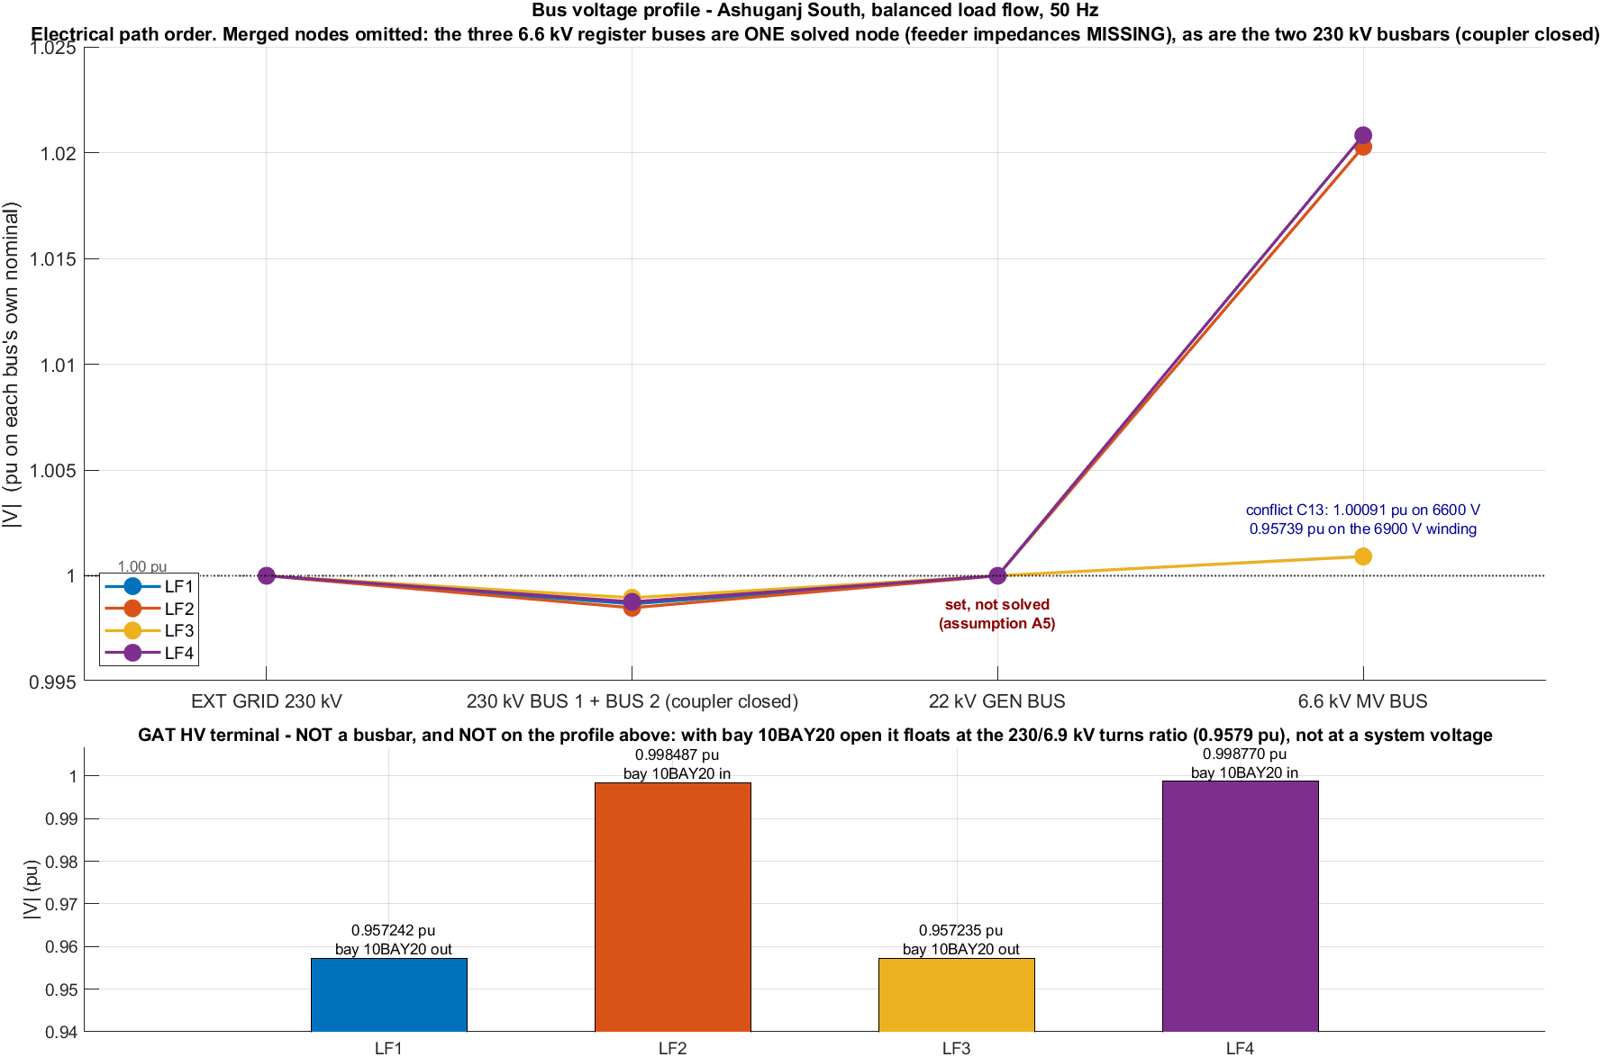
Figure 43 — Plant busbar voltage profile, Generation 1 (LF1–LF4). Top panel: voltage in per unit along the electrical path BGRID230 → B230_1 → B22 → B6_6, one line per case, with a reference line at 1.0 pu. The annotation at B22 reads "set, not solved (assumption A5)"; the annotation at B6_6 flags the dual-base conflict C13. Bottom panel: GAT_HV shown separately as a bar chart, because with the GAT bay open it sits at the transformer turns ratio (0.9572 pu) rather than at a system voltage; closing the bay moves it to 0.9985 pu, which is 0.51 V below the busbar across 0.01 Ω of contact resistance. No pass/fail band is drawn, because none exists in the project document set.
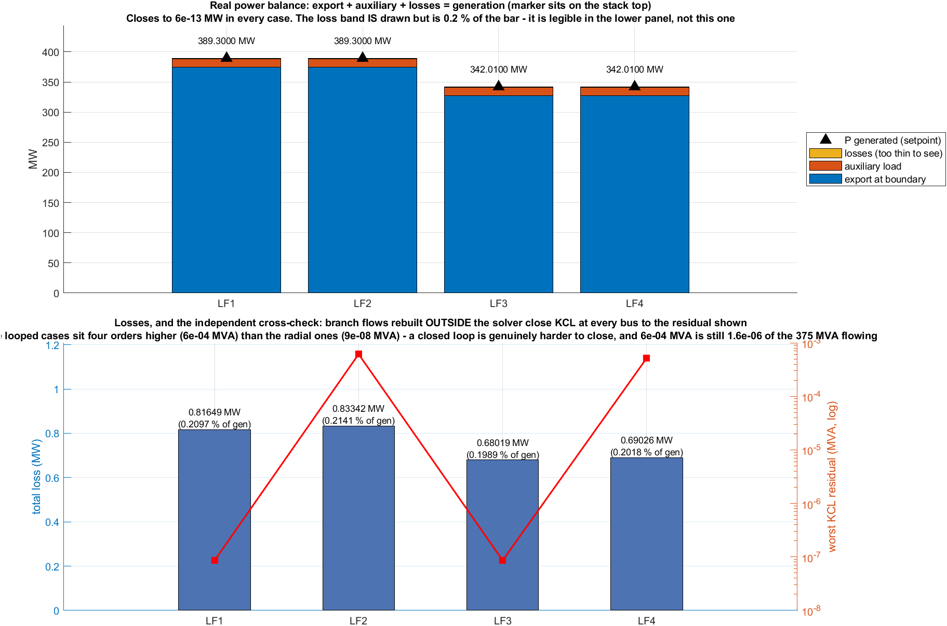
Figure 44 — Power balance and solution quality, Generation 1 (LF1–LF4). Top panel: stacked bars of export, auxiliary and loss, with a black triangle marking the generated power; the loss band is drawn but is only about 0.2 % of the bar. Bottom panel: loss bars on the left axis against a log-scale red line of the worst-bus KCL error on the right axis, showing the looped cases sitting four orders of magnitude higher (about 6 × 10⁻⁴ MVA) than the radial ones (about 9 × 10⁻⁸ MVA). Both remain far below the 0.05 MVA acceptance gate.
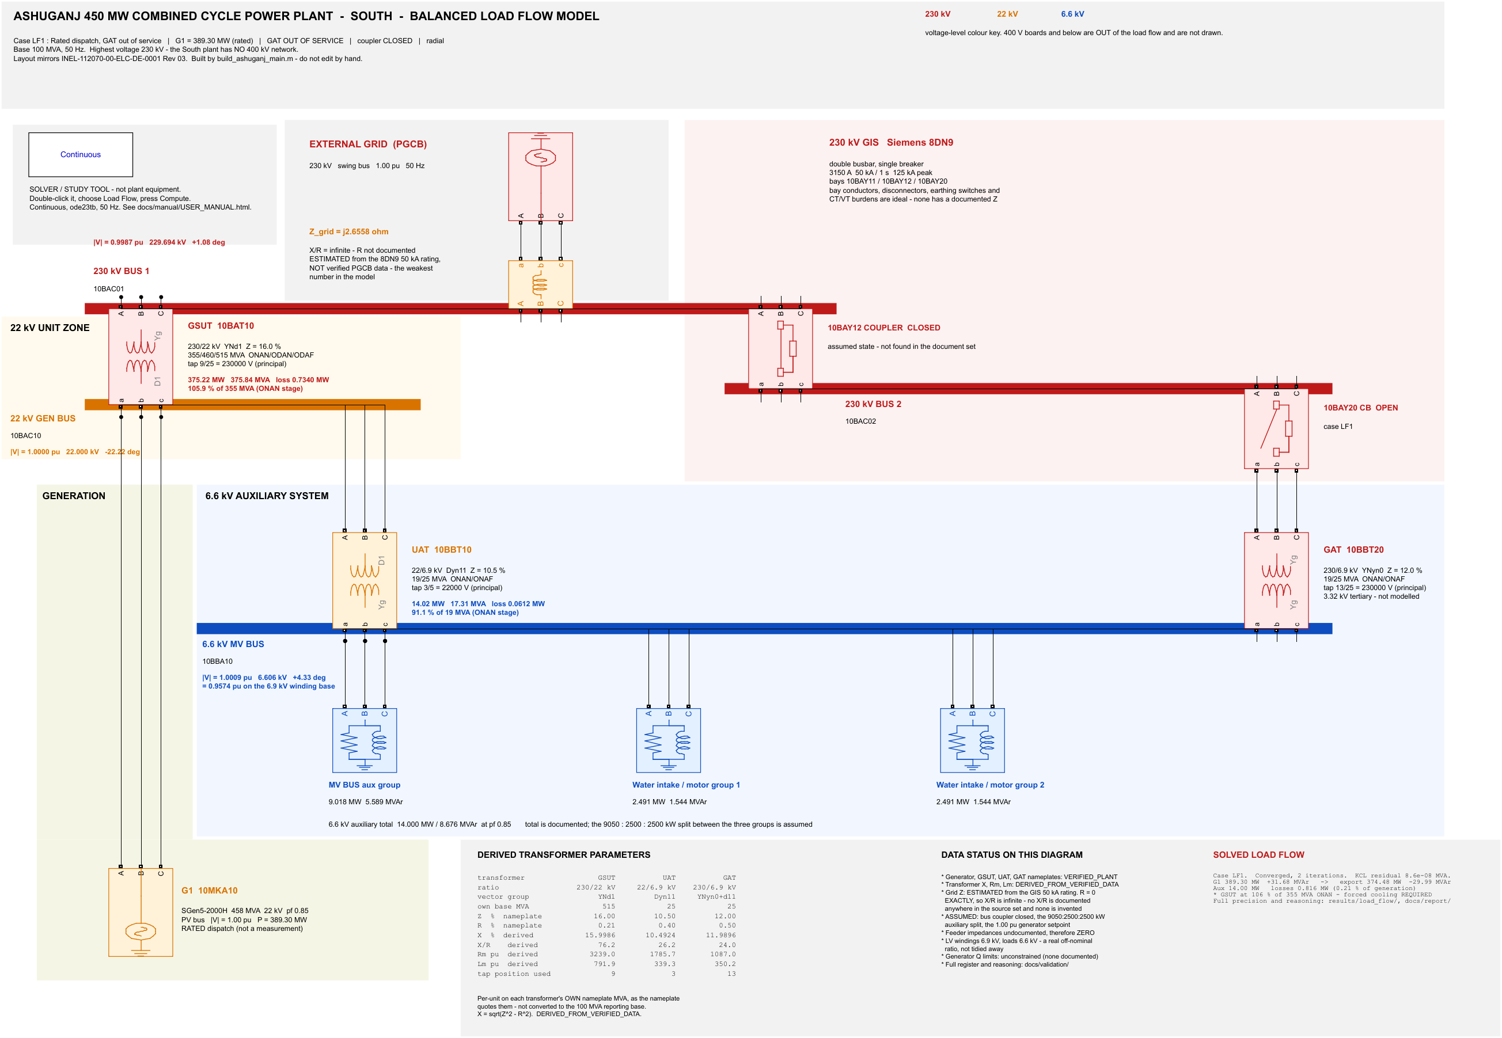
Figure 45 — Annotated load-flow one-line, case LF1 — Generation 1, 389.30 MW dispatch, GAT bay out, radial topology.
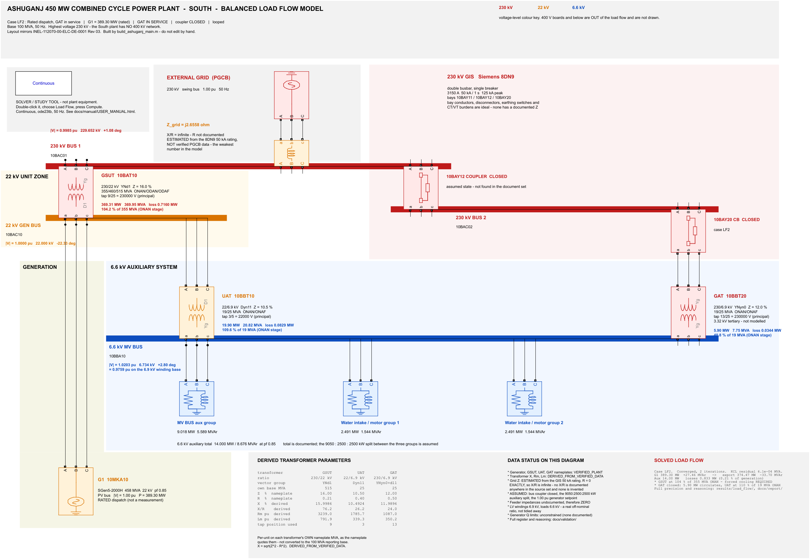
Figure 46 — Annotated load-flow one-line, case LF2 — Generation 1, 389.30 MW dispatch, GAT bay closed, looped topology. This is the case in which the circulating loop appears.
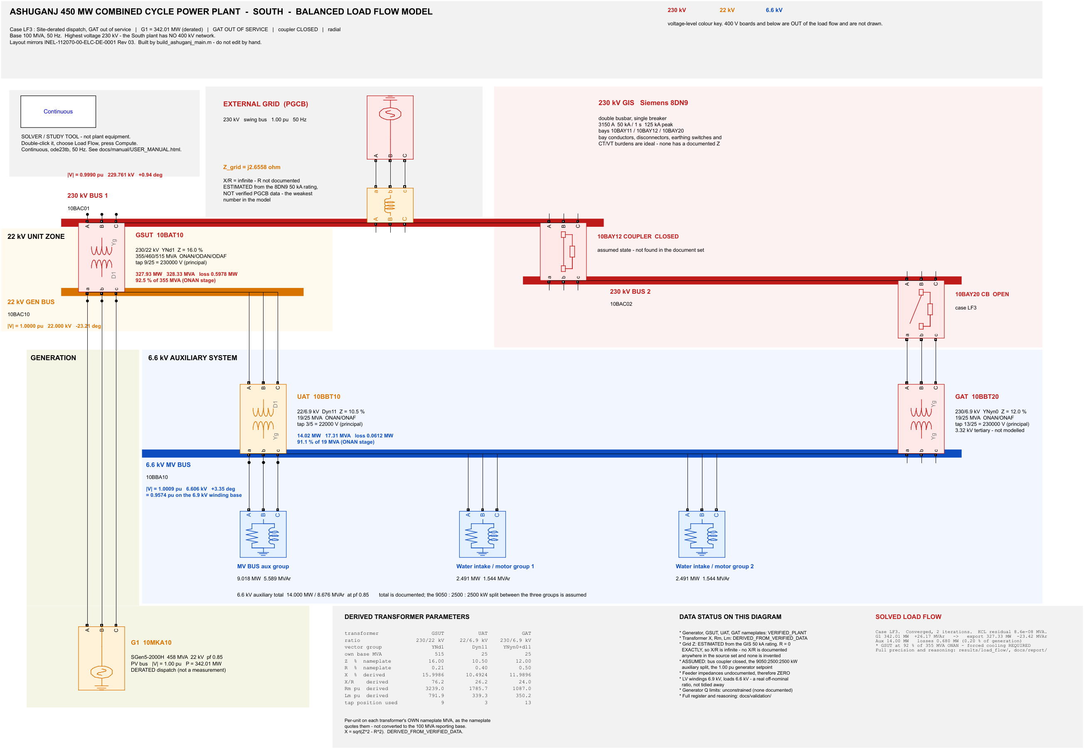
Figure 47 — Annotated load-flow one-line, case LF3 — Generation 1, 342.01 MW dispatch (the BPDB operational record), GAT bay out.
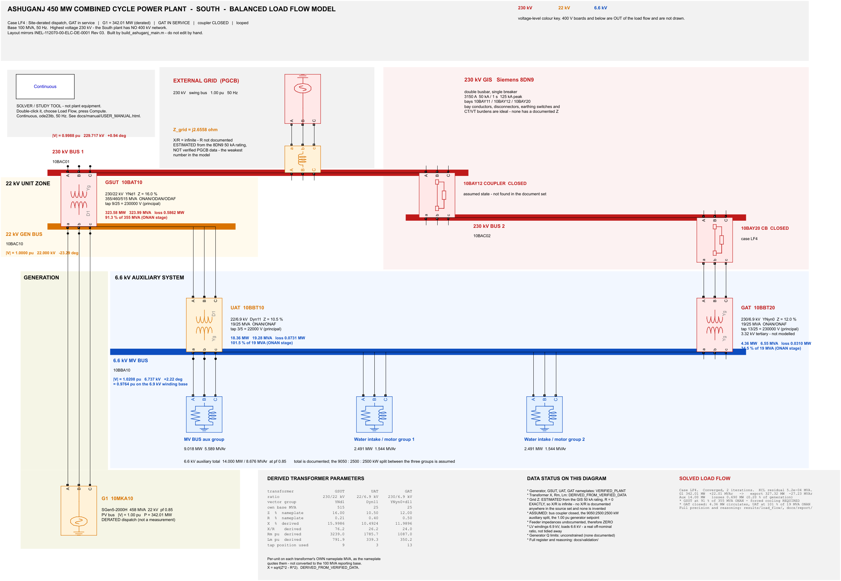
Figure 48 — Annotated load-flow one-line, case LF4 — Generation 1, 342.01 MW dispatch, GAT bay closed.
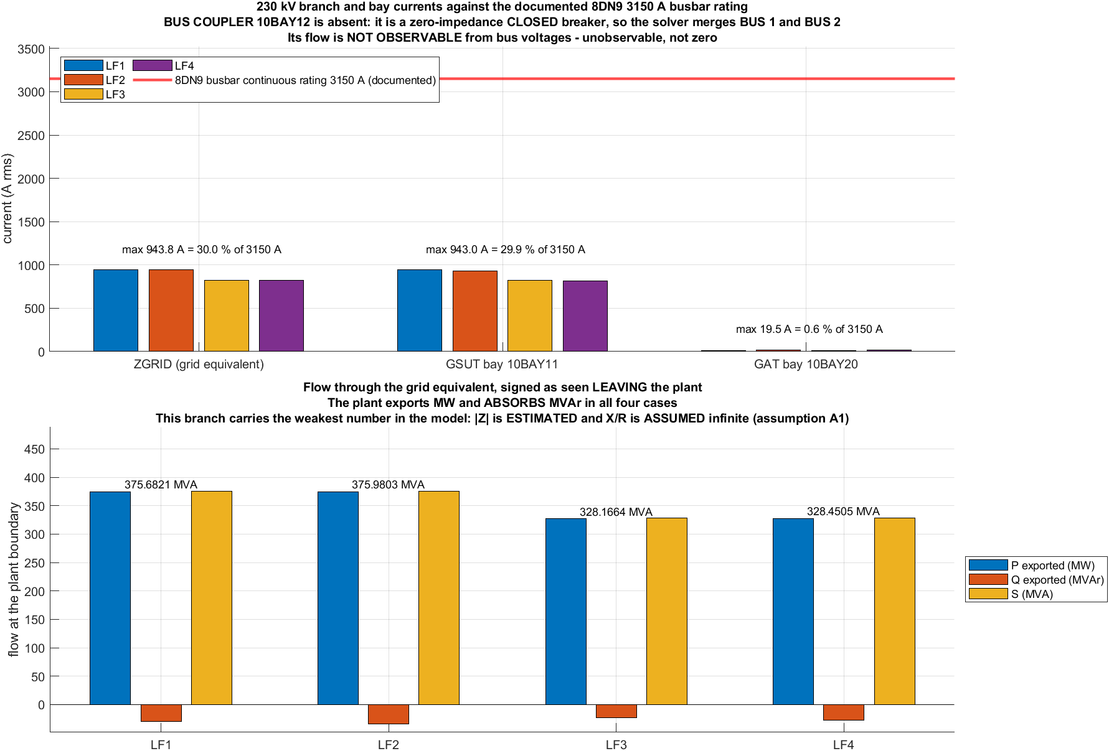
Figure 49 — 230 kV branch and bay currents, and plant boundary flow, Generation 1 (LF1–LF4). TOP: bar chart of current in A rms for the grid equivalent, the GSUT bay 10BAY11 and the GAT bay 10BAY20, against a red reference line at the documented 8DN9 busbar continuous rating of 3 150 A. The maxima are 943.8 A on the grid equivalent (30.0 % of 3 150 A), 943.0 A on the GSUT bay (29.9 %) and 19.5 A on the GAT bay (0.6 %). BOTTOM: flow through the grid equivalent signed as leaving the plant, showing P exported, Q exported and S for each case — 375.6821, 375.9803, 328.1664 and 328.4505 MVA, with Q negative in all four.

5.3.3 Results and Analysis

(a) Load Flow
The main load-flow case was LF360_GAT_OUT, representing 360 MW generation with the GAT bay out of service. The system remained within its capability limits and converged in 2 Newton–Raphson iterations.
Main Load-Flow Results
Parameter | GAT_OUT | GAT_IN
Generator apparent power | 361.074 MVA | 360.777 MVA
Power factor | 0.997 lagging | 0.998 lagging
Exported real power | 345.207 MW | 345.195 MW
Total real loss | 0.793 MW | 0.805 MW
Line real loss | 0.063 MW | 0.063 MW
Worst-bus KCL error | 3.27 × 10⁻⁵ MVA | 5.77 × 10⁻⁴ MVA
Capability | Within capability | Within capability
Verdict | OK | OK
NR iterations | 2 | 2
The 230 kV system also showed comfortable current margins. The maximum bay current was 943.8 A, corresponding to about 47.2% of the 2,000 A bay rating. The bus coupler current could not be directly obtained because the closed zero-impedance breaker is merged into the bus model.

(b) 0.7 km Transmission Line
The locked 0.7 km dual-circuit line had very small losses and voltage drop.
Quantity | Value
Line resistance | 0.0277725 Ω
Line reactance | 0.1425655 Ω
Sending apparent power | 346.2052 MVA
Current | 869.96 A
Real power loss | 0.062928 MW
Reactive flow | 0.115169 MVAr
Voltage drop | 29.203 V
Voltage drop | 0.012710%
Thermal loading | Not calculated
The thermal loading was left as NaN because no conductor ampacity was available in the source data; therefore, no rating was assumed.

(c) Generator Performance
At 360 MW, the generator operated well within its documented capability. The calculated reactive-power headroom was approximately 225.96 MVAr, indicating that the generator was not close to its reactive limit.

(d) Sensitivity Analysis
The sensitivity study showed that the system remained stable for the tested parameter variations.
Perturbation | Main Effect
Single circuit out | Line loss → 0.125847 MW
Series R ±20% | Export changes by ±12.6 kW
Series X ±20% | Reactive flow changes by ±64.6 kVAr
Shunt B ±20% | Reactive flow changes by ∓41.6 kVAr
Legacy 45.01 kA grid | Export changes by −0.605 MW
Grid X/R = ∞ → 5 | Loss increases from 0 to 1.3862 MW
Magnetising Lm = 500/200/100 pu | Q generation increases to 31.85/32.88/34.60 MVAr
All sensitivity cases converged in 2 iterations with an OK verdict.

(b) Transformer loading — the figures our course teacher asked for
This block is reported in full detail because our course teacher specifically asked to see the transformer loading graphs across the radial and looped cases.
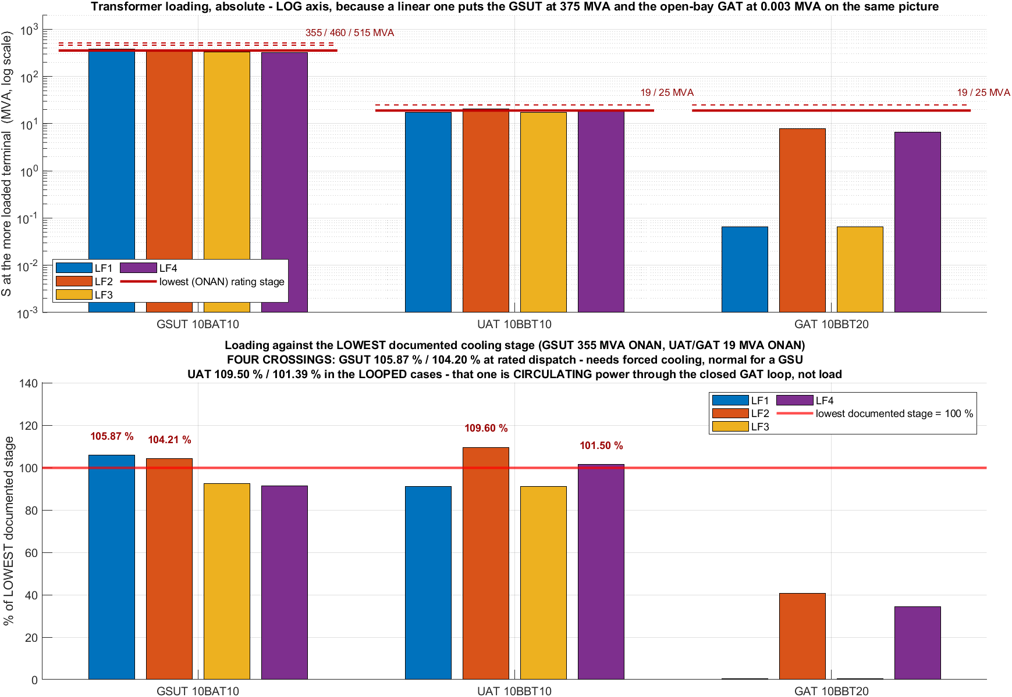
Figure 50 — Transformer loading across cases and cooling stages — Generation 1 (LF1–LF4), from results/load_flow/transformer_results.csv. Two panels. TOP: absolute apparent power in MVA on a logarithmic y-axis spanning 1 × 10⁻³ to 2 × 10³ MVA; each bar is max(S_LV, S_HV) for that transformer; the dark-red horizontal lines are the documented cooling-stage ratings, with the lowest (ONAN) stage drawn solid and the higher stages dashed, captioned "355/460/515 MVA" for the GSUT and "19/25 MVA" for the UAT and GAT. BOTTOM: loading as a percentage of the LOWEST documented stage, with a reference line at 100 % and bold labels only where loading exceeds 100 %. NOTE ON THE FIGURE'S OWN TEXT: the embedded subtitle prints 104.20 / 109.50 / 101.39 %, which is stale by about 0.1 percentage points; the CSV and the render-time bar labels give 104.21 / 109.60 / 101.50 %, and those are the values quoted in the table below.

Transformer Loading and Analysis
The transformer loading study used a logarithmic scale because the transformer ratings and loading values vary greatly. The GSUT carries around 375 MVA, while the GAT carries only a few MVA in some cases, so a linear graph would make the smaller transformers difficult to see.

Generation 1 Transformer Loading
Case | Dispatch / Topology | GSUT (% of 355 MVA ONAN) |  | UAT (% of 19 MVA ONAN) | GAT (% of 19 MVA)
LF1 | 389.30 MW, radial | 105.87% |  | 91.09% | 0.34%
LF2 | 389.30 MW, looped | 104.21% |  | 109.60% | 40.82%
LF3 | 342.01 MW, radial | 92.49% |  | 91.09% | 0.35%
LF4 | 342.01 MW, looped | 91.26% |  | 101.50% | 34.49%
Although the GSUT exceeds its 355 MVA ONAN rating in the higher-generation cases, it remains well within its 515 MVA ODAF rating, reaching a maximum of only 72.98%. This means the apparent ONAN overload is mainly a cooling-stage issue rather than an actual transformer overload.

Generation 3 — Primary 360 MW Cases
Case | GSUT (% of 515 MVA ODAF) | UAT (% of 25 MVA ONAF) | GAT (%)
LF360_GAT_OUT | 67.258% | 69.227% | 0.263%
LF360_GAT_IN | 66.301% | 79.462% | 28.001%
The UAT values above 100% occur only in the looped Generation-1 cases. The study shows that this is caused by circulating power when the GAT and UAT are connected to the same 6.6 kV bus. About 5.9 MW circulates through the loop, while the actual auxiliary demand remains about 14 MW. Therefore, the apparent UAT overload is mainly associated with the looped operating condition rather than a new plant load.
An important documentation gap was also identified: the source documents do not contain the UAT/GAT interlock schedule.

Hand Verification
Quantity | Hand Calculation | Model | Agreement
Grid equivalent reactance | 2.65582 Ω | 2.6558 Ω | 4 significant figures
GSUT phase angle | 6.7025° | 6.6962° | 0.09%
UAT phase angle | 3.3672° | 3.4402° | 2.1%
GAT iron loss | 21.1020 kW | 21.1023 kW | 5 significant figures
The close agreement between the hand calculations and the model provides a useful check on the transformer representation, with the GAT iron-loss calculation showing particularly strong agreement.

Line and Bay Loading
Branch | Maximum Current | Loading of 2000 A Bay Rating
ZGRID | 943.79 A | 47.2%
GSUT bay 10BAY11 | 943.05 A | 47.2%
GAT bay 10BAY20 | 19.50 A | 1.0%
The correct bay rating is 2000 A, while 3150 A applies to the busbar/bus-coupler rating. The open GAT current of 0.009 A is a simulation snubber artefact, not actual plant leakage. Similarly, the bus-coupler NaN means the current is unobservable in the zero-impedance model, not zero.

(c) Fault study
Because the marked-up single-line diagram the writing manual points at does not exist in this workspace, the fault locations are given as a table keyed to the real OEM drawing.
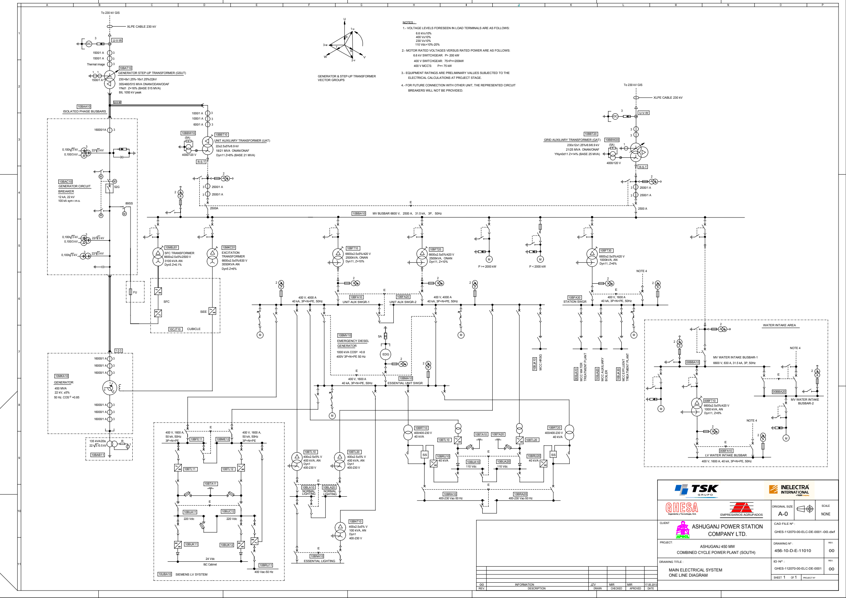
Figure 51 — The real OEM master single-line diagram, Siemens / TSK / INELECTRA S008-112070-00-ELC-DE-1011 Rev 04, "As-Built Factory". The five fault locations F1–F5 are identified against this drawing in the table below rather than overprinted on it.

5.3.3 Results and Analysis

(b) Fault Analysis
The fault study considered five locations: F1 – generator terminals, F2 – GSUT LV terminals, F3 – 230 kV GIS bus, F4 – 0.7 km line, and F5 – remote grid boundary. Four fault types were studied: LLL, LG, LL and LLG.

Fault Current Results
Location | LLL (kA) | LG (kA) | LL (kA) | LLG (kA)
F1 – 22 kV Generator | 126.21 | 0.007 | 109.25 | 109.25
F2 – GSUT LV | 126.21 | 0.007 | 109.25 | 109.25
F3 – 230 kV GIS | 50.53 | 45.74 | 43.76 | 48.50
F4 – 0.7 km Line | 51.06 | 46.12 | 44.22 | 48.97
F5 – Remote Grid | 53.09 | 48.47 | 45.97 | 51.18
The results show that the LLL fault produces the highest RMS current at every location. The generator bus has the highest fault level because it is directly connected to the generator source. F1 and F2 have identical results because they represent the same electrical node.

Branch Current Contributions
Fault | Total Current (kA) | Main Contributions
F1 LLL | 126.214 | GEN: 55.049; GSUT: 72.105; GRID: 72.105
F1 LG | 0.00727 | GEN: 8.414; GSUT: ≈8.015; UAT: 0.454; NER: 0.00242/sequence
F1 LL | 109.252 | GEN: 8.322; HV: 29.017
F1 LLG | 109.253 | GEN: 8.321; HV: 29.017
F3 LLL | 50.531 | GEN: 3.229; GSUT: 3.218; UAT: 0.017; LINE/GRID: 47.370
F3 LG | 45.738 | GEN: 2.155; GSUT LV: 2.120; GSUT HV: 5.180; GRID: 40.583
F4 LLL | 51.058 | B1: 14.325; B2: 36.737; GRID: 47.946
F4 LG | 46.117 | B1: 14.033; B2: 32.087
F5 LLL | 53.087 | GRID: 49.941
The F1 LG case is particularly interesting. Although the total earth-fault current is only 7.27 A, normal phase and circulating currents are still present in the branches. The actual earth-fault component is limited by the generator neutral earthing resistor.

Peak Fault Current
The first peak fault current was calculated using:
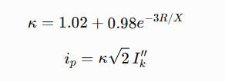
where Ik′′ is the initial symmetrical RMS fault current and ip is the first peak current.

Location | R/XR/X | κ\kappa | LLL RMS (kA) | Peak (kA)
F1/F2 – Generator | 0.0171 | 1.9511 | 126.21 | 348.26
F3 – GIS | 0.0694 | 1.8159 | 50.53 | 129.76
F4 – Line | 0.0683 | 1.8185 | 51.06 | 131.33
F5 – Remote Grid | 0.0635 | 1.8301 | 53.09 | 137.42
Thus, the 126.21 kA RMS fault at the generator can reach about 348.26 kA at the first peak, which is important for breaker peak withstand and making capability.

Fault Current Along the 0.7 km Line
Position mm | LLL Fault Current (kA)
0.05 | 52.205
0.50 | 51.058
0.95 | 49.959
The current decreases gradually as the fault moves along the line toward the plant side. The line-end results also match the corresponding F3 and F5 bus-fault results, providing a useful continuity check.

Why LLL Is Higher Than LLG
The study also corrected an earlier presentation error in which the LLL and LLG columns were accidentally interchanged. The actual calculation shows:
Location | Fault Current Ordering
F3 – GIS | LLL 50.531 > LLG 48.504 > LG 45.738 > LL 43.759 kA
F1 – Generator | LLL 126.214 > LLG 109.253 ≈ LL 109.252 >> LG 0.00727 kA
The relationship depends on the sequence impedances. For the F3 LLG fault:
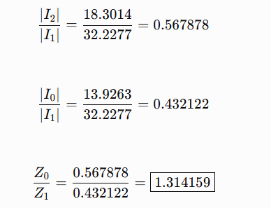

which provides an additional consistency check.

Theoretical and Computed Fault Currents
Fault | Predicted (kA) | Computed (kA) | Error
LLL | 50.531 | 50.5309 | —
LLG | 48.492 | 48.5037 | −0.025%
LG | 45.741 | 45.7377 | +0.007%
LL | 43.761 | 43.7589 | +0.005%
The theoretical values agree with the numerical results to better than 0.03%, providing strong evidence that the fault model is behaving consistently.

LLL Fault Voltage
For a bolted three-phase fault,
$$Z_{f}=0$$

$$V_{a}=Z_{f}I_{a}=0$$
$$V_{b}=Z_{f}I_{b}=0$$
$$V_{c}=Z_{f}I_{c}=0$$

$$V_{a}=V_{b}=V_{c}=0$$

$$V_{0}=\frac{V_{a}+V_{b}+V_{c}}{3}=0$$

$$V_{1}=\frac{V_{a}+aV_{b}+a^{2}V_{c}}{3}=0$$
$$V_{2}=\frac{V_{a}+a^{2}V_{b}+aV_{c}}{3}=0$$

$$V_{0}=V_{1}=V_{2}=0$$

$$V_{1}=V_{f}-I_{1}Z_{1}$$
$$0=V_{f}-I_{1}Z_{1}$$

$$I_{1}=\frac{V_{f}}{Z_{1}}$$
$$I_{2}=0, I_{0}=0$$
$$I_{a}=I_{1}$$
$$I_{b}=a^{2}I_{1}$$
$$I_{c}=aI_{1}$$

$$a=e^{j{120}^{∘}}$$
$$I_{a}=I_{1}, I_{b}=I_{1}∠-{120}^{∘}, I_{c}=I_{1}∠+{120}^{∘}$$
The important point is that only the fault point has zero voltage. Healthy buses retain non-zero voltage according to their electrical distance from the fault:
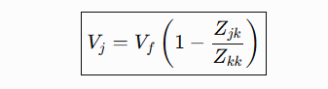
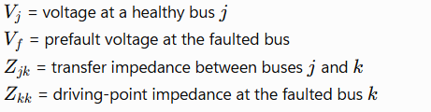
Therefore, a fault depresses the voltage throughout the network, but it does not make every bus voltage zero.

Fault-Study Validation
Validation Check | Result
Independent validation engine | 27/27 passed
Review gates | 23/23 passed
Nodal/Thevenin residual | ≤ 3 × 10⁻¹⁴
KCL residual | ≈ 1 × 10⁻¹⁵
Prefault reproduction | 0.033 / 0.033 < 0.10 limit
6.6 kV auxiliary-bus gate | 0.025691 / 0.028839 < 0.05
Stage-source closure | ≈ 1 × 10⁻¹⁶
Line/bus continuity | Exact
Regression tests | 161 passed / 0 failed

Figure 52— Scenario bus_3ph — bus voltage and frequency through a three-phase fault at the 230 kV GIS bus. The fault is applied at 0.150 s and the faulted-bus voltage collapses to essentially zero, confirming the V = 0 boundary condition in the time domain; voltage recovers after the Q0 and local-line breakers open at 0.237 s.
Figure 53 — Scenario bus_3ph — fault-current waveforms for the same event, showing the three balanced phase currents characteristic of a symmetrical three-phase fault, and their cessation after contact separation.

(e) Protection Coordination
The protection coordination study evaluated 96 relay-coordination rows. The final result was 12 PASS, 12 CONDITIONAL-PASS, 0 FAIL, 24 NO-TRIP, and 48 NO-PAIR. The selected time-multiplier settings were GEN-51 = 0.10, GSUT-51 = 0.55, Q0-51 = 0.80, and GEN-51N = 0.15. After correcting the current base and faulted-phase selection, no further tuning of the settings was required.

Relay Settings
Relay | Function | Pickup (Primary A) | CT | Curve | TMS | Delay
GEN-51 | Generator phase OC | 17,170.8 | 15000/1 | IEC Standard Inverse | 0.10 | Inverse
GEN-51N | Stator earth fault | 4 | 20/1 | IEC Standard Inverse | 0.15 | Inverse
GSUT-HV-51 | GSUT HV-side OC | 1,380 | 1600/1 | IEC Standard Inverse | 0.55 | Inverse
GIS-Q0-51 | Bay backup | 1,500 | 1600/1 | IEC Standard Inverse | 0.80 | Inverse
GEN-87G | Generator differential | 2,403.8 | 15000/1 | Percentage bias | — | 0.045 s*
GSUT-87T | Transformer differential | 387.84 | 1600/1 | 30% / 60% slope | — | 0.045 s*
GIS-87B | Busbar differential | 320 | 1600/1 | 30% slope | — | 0.035 s*
LINE-7SD | Line differential | 320 | 1600/1 | — | — | 0.035 s*
GEN-51-SIEMENS-BL | Definite-time comparator | 17,171 | 15000/1 | Definite Time | — | 3 s
*Timing values marked as engineering study proxies, not verified installed settings.
The study explicitly labels these as numerical study settings; actual installed values are unverified.

Coordination Criterion
The study used a 0.30 s Coordination Time Interval (CTI). This means the upstream relay should operate at least 0.30 s after the downstream relay so that the downstream protection gets the first opportunity to clear the fault.
The coordination margin can be expressed as

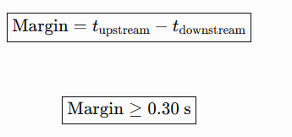

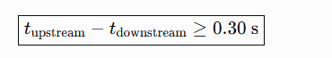

Key Coordination Results
Relay Pair | Fault | Downstream Time (s) | Upstream Time (s) | Margin (s) | Result
GEN-51 → GSUT-HV-51 | F1 LLL | 0.594 | 2.354 | 1.761 | PASS
GEN-51 → GSUT-HV-51 | F1 LL | — | — | 1.727 | PASS
GEN-51 → GSUT-HV-51 | F1 LLG | — | — | 1.727 | PASS
GEN-51 → GSUT-HV-51 | F1 LG | — | — | — | NO-TRIP
GSUT-HV-51 → GIS-Q0-51 | F1 LLL | — | 2.354 | 1.260 | CONDITIONAL-PASS
GEN-51N → GSUT-HV-51 | F1 LG | 1.746 | — | — | NO-PAIR
For the looped LF360_GAT_IN case, the results remained almost unchanged: the GEN-51 → GSUT-HV-51 margin was 1.768 s (PASS), while GSUT-HV-51 → GIS-Q0-51 gave 1.266 s (CONDITIONAL-PASS).

Meaning of the Verdicts
PASS: Both relays operate and the required 0.30 s coordination margin is achieved.
CONDITIONAL-PASS: The timing margin passes, but a conditional assumption affects the physical relay identification. This applies to the GSUT → Q0 coordination because the SLD's “Q0” label is ambiguous.
NO-TRIP: The relay correctly does not operate for that fault.
NO-PAIR: No applicable upstream/downstream relay pair exists for that particular fault.
Therefore, there were no FAIL cases, and the weakest evaluable coordination margin was 1.260 s, which is more than four times the required 0.30 s CTI.
One important data-handling point is that the coordination CSV's values are CT-secondary currents, not primary currents. The primary pickup values should therefore be taken from the relay-settings table rather than directly from those CSV columns.

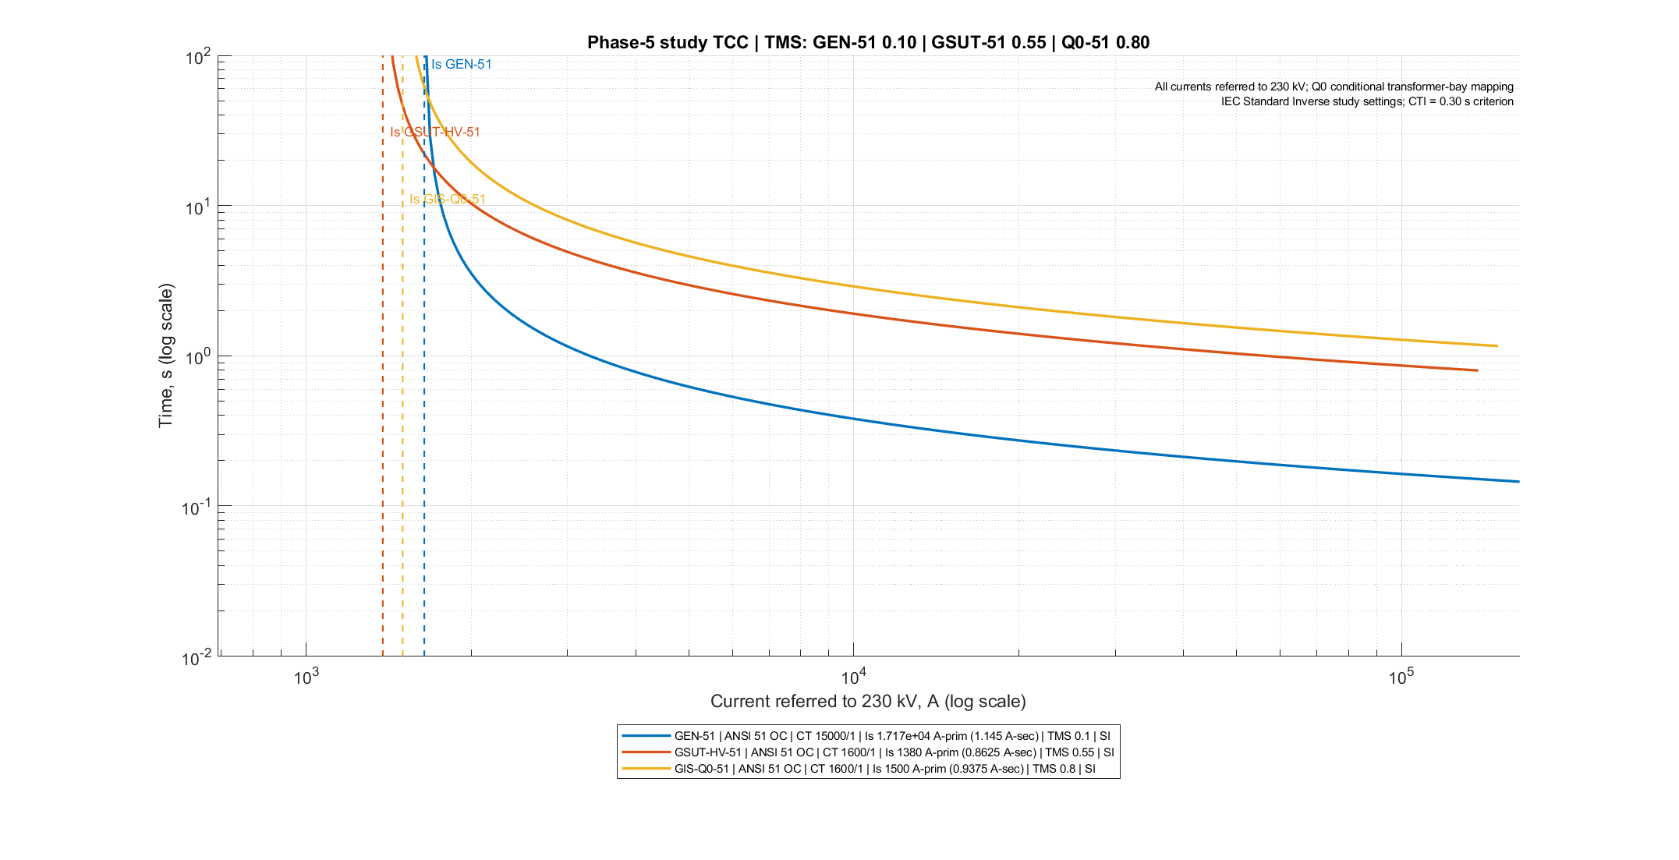
Figure 54 — Phase-5 study time–current characteristic, log–log. Title: "Phase-5 study TCC | TMS: GEN-51 0.10 | GSUT-51 0.55 | Q0-51 0.80". Three IEC Standard Inverse curves, each drawn from 1.005 × to 100 × its own pickup over 240 logarithmically spaced points; current axis 690 A to 164 242.43 A, time axis 0.01 s to 100 s. Pickups as plotted, all referred to 230 kV: GEN-51 at 1642.4243478260869 A (= 17 170.8 A × 22/230), GSUT-HV-51 at 1380 A, GIS-Q0-51 at 1500 A. Footer: "IEC Standard Inverse study settings; CTI = 0.30 s criterion".

Time–Current Characteristic
The time–current characteristic (TCC) comparison shows clear separation between the three overcurrent protection curves when their pickups are referred to the 230 kV side.
Relay | Pickup referred to 230 kV | TMS | Operating time at 2× pickup
GEN-51 | 1,642.42 A | 0.10 | 1.003 s
GSUT-HV-51 | 1,380 A | 0.55 | 5.516 s
GIS-Q0-51 | 1,500 A | 0.80 | 8.023 s
The time separation is:
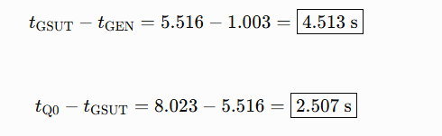
The generator pickup had to be referred from 22 kV to 230 kV using the transformer voltage ratio:

This conversion allows all three relay curves to be plotted on the same 230 kV current axis. The study identified this base conversion as an important correction in the protection analysis.
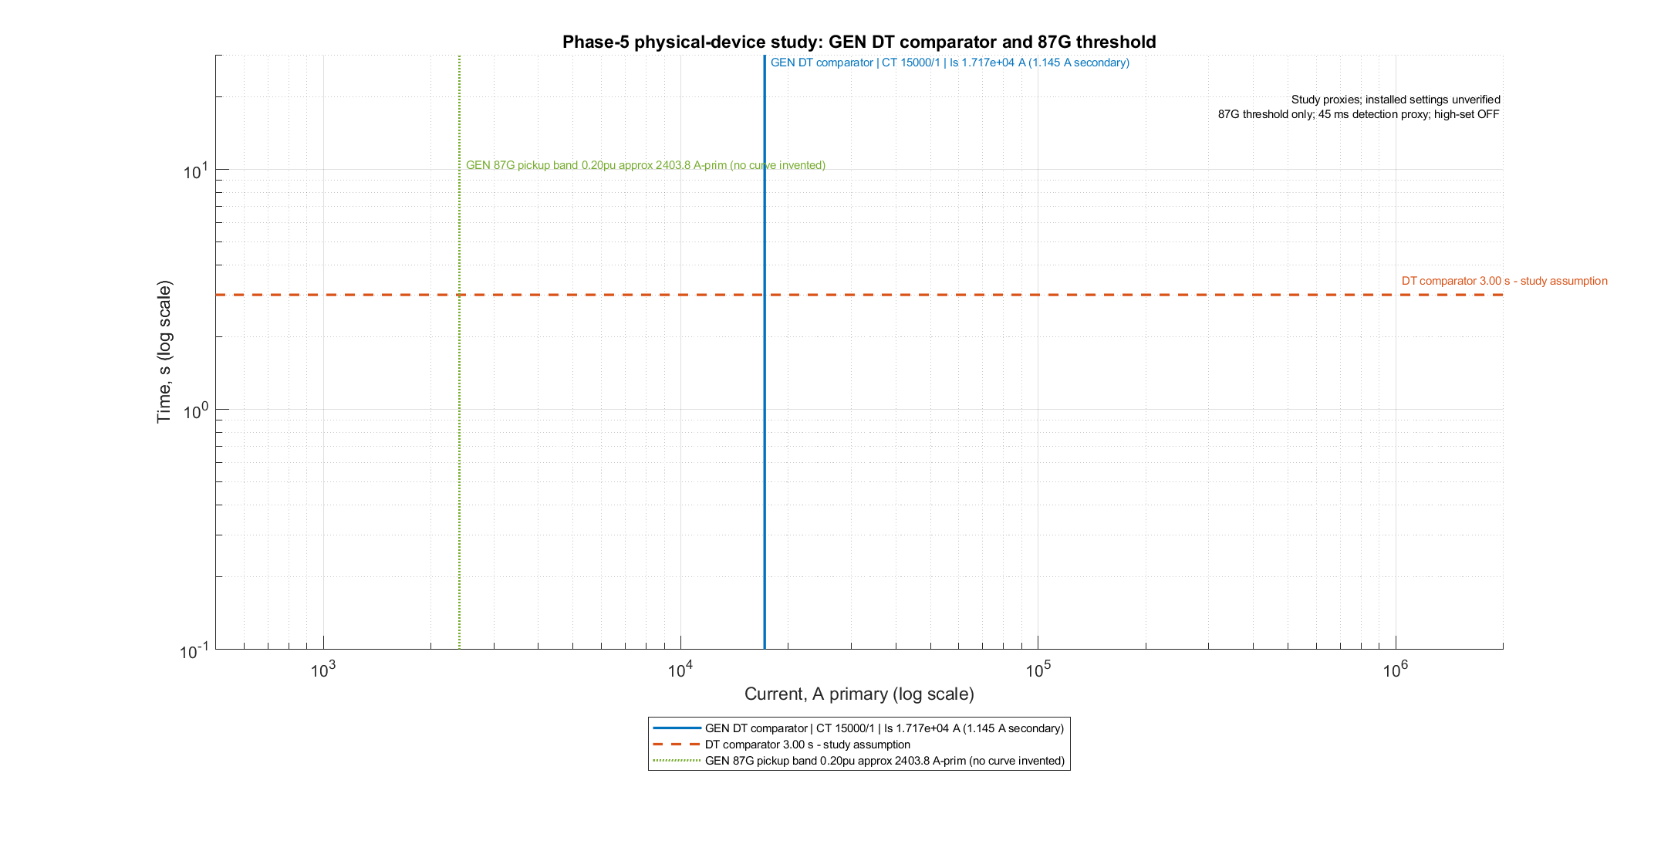
Figure 55 — Phase-5 physical-device study — the generator definite-time comparator and the 87G threshold, log–log, current axis 500 A to 2 × 10⁶ A, time axis 0.1 s to 30 s. Blue solid vertical line at the definite-time start of 17 171 A (secondary 1.1447333333333334 A); orange dashed horizontal line at the 3 s definite-time delay; green dotted vertical line at the 87G threshold of 2403.8 A. Footer: "All currents referred to 230 kV; Q0 conditional transformer-bay mapping". IMPORTANT: this figure carries NO inverse curves — it is a threshold overlay only, and must not be read as a grading study.

Protection Effectiveness
The effectiveness study identifies which protection device actually clears each fault and shows whether backup protection is available.
Fault | Primary Protection | Current vs Pickup | Operating Time | Backup / Result
F1 LLL | GEN-87G | 55,048.71 A vs 2,403.8 A | 0.045 s | GEN-51: 0.594 s
F1 LG | GEN-51N | 7.272 A vs 4 A | 1.746 s | Earth path provides protection
F1 LLG | GEN-51N | 3.638 A < 4 A | No trip | 51N just below pickup
F2 LLL | GSUT-87T | 5,265.53 A vs 387.84 A | 0.045 s | —
F2 LG | GSUT-87T | 0.696 A vs 387.84 A | No trip | Delta winding blocks zero sequence
F3 LLL | GIS-87B | 47,369.79 A vs 320 A | 0.035 s | Q0-51 backup
F4 LLL | LINE-7SD | 14,325.14 A vs 320 A | 0.035 s | —
F5 | None mapped | — | No trip | Out-of-zone / No-pair
The most important case is the F1 LG earth fault. The total fault current is only 7.272 A, so the normal phase overcurrent and generator differential protection do not operate. Instead, the dedicated GEN-51N neutral protection detects the fault and operates in 1.746 s. The 20/1 neutral CT makes this small earth-fault current detectable, providing a calculated margin of about 1.8.
For the F1 LLG fault, the residual current is only
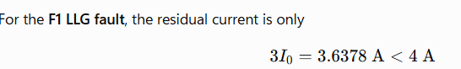
So, the 51N relay does not operate. This is reported as an actual edge case rather than being artificially corrected by changing the pickup.
For F2 LG, the GSUT differential protection does not operate because the HV-referred current is far below its pickup, and the delta winding blocks zero-sequence current from reaching the high-voltage side.
The differential characteristics.
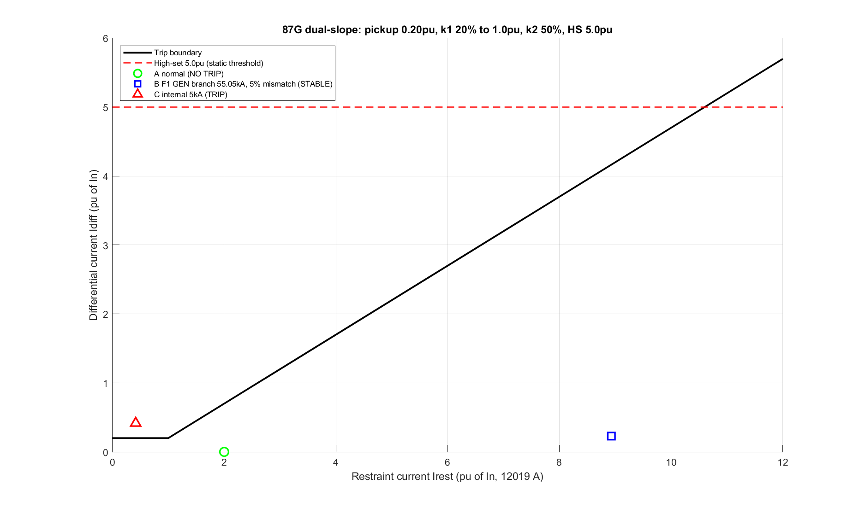
Figure 56 — Generator differential 87G operating characteristic. Basis 458 MVA / 22 kV, rated current I_N 12 019.3828 A, CT 15000/1 on both sides, rated secondary 0.80128 A. Pickup 0.20 pu = 2403.84 A (0.160256 A secondary); first slope k1 = 20 % up to the breakpoint at restraint 1.00 pu; second slope k2 = 50 %; the high-set at 5.0 pu = 60 096.9 A is drawn statically but is OFF in the central study. Axes: restraint 0 to 12 pu, differential 0 to 6 pu. Siemens convention Idiff = |It − In|, Irest = |It| + |In|. The boundary is flat at 0.20 pu from 0 to 1.0 pu restraint, then rises as 0.20 + 0.50(Irest − 1.0), reaching 5.70 pu at 12 pu restraint and crossing the 5.0 pu high-set at 10.6 pu. Point A (green circle): healthy through-load, 12 019.3828 A both sides, Idiff 0 at Irest 2.0 — NO TRIP. Point B (blue square): the F1 external fault with a 5 % CT mismatch, terminal 55 048.7096805279 A against neutral-end 52 296.274696502 A, Idiff 0.22900 pu at Irest 8.93099 pu — STABLE. Point C (red triangle): internal fault with one end dead, 5000 A against 0 A, 0.41599 / 0.41599 pu — TRIP. Required caveat: the five-percent mismatch at point B is an illustrative assumption, not CT transient proof.
Point B is the one that matters for this plant. The F1 three-phase fault is external to the generator differential zone, and it pushes 55 kA through the zone. A differential relay that tripped on it would be a disaster — it would disconnect a healthy machine during a fault elsewhere. With a deliberately pessimistic 5 % CT mismatch assumed, the operating point still sits below the characteristic: stable. That is the single most important stability check on the 87G setting.
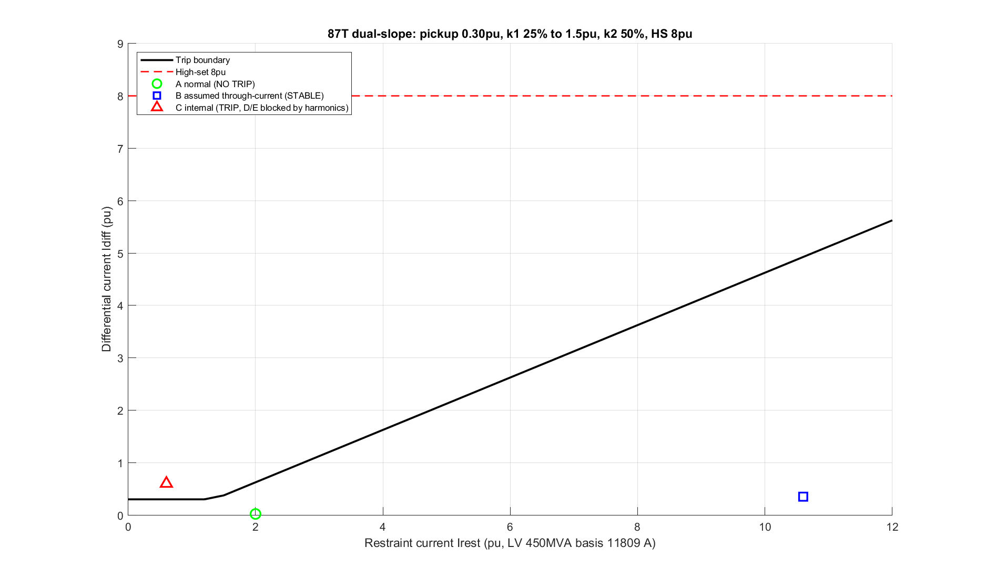
Figure 57 — Transformer differential 87T operating characteristic — THE FIGURE WITH THE DISCLOSED BASIS MISMATCH. The script's own header flags it: "Hypothetical plot basis: 450 MVA, 22/400 kV (not the South transformer)." As plotted: pickup 0.30 pu, first slope k1 = 25 %, knee at 1.50 pu, second slope k2 = 50 %, high-set 8.0 pu, second-harmonic inrush block at 15 %, fifth-harmonic block at 30 %; axes restraint 0 to 12 pu over 600 points, differential 0 to 9 pu. Points A (0.02 / 2.0 NO TRIP), B (0.35 / 10.6 STABLE), C (0.60 / 0.60 TRIP), D (25 % second harmonic, BLOCKED), E (35 % fifth harmonic, BLOCKED). THE CENTRAL STUDY SETTING IS DIFFERENT: 30 % / 60 % slopes, knee at 2 × 1292.8 A, pickup 387.84 A, no high-set, on the real 515 MVA 22/230 kV GSUT. This figure therefore illustrates the SHAPE of a dual-slope characteristic and the harmonic-blocking principle; the numbers that apply to Ashuganj South are the ones given in the settings table and in the text.

(f) Breaker Duty Screening
The breaker-duty study was limited to devices for which actual breaker ratings were available. Q1, Q2 and Q9 are disconnectors, not circuit breakers, so no breaker-duty calculations were assigned to them. Q51, Q52 and Q8 also had no usable rating information.
Only Q0 and 52G were screened. The study produced 80 duty rows plus 1 NOTE row, with 0 exceedances. All 80 evaluated rows were classified as CONDITIONAL-PASS.
Device | Rating | Worst Fault | Branch Current | Duty Ratio | Margin
52G – Generator CB | 100 kA | F1/F2 LLL | 55.049 kA | 55.05% | 44.95%
Q0 – GIS breaker | 50 kA | F1/F2 LLL | 6.897 kA | 13.79% | 86.21%
The percentages are based on the current actually flowing through each breaker, not the total fault current at the bus. For example, the F1 total LLL fault current is 126.21 kA, but only 55.05 kA flows through the generator breaker. Similarly, the Q0 duty uses the HV-referred branch current of 6.897 kA, not the total fault current. This distinction is important for a meaningful breaker-duty assessment.
Some representative additional results were:
Device | Fault | Branch Current | Duty
52G | F1 LL/LLG | 51.79 kA | 51.79%
52G | F1 LG | 8.414 kA | 8.41%
52G | F3 LLL | 33.753 kA | 33.75%
52G | F3 LG | 22.530 kA | 22.53%
Q0 | F1 LG | 0.767 kA | 1.53%
Q0 | F3 LLL | 3.218 kA | 6.44%
Q0 | F3 LG | 5.180 kA | 10.36%
Q0 | F3 LLG | 4.663 kA | 9.33%
Two important limitations should also be noted. Peak making current was not used to give a branch-duty verdict, because the calculated peak factors describe the fault node rather than an individual breaker branch. Also, the actual interrupting current at contact-parting time Ib was not calculated; therefore, this is a screening study, not a complete interrupting, asymmetric DC, thermal short-time, or TRV assessment.
There was one informational note: the calculated F3 LLL total current was 50.53 kA, compared with an estimated 50 kA station reference:
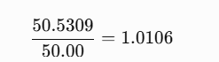
Or approximately +1.06%. This was not classified as PASS or FAIL, because the 50kA reference is only estimated and the total bus current is not the same as the current through an individual breaker.
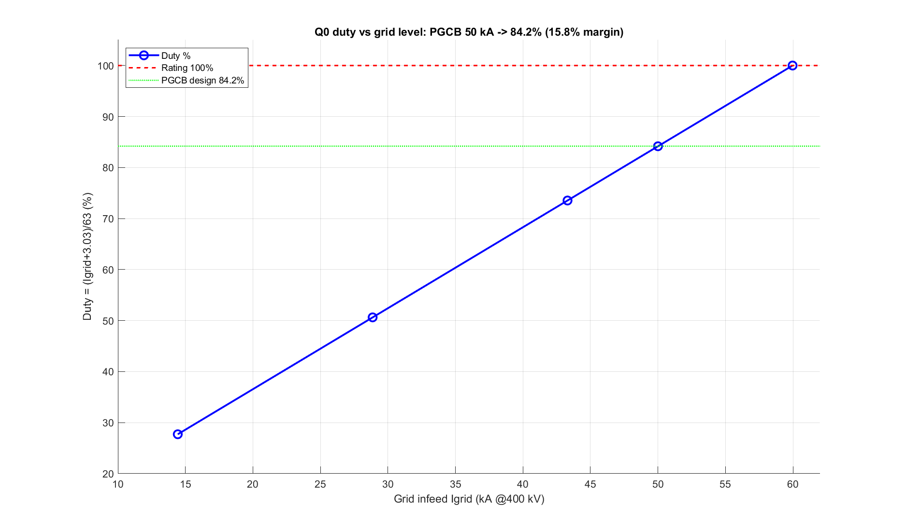
Figure 58 - The duty sensitivity envelope.

Grid Duty Envelope and Dynamic Verification — Summary

Grid Duty Envelope
The grid-strength sensitivity study checked how the breaker duty changes as the available grid fault level increases.
Grid Case | Grid Current (kA) | Total Current (kA) | Duty
Weak, 10 GVA | 14.43 | 17.46 | 27.72%
Moderate, 20 GVA | 28.87 | 31.90 | 50.63%
Strong, 30 GVA | 43.30 | 46.33 | 73.54%
PGCB maximum, 50 kA | 50.00 | 53.03 | 84.17%
Boundary | 59.97 | 63.00 | 100%
The calculated maximum allowable grid current is 59.97 kA, corresponding to about 41.55 GVA. Thus, a 63 kA breaker reaches its screening boundary when the grid can supply approximately 59.97 kA. The PGCB 50 kA reference therefore has about 15.83% margin.
The study also distinguishes this envelope result from the actual Ashuganj case, where the recorded 230 kV duty is only 13.79%. In other words, the envelope shows the theoretical operating range, while the 13.79% value represents the actual studied condition.

(g) Dynamic Verification
The steady-state protection results were further checked using a closed-loop time-domain simulation. A three-phase fault was applied to the 230 kV GIS bus at 0.150s.
Event | Time
Fault applied | 0.150 s
87B pickup | 0.153 s
87B trip request | 0.187 s
DC trip coil energized | 0.188 s
Breakers open | 0.237 s
Total fault-clearing time | ≈ 87 ms
The total clearing time is approximately
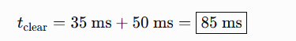
with the observed fault-to-contact-separation time approximately 87 ms because of the acquisition/discrete timing effects.
The generator and GSUT overcurrent relays picked up at approximately 0.156 s and 0.157 s, but did not trip because their inverse-time operating times were much longer (25.4 s and 4.92 s). This confirms the intended grading: 87B clears the fault quickly, while the backup overcurrent relays remain restrained.
The 87 ms clearing time is a result of this study. The commonly referenced 100 ms critical-clearing benchmark is external literature, not a calculated transient-stability limit from this project.
Figure 59 — Scenario bus_3ph — station 110 V DC bus voltage and trip-coil current pulse. The DC bus stays within 114–124 V throughout the event, with a dip of about 1.0 V on trip-coil energization — that is 109.0 V against the 88.0 V gating threshold, so the trip is never inhibited. The gating condition modelled is Demand = TripRequest AND (V_dc ≥ 88.0 V).

5.3.4 Interpretation and Conclusions on Data
The study shows that the steady-state operation of the Ashuganj South plant is generally comfortable, with no major operating limit reached. At 360 MW dispatch, real power loss is only 0.2202%, the 230 kV bus voltage is 0.998959 pu, the maximum bay loading is 47.2% of the correct 2000 A rating, and the GSUT loading is 72.98% of its 515 MVA ODAF rating. Therefore, the main engineering challenges are not steady-state limits but data quality, assumptions, and missing plant information.

Main conclusions
- Data uncertainty is the major concern. Assumptions such as grid X/R ratio and base voltage can affect results more than some explicitly identified uncertainties. The 6.6/6.9 kV base-voltage issue has a much larger effect than the magnetising-inductance assumption.
- A5 is a fundamental limitation: the generator terminal voltage was assumed to be 1.0 pu. Therefore, the results are internally consistent, but absolute voltage values depend directly on this assumption. Ratios, percentages, and relative margins are more reliable than absolute kV values.
- LLL is the maximum fault type because the system has Z0/Z1>1Z_0/Z_1>1. At the 230 kV bus, Z0/Z1=1.314159Z_0/Z_1=1.314159, so the fault ordering is physically determined rather than being a simulation coincidence.
- For a bolted three-phase fault, voltage becomes zero only at the fault point. Nearby buses retain voltage according to their electrical distance from the fault, so the entire network does not collapse.
- Protection coordination performed well within the study model: there were 0 FAILs in 96 coordination rows, and the weakest evaluable coordination margin was 1.2604 s, compared with the required 0.30 s CTI. However, 12 rows were conditional because the physical identity of “Q0” was not uniquely established.
- The F1 earth fault is the most interesting protection finding. Although the generator is 458 MVA, the calculated fault current is only 7.272 A because of the neutral earthing arrangement. A dedicated 20/1 neutral CT allows the 51N relay to detect this fault. However, the F1 LLG case produces 3.638 A, just below the 4 A pickup, so this limitation remains unresolved without measured unbalance data.
- The apparent GSUT overload of 105.87% is actually relative to the 355 MVA ONAN stage. Against the forced-cooling 515 MVA ODAF rating, it is only 72.98%. Thus, forced cooling is important during full dispatch.
- The apparent UAT overload of 109.60% in the looped case is caused by circulating power. About 5.9 MW circulates through the UAT/GAT loop, while the GSUT loading actually decreases. This also revealed a missing UAT/GAT interlock schedule, showing how the analysis helped identify missing plant documentation.

What the study does not establish
The load-flow study alone does not establish fault performance, protection coordination, dynamics, unbalanced operation, 400 V auxiliary distribution, measured plant validation, operating recommendations, or tap optimization. Loading percentages are only thermal-rating comparisons.

5.4–5.7 Summary

5.4 Limitations of Tools (PO(e))
The study used MATLAB R2024a, Simulink, Simscape Electrical, and project-specific MATLAB functions for load flow, fault analysis, protection calculations, breaker-duty screening, and dynamic simulation. No commercial short-circuit software or on-site measurements were used.
The main limitations are:
- The model works mainly in the phasor/fundamental-frequency domain, so it cannot accurately study TRV, current chopping, SF6 restriking, or very fast electromagnetic transients.
- The national grid is represented by a Thevenin equivalent, so wide-area grid dynamics and inter-area oscillations are not captured.
- Standard excitation/governor models are used instead of the actual Siemens control firmware.
- Auxiliary loads are represented as a static 14 MW P-Q load, so motor starting and reacceleration are not modeled.
- The station battery is simplified, so long-term battery ageing and capacity are not assessed.
- Zero-sequence mutual coupling between the parallel lines is neglected.
Other important limitations are that there is no full breaker TRV/asymmetric-current study, no data-grounded CT saturation model, and no actual relay firmware or wiring verification. Therefore, passing the simulations does not certify installed relay performance.
Some missing values correctly appear as NaN, such as the line thermal loading and unobservable bus-coupler quantity. Other unusual values were identified as modeling artefacts rather than plant behavior.

5.5 Impact Assessment (PO(f))
The protection study has a direct societal benefit:
Correct coordination → correct breaker operates → faulted equipment is isolated → 360 MW unit remains available → less unnecessary load shedding.
The protection results show 12 PRIMARY PASS, 12 CONDITIONAL-PASS, and 0 FAIL among evaluable pairs. However, the conditional results depend on identifying the actual device represented by the ambiguous Q0 label.
Important residual risks include:
- F1 LG is detected by 51N, but the F1 LLG residual current of 3.638 A is below the 4 A pickup.
- Breaker margins are comfortable, but TRV, asymmetric DC, making current, thermal duty, and interrupting-time IbI_b were not calculated.
- The DC system performs well during the modeled trip, but battery endurance was not assessed using IEEE 485.
- SF6 arc by-products remain an operational safety hazard requiring proper detection, ventilation, PPE, and procedures.

5.5.3 Legal Issues
The study does not claim Grid Code or international-standard compliance. It is informed by concepts from standards such as IEC 60909, IEEE C37 series, IEC 62271-100, IEC 60255, and IEEE 485, but it was not performed as a formal standards-compliance study.
It is also not a compliance certificate, commissioning document, or type-test report. Any relay setting would require engineer approval, vendor confirmation, and site commissioning tests before implementation.

5.6 Sustainability Evaluation (PO(g))
Three main sustainability areas were considered:
Environmental sustainability:
GIS saves land and is suitable for the local climate, but SF6 has a very high global-warming potential and must be carefully monitored, recovered, and reclaimed. Transformer oil also requires proper containment and disposal
Technical/asset sustainability:
Proper protection reduces damage to expensive equipment. The NER limits generator earth-fault current, 87T protects the GSUT, and correctly interpreting the GSUT cooling rating prevents unnecessary derating or overheating.
Study sustainability:
Inputs are frozen, outputs are script-generated, and the study can be reproduced and extended without manually recreating calculations. The major limitation is dependence on a commercial MATLAB/Simulink/Simscape Electrical license.

5.7 Ethical Issues (PO(h))
The central ethical principle is not to overclaim. Every important value is given a provenance/status, distinguishing verified data, assumptions, derived values, and study proxies. A verified input does not mean a verified plant result.
The study deliberately reports unfavorable or incomplete findings, including:
- LLG earth fault below 51N pickup.
- 12 conditional coordination results.
- No mapped primary protection at F5
- Open Phase-6 validation gates.
- Stale/inconsistent report figures and the corrected 2000 A bay rating.
The 50.53 kA calculated 230 kV fault current vs. estimated 50 kA reference is reported only as an informational note, not artificially labeled as either a pass or failure. No fault current or equipment rating was changed to obtain a favorable result.

6. Reflection on Individual and Team Work

6.1 Individual Contributions
The five members divided the project into five main work packages:
Member | Work Package | Main Work
Sasshata Talukder | WP1 – Data Audit | Drawings, nameplates, data sheets, conflict register, parameter classification
S. M. Sindid Islam Mahodi | WP2 – Load Flow | Per-unit system, Newton–Raphson load flow, six Gen-3 cases, sensitivity analysis
Rajib Khan | WP3 – Fault Study | Symmetrical components, fault solver, fault matrix, peak/duration calculations
Iftekhar-E-Islam | WP4 – Protection | Relay settings, CT/VT data, coordination matrix, TCC, breaker-duty screening
Abu Mohammed Ibn Julker Nahin | WP5 – Dynamic Verification | Simulink model, 26 scenarios, S-functions, testing and validation
All members also participated in cross-checking, report writing, and presentation. Every important result was independently checked by another member.

Key individual learning
WP1: Data reconciliation can be more important than calculations; the 6.6/6.9 kV base conflict had a major impact.
WP2: Numerical convergence does not automatically mean physical accuracy; assumptions such as A5 must be recognized.
WP3: Apparently unusual fault results can be physically correct when sequence-network theory is considered.
WP4: A relay not operating can sometimes mean it is correctly blind to a fault, rather than being defective.
WP5: Dynamic simulations can legitimately differ from frozen fault calculations because machine dynamics are active in the dynamic model

6.2 Teamwork
The team followed a frozen-handoff workflow. Each phase was completed, validated, and frozen before its results were passed to the next phase. This allowed members to work in parallel while maintaining a single source of truth.
Testing was also divided into separate scopes
Phase-3: 1388 passed / 0 failed
Phase-4: 161 passed / 0 failed
Phase-5b: 528 passed / 0 failed
Top-level test harness: 434–447 passed / 0 failed
Phase-4 validation: 27/27
Phase-4 review gates: 23/23
Phase-5 validation: 14/14
Sensitivity analysis: 1793 rows across 188 parameters
The team resolved conflicts by giving priority to production artifacts over narrative documents, while explicitly documenting disagreements instead of hiding them.

6.3 Diversity
The team did not have diversity in terms of department, institution, or academic level—all five members were BUET EEE undergraduates from the same cohort. However, there was genuine diversity in technical skills, working styles, and approaches, including power-system theory, numerical analysis, MATLAB/Simulink, documentation, and presentation.
Theory-focused and implementation-focused members were deliberately paired for difficult tasks so that results were checked from both the mathematical and coding perspectives. Decisions were documented clearly so that every member could understand the reasoning even when they were not present during the discussion.

6.4 Log Book of Project Implementation
The project log book records the implementation through six dated artifact anchors, supported by the course's weekly assessment plan. Where no exact date was available, activities were placed according to the project phase sequence rather than inventing dates.
Week | Main Activity | Evidence
1–3 | Plant study, scope definition, literature review | 3.1 and modelling rules
4–5 | Document audit and data reconciliation | Master data files and conflict register
6 | Proposal completed and presented — 10 Aug 2026 | Project proposal
7 | 100 MVA base, impedance conversion and Ybus development | MATLAB data/model files
8 | First load-flow report — 18 Aug 2026 | LF1–LF4 report
8 | Load-flow regeneration — 21 Aug 2026 | Load-flow CSVs and one-line diagrams
9 | Design presentation and sequence-network/fault-model development | Phase-4 MATLAB files
10 | Fault study: 5 locations × 4 fault types, peak factor and duration analysis | Fault CSVs and validation results
11 | Protection settings, coordination, TCC and breaker-duty analysis | Phase-5 results and validation
11–12 | REV3.1 reconciliation — 18 Sep 2026 | Load-flow results; bay rating corrected 3150 A → 2000 A
12 | Closed-loop dynamic demonstration — 25 Sep 2026 | Simulink model, 26 scenarios, validation reports
13 | Final presentation and submission | Final report and demonstration video

Important log-book points
The recorded dates are internally consistent: 10 Aug → 18 Aug → 21 Aug → 18 Sep → 25 Sep 2026.
Because these dates do not directly match the 13-week course timeline, the week numbers represent project phases and assessment milestones, not strict calendar calculations.
The 18 Aug load-flow report was later superseded by the regenerated 21 Aug CSV results. The CSVs were treated as the authoritative results because the later figures were generated from them.
The project also documented important corrections, including the 230 kV bay rating correction from 3150 A to 2000 A and equipment relabeling.

How this demonstrates PO(i)
The log book demonstrates both individual responsibility and teamwork. Each member had a defined work package with identifiable deliverables, while the frozen hand-off system allowed members to work independently without conflicting versions. Results were independently cross-checked, disagreements were documented, and project decisions were tied to actual artifacts rather than memory. This provides evidence of effective participation as both individual contributors and team members.

7.1 Executive Summary — Short Version
The study analyzed the Ashuganj South 450 MW combined-cycle power plant, focusing on the 360 MW generator, GSUT, auxiliary system, and 230 kV grid connection. It examined normal operation, fault currents, protection coordination, and breaker duty.
Normal operation: Loss = 0.79 MW (0.22%), bus voltage ≥ 0.998 pu, generator loading ≈ 85%, with about 226 MVAr reactive reserve.
Fault study: Maximum fault current = 126.21 kA at the generator terminals; 230 kV GIS fault current = 50.53 kA. Three-phase faults are the most sever
Protection: 0 coordination failures; all evaluable margins are comfortably above the 0.30 s CTI requirement
Breaker duty: 230 kV breaker = 13.79% of rating; generator breaker = 55.05%
The 230 kV fault result should be treated carefully because the grid strength is based on an estimated 50 kA input, not measured data.

7.2 User Manual
- Requirements: MATLAB R2024a, Simulink, Simscape Electrical.
- Workflow: Setup → Tests → Load Flow → Fault Study → Protection → Dynamic Simulation.
- Main commands: ashuganj_setup → run_all_tests → load-flow commands → Phase-4 → Phase-5b → START_PHASE6.
- Primary results: Generation 3 load-flow results.
- Key precautions: Don't mix generations, treat NaN as unknown, check convergence, use correct 2000 A bay rating, and respect the 360 MW capacity limit.
- Verification: All major test suites passed with 0 failures.
- Main limitation: Passing software tests does not prove actual relay, CT, breaker, wiring, or plant performance.

7.3 GitHub Link
- GitHub link: To be added before submission.
- No repository URL currently exists in the project files, so none is invented.
- The future repository will contain the MATLAB/Simulink code, input data, result CSVs, figures, test suites, and report.
- APSCL and Siemens proprietary documents will not be uploaded; only derived parameter tables with their sources will be included.
- Original source documents must be obtained directly from APSCL/Siemens.

7.4 YouTube Link
- YouTube link: To be added before submission.
Add the Video link here ::::
- Planned demonstration duration: 8–12 minutes with 5 speakers.
- Demonstration sequence:
  - Plant layout and fault locations F1–F5 — WP1
  - Simulink model and subsystems — WP5
  - Load-flow simulation and 2-iteration convergence — WP2
  - Fault analysis showing LLL as the highest fault — WP3
  - Course-teacher questions and theoretical checks — WP3
  - Relay coordination/TCC curves — WP4
  - Dynamic trip simulation, showing approximately 87 ms fault clearance — WP5

8. Project Management and Cost Analysis
The project is an engineering study, so the main resources are engineer-hours, software, and verified data, rather than physical materials.
900 engineer-hours were estimated for the six project phases, with reporting and cross-verification included.
The study used MATLAB, Simulink, Simscape Electrical, one workstation, and project documents.
The analyzed protection scheme includes generator, transformer, busbar, line protection, CTs/VTs, NER, battery, and trip interfaces.
Several original OEM documents/settings are missing, so some protection information remains unverified.
The protection investment is treated only as an indicative engineering estimate, not a quotation.
Estimated protection investment: about USD 210,000.
Estimated combined asset/outage exposure: about USD 157.5 million.
Approximate benefit-to-cost ratio: 750:1.

8.3 Per Unit Cost of Mass Production
The analysis is highly reusable because all results are script-generated from frozen input data; no result files are manually edited.
For a second similar unit at the same site:
Data substitution: 16 h
Computation: ≈1 h
Review/sign-off: 40 h
Total ≈57 h
This is 6.3% of the original 900 h, or about 1:16.
For a second plant, document reconciliation and assumption re-validation must be repeated:
57 h + 120 h + 30 h = ≈207 h
About 23% of the first build, or 1:4.3.
At the stated indicative rate, 57 h ≈ USD 1,425.
Cost basis: Provenance C — indicative engineering estimate, not a quotation.

8.4 Project Timeline
Phase | Main Work | Verification | Status
1 | Document audit | Provenance for every parameter | Closed
2 | Base system & load flow | Convergence + KCL checks | Closed
3 | Locked-line load flow | 1388/0 tests | Closed
4 | Fault study | 161/0, 27/27 validation | Closed
5 | Protection study | 528/0, 14/14 live legs | Closed
6 | Dynamic model | 14/14 operating point, 11/11 scenarios | 2 gates open
Reporting | Report, presentation, video | Week 13 presentation | In progress
Key project-management point: The document audit was the critical path, because every later phase depends on its verified data. A delay in Phase 1 delays the whole project, whereas a delay in Phase 6 mainly affects the dynamic-model stage.

9. Future Work
The future work focuses on closing the specific gaps identified during the study, rather than adding unrelated improvements.
HIL relay testing with IEC 61850 GOOSE – Verify the actual Siemens relay trip wiring and convert the current “as drawn” results into measured verification.
EMTP/PSCAD transient study – Calculate TRV, RRRV, peak/asymmetric current and thermal duty that were not covered by the present phasor model.
Dynamic motor & bus-transfer study – Replace the 14 MW static auxiliary load with motor models and investigate fast bus transfer and the missing UAT/GAT interlock schedule.
WAMS/PMU measurements – Obtain measured grid short-circuit level and X/R ratio instead of relying on the estimated 50 kA grid equivalent.
Obtain missing OEM documents – Collect relay setting pages, drawings, CT excitation data, transformer tap/core information, etc., to verify currently unverified settings.
Obtain missing acceptance criteria – Determine the 230 kV voltage tolerance and conductor thermal rating so currently unjudged values can receive proper verdicts.
Complete Phase-6 validation – Close the two remaining validation gates and fix the -nojvm headless test failure.
Model additional protection functions – Add/assess 64G, 67, 50N and review the 51N pickup, especially because the studied residual current is close to the pickup boundary.
Resolve the 6.9 kV vs 6.6 kV conflict – Confirm the actual auxiliary-transformer voltage from the nameplate or commissioning certificate.
Arc-flash and earth-grid studies – Assess personnel safety using actual equipment gaps, working distances, soil resistivity and grounding-grid data.
IEEE 485 battery sizing – Perform a proper DC battery duty-cycle calculation using the actual load schedule and battery discharge characteristics.

Extend the study to the North unit and 400 kV interface – Investigate inter-unit interaction, shared-bus fault contribution and combined dispatch effects. The analysis-side effort is about 57 h for a similar unit, while a different plant may require around 207 h because document reconciliation must be repeated.

10 References
References are grouped by type. The provenance class shown against each group is the one used throughout this report: A = project or official document, B = strong secondary source, C = engineering assumption, D = derived.

Project and plant documents (provenance A)
• APSCL / Ashuganj South 450 MW CCPP, Single-line diagram and electrical arrangement, drawing S008-112070-00-ELC-DE-1011, Rev 04 and Rev 04_1, marked "As-Built Factory".
• APSCL / Ashuganj South 450 MW CCPP, Electrical design document, INEL-112070-00-ELC-DE-0001-REV3.
• INEL-112070-00-ELC-DE-0026 — cited within the supplied drawing set but omitted from the ZIP provided to the team. Listed here because the line differential scheme had to be inferred in its absence; it is a reference the study needed and did not have.
• Ashuganj South Final Master Data and Assumptions, Ashuganj_South_Final_Master_Data_and_Assumptions.pdf.
• Generation and Transformers System, GENERATION AND TRANSFORMERS SYSTEM.pdf.
• Consolidated plant parameter table, data/master/Ashuganj_Master_Data.csv.

OEM data sheets and equipment manuals (provenance A / B)
• Siemens, SGen5-2000H generator technical data — 458 MVA, 360 MW, 22 kV, 50 Hz, I_rated 12 019 A, H 5.287 s, SCR 0.601.
• Siemens, SGT5-4000F gas turbine technical data (2 units).
• Siemens, SST-3000 steam turbine technical data.
• Generator step-up transformer 10BAT10 data sheet — 355 ONAN / 460 ODAN / 515 ODAF MVA, 22/230 kV, YNd1, Z 16.0 %.
• Unit auxiliary transformer 10BBT10 data sheet — 19/25 MVA, 22/6.9 kV, Dyn11, Z 10.5 %.
• Station (general) auxiliary transformer 10BBT20 data sheet — 230/6.9/3.32 kV, YNyn0+d11, Z 12.0 %.
• Neutral earthing equipment 10BAB11 data — 3·Z_N ≈ 5252.32 Ω.
• Siemens, 8DN9 245 kV gas-insulated switchgear technical description.
• Generator circuit breaker 10BAC10 data.
• Maschinenfabrik Reinhausen, on-load tap changer documentation.
• Siemens, SIPROTEC 7UM622 generator protection relay manual. Only pages 6–7 were available to this study; pages 8–39, which carry the setting tables, are absent from the supplied set.
• Siemens, SIPROTEC 7UT6331-5QB92-4BC0+L0S transformer differential relay manual. Setting pages absent.
• Siemens, SIPROTEC 7SS523 busbar differential relay manual. Setting pages absent.
• Siemens, SIPROTEC 7SD5221 line differential relay manual (2 units). Setting pages absent.
• Siemens, SIPROTEC 6MD66 bay control unit manual.

Standards
• IEC 60909, Short-circuit currents in three-phase a.c. systems.
• IEC 62271-100, High-voltage switchgear and controlgear — alternating-current circuit-breakers.
• IEC 60255, Measuring relays and protection equipment.
• IEEE C37.010, Application guide for AC high-voltage circuit breakers rated on a symmetrical current basis.
• IEEE C37.102, Guide for AC generator protection.
• IEEE C37.013, Standard for AC high-voltage generator circuit breakers rated on a symmetrical current basis.
• IEEE 485, Recommended practice for sizing lead-acid batteries for stationary applications.
• IEEE 242, Recommended practice for protection and coordination of industrial and commercial power systems.
• IEEE 141, Recommended practice for electric power distribution for industrial plants.
• IEEE 421.5, Recommended practice for excitation system models for power system stability studies.
Statement on the standards above. These documents are cited because they frame the calculation concepts this study uses — short-circuit current definitions, peak and breaking current ideas, inverse-time relay characteristics, breaker duty quantities and battery sizing method. This report does not claim compliance with any of them. No calculation here was performed under a standard's full procedure, no result was certified against a standard, and no statement in this report should be read as an assertion of conformity. Where a standard's concept is used, it is used as a concept.

Software and tools
• MathWorks, MATLAB R2024a (24.1.0.2537033).
• MathWorks, Simulink 24.1.
• MathWorks, Simscape Electrical Specialized Power Systems — powergui, power_loadflow.

Course and programme material
• EEE 306 Power System I Laboratory, course outline, Department of Electrical and Electronic Engineering, BUET — Course Outcomes CO1–CO9, the CO–PO mapping, the K1–K8 / P1–P7 / A1–A5 attribute framework and the weekly assessment plan.
• BUET Department of Electrical and Electronic Engineering, Programme Educational Objectives and Programme Outcomes, https://eee.buet.ac.bd/academics/undergraduate/obe/peo-po.

Textbooks
• J. J. Grainger and W. D. Stevenson Jr., Power System Analysis, McGraw-Hill, 1994.
• A. R. Bergen and V. Vittal, Power Systems Analysis, 2nd ed., Prentice Hall, 2000.
• J. L. Blackburn and T. J. Domin, Protective Relaying: Principles and Applications, CRC Press.
• P. Kundur, Power System Stability and Control, McGraw-Hill, 1994.

Project artifacts (provenance A, internal to this study)
• Phase-4 fault production archive — results/phase4_fault/production/, including phase4_fault_currents.csv, phase4_contributions.csv, phase4_bands.csv, phase4_ct_data.csv, analytic_bounds.csv, manifest.json, sha256.txt and run_log.txt.
• Phase-5 protection result set — results/phase5_protection_v2/, fifteen CSVs including phase5_relay_settings.csv, phase5_coordination_matrix.csv, phase5_breaker_duty.csv, phase5_trip_logic.csv, phase5_parameter_values.csv, phase5b_effectiveness.csv, phase5c_fault_enriched.csv, phase5c_sliding_F4.csv and q0_breaker_duty_matrix.csv, with manifest.json and sha256.txt.
• Load-flow result sets — results/load_flow/ (Generation 1), results/phase2_loadflow/ (Generation 2) and results/phase3_loadflow/ (Generation 3, the primary reported case).
• REV3.1 reconciliation record — docs/validation/rev31_phase3/phase2_vs_phase3.csv.
• Phase 6 Validation Report, Phase6/docs/PHASE6_VALIDATION_REPORT.md, together with the closed-loop model Phase6/PHASE6_ASHUGANJ_CCPP_CLOSED_LOOP_TRIP.slx and the results under Phase6/results/.
• Protection Settings Manual, Phase 5 Docs/PROTECTION_SETTINGS_MANUAL.html and .md, with the supporting snapshots in Phase 5 Docs/snapshots/.
• User Manual, docs/manual/USER_MANUAL.html, and the Phase-6 demonstration guide Phase6/docs/PHASE6_TEACHER_DEMO.md.
• Group 03, EEE 306 January 2026 project proposal v2, grp3_eee306_jan26_project_proposal_v2.pdf.

